**How to register for   
Warhawks SOAR**

**Warhawks SOAR registration opens as follows:**March 1 for students starting in SeptemberOctober 1 for students starting in January

1. Log into WINS:
   * From uww.edu, click on “WINS” at the top.
   * Log-in:
     + Username: enter your NetID which is your last name (the first 8-9 characters), your first initial, middle initial, and the two digit day you were born (i.e. May 4= 04): <https://my.uww.edu/NetId.aspx>.
     + Password: the first time you log in your password is your 7 digit student ID number. This number can be found in your admit letter. If you are unable to locate your ID number, call the Admissions Office at 262.472.1440.
2. In WINS, from “Student Home”, click on the Warhawks SOAR tile:

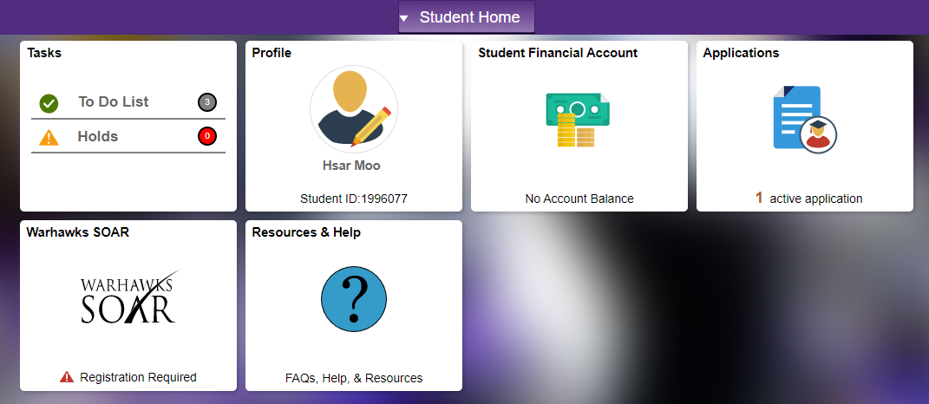

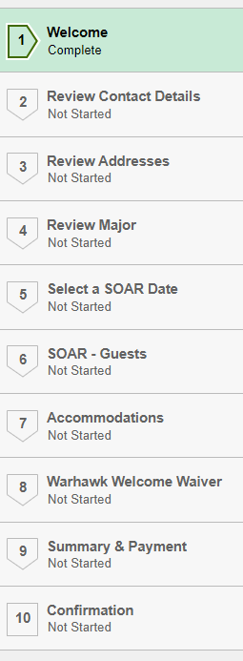

1. Complete the 10 step registration process:

**Step 5 Tip:** If no dates or a specific date is not displaying the date is full or closed. When selecting a date, be sure to click “save”, and the “Next” button will appear.

**Step 9 Tip:** Check that each step on the lefthand side says “complete”. Then click on each of the three buttons under “Payment” to complete registration.

**Step 10 Tip:** A confirmation email will be sent upon completion. Check spam/junk email folders.

Need to change your SOAR Registration Date? Students can update SOAR dates in WINS by clicking “save” and going all the way to Step 9. Then resubmit your registration.

Please note: to complete your reservation, payment of the new student fee ($175 for freshmen and two guests, $120 for transfers and two guests), additional guest fee ($25 for each guest beyond allotted two), as well as the $100 enrollment deposit is required. Students who are change of campus from the Rock County campus will not be charged the New Student Fee as they are already a UWW student. The “Summary & Payment” screen on Step 9 will have a “Click To Pay” button to submit payment.

**Questions? Please contact the First Year Experience Office at  
262-472-3205 or** [**fye@uww.edu**](mailto:fye@uww.edu)**.**