Workday – Assigning a Work Schedule
- Log into Workday.
- Enter the employee’s name in the search bar, then select the employee from the search results.
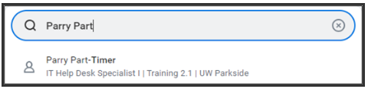
- On the Worker Profile, select Actions, Time and Absence, and Assign Custom Work Schedule.
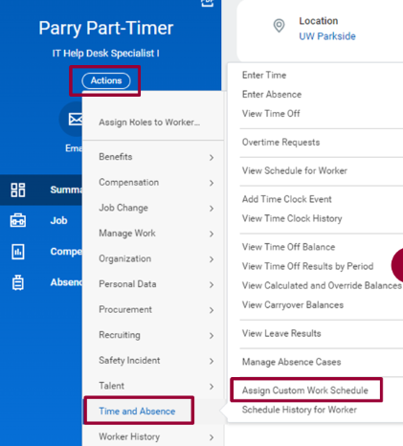
- The Assign Work Schedule will pop up with the worker’s name. Complete the following fields:
- Start Date: enter the date 06/29/2025 for the schedule to begin. Note: Date entered should correspond with start of a pay period. The first Workday pay period began on 06/29/2025.
- End Date: enter the date for the schedule to end, if necessary. Note: Leave the End Date field blank unless you are adding a temporary work schedule.
- Work Schedule Calendar: using the drop down menu, choose to Start from Blank Schedule or Start from Another Worker’s Schedule.
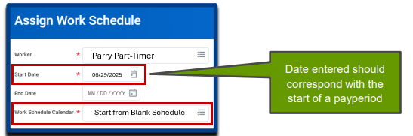
  - Start from Blank Schedule – recommended when creating your first work schedule.
  - Start from Another Worker’s Schedule – recommended if you want to duplicate another worker’s schedule for this worker.
- The Assign Custom Work Schedule window will now display for the week. Select the Pattern Details button. Note: The scheduled pattern for one week will repeat continuously.
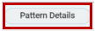
- The Pattern Details window will display. In the example shown, this employee works four 10-hour days with a 30 minute meal break. Complete the following fields:
- Schedule Pattern Type: Using the drop-down, select the Schedule Single Shift and Meal.
- For the applicable days, enter the Start and End times (and mealtimes if applicable).
- Select Done.
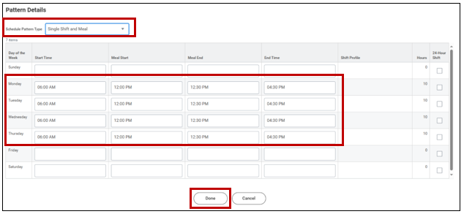Note: For accurate time tracking and overtime calculations, the total hours on the schedule should accurately reflect the workers scheduled. For example, if an employee is scheduled to work 8 hours per day, their Workday work schedule should reflect 8 hours per day. If they work a 10-hour shift, the system should be able to track that extra 2 hours as overtime, if applicable.
- Select OK to confirm the finalized schedule.

