COEPS CRP Self-Assessment 2025-2026

Since its founding, UW-Whitewater has distinguished itself as a leader in teacher education. The College of Education and Professional Studies (COEPS) continues this tradition of creating a community of learners. This community, composed of students, university faculty and staff, school educators, and community leaders, is characterized by reflection, engagement, service and responsiveness as befits reflective facilitators of learning. COEPS’ conceptual framework, “The Teacher as a Reflective Facilitator/Practitioner'' provides a framework and direction to connect and articulate the many facets of educator preparation such as licensure program courses, teaching, candidate assessment/performance, faculty scholarship and service, and overall accountability to the work we do in preparing educators. In large part, the aim of all licensure programs is to develop teachers and other school personnel as reflective practitioners who continually evaluate the effects of their choices and actions on others and who actively seek out opportunities to grow professionally. In short, our educator preparation program is committed to:
- reflection of practice
- facilitation of creative learning experiences for pupils
- constructivism in that all learners must take an active role in their own learning
- information and technology literacy
- inclusion of all learners
- inquiry (research/scholarship) and assessment.

1. What data or trends are you seeing regarding the impact of your program in each of the areas below in successfully preparing candidates for licensure?

A. Assessment System (Reference PI 34.021: communication skills, human relations and professional dispositions, content knowledge, pedagogical knowledge, performance in the clinical program, and reading)

To track how the Assessment System is implemented across all UW-Whitewater programs, we maintain an outline of how the PI 34.021 Assessment System categories are assessed across all of our licensure programs (teacher, administrator, and pupil services). The following sections summarize what we are learning that contributes to successfully preparing candidates for licensure in each of the three areas (teacher, administrator, and pupil services). Our Appendix E includes program-specific assessment data in addition to the EPP-level teacher data provided in this report. In reviewing all of the data shared below, we are confident that the initial licensure programs housed in our college are more than adequately preparing teacher candidates for successful careers as licensed educators in WI. The data gathered and reported are also helpful for both the entity and individual programs to continue to review, revise and improve our educator licensure programs.

In 2024-2025, the COEPS TELCE ((Teacher) Educator Licensure and Clinical Experiences) committee worked to update our assessment model. The new version of the model is designed to be easily adaptable across all licensure programs. Seven versions of the model are prepared to represent all licensure programs offered by the college: undergraduate and graduate initial teacher programs without reading requirement; all add-on/supplemental teacher programs (without reading); all administrator programs (except reading specialist); all pupil services programs; undergraduate and graduate initial teacher programs with reading requirement; reading teacher program; and reading specialist program. Figures 1 and 2 provide two examples.

Figure 1. COEPS Assessment Plan for initial teacher preparation programs that do not hold reading requirements.
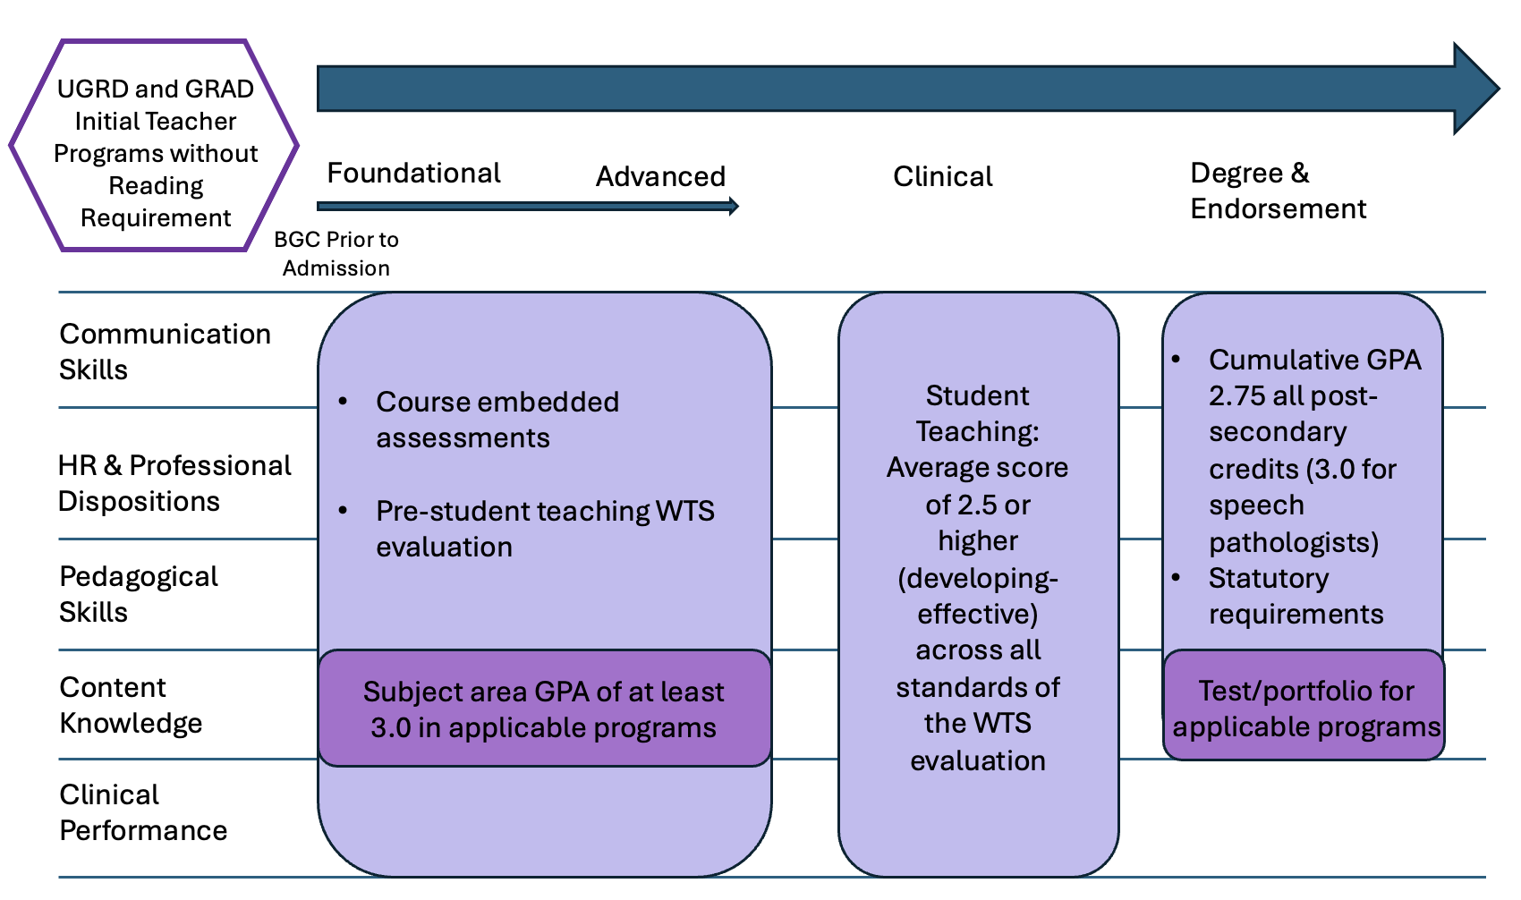

Figure 2. COEPS Assessment Plan for initial teacher preparation programs that do hold the reading requirements.
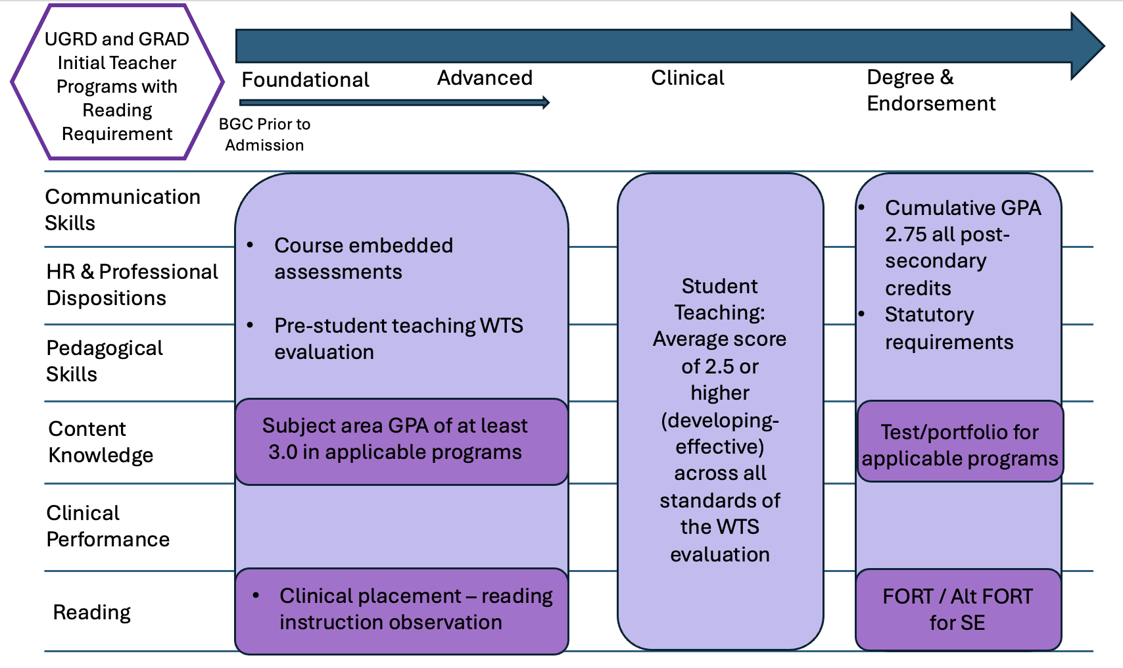

All Programs - PI 34.021(1)(c) Content Knowledge and PI 34.021(f) Reading

Evaluation of Content Knowledge

Each educator preparation program at UW-Whitewater has a clearly defined mechanism for measuring content knowledge of each candidate. Content knowledge measures for each program are listed in the LPs for All Programs sheet, “LP List” tab, column E. Tables 1 and 2 outline content test attempts and pass rates for each program. This year, we have updated our method of tracking and presenting test passing rates from previous years and added pass rates for content-based portfolios for applicable programs.

Praxis II testing in the secondary content areas provides the greatest challenge for our students. Half of the English & Language Arts students and science students required more than one attempt to pass the test, however, all students in those areas passed by the time they graduated from UW-Whitewater. While a greater proportion of social studies students passed on the first attempt, some students (3 this year) were unsuccessful in passing the test by graduation. These students were in our affirmed, developmental-level social studies program, and the new version of the program no longer requires Praxis II except for students who do not meet the minimum 3.0 subject area GPA requirement.

Table 1. Praxis II attempts, pass rates, and endorsements by educator program.
Name of EPP | # Student Teachers | # Students who Attempted Praxis II | # Praxis II Attempts | # Students who Passed Praxis II | # Completed Content-based Portfolios | # Endorsed
Art Education (undergraduate) | 13 | - | - | - | - | 12
Business Education Grad | 12 | - | - | - | - | 11
Business Education Residency | - | - | - | - | - | -
Business Education UG | 6 | - | - | - | - | 6
Computer Science | - | - | - | - | - | -
Early Childhood Regular Education UG | 36 | - | - | - | - | 13
Early Childhood Special Education UG | 36 | - | - | - | - | 13
Elementary - MCEA UG | 122 | 1 | 1 | 1 | - | 75
Elem-middle - K-9 UG | 23 | 1 | 1 | 1 | - | 6
Elem-Middle FOTE to K-9 | - | - | - | - | - | -
Elem-middle K-9 Grad | - | - | - | - | - | -
English and Language Arts 4-12 | - | - | - | - | - | -
English Education 6-12 UG | 8 | 8 | 12 Total: 4 passed on 1st att, 2 students 1/2, 1 student 1/3 | 8 | - | 7
English as Second Language | 3 | - | - | - | - | 2
Health Education Undergraduate | 45 | - | - | - | - | 44
Health Education PostBacs | 1 | - | - | - | - | 0
Instructional Library Media Specialist | 15 | - | - | - | 15 | 15
Marketing Education UG | 6 | - | - | - | - | 6
Math Education Residency Program | - | - | - | - | - | -
Mathematics Undergraduate | 6 | - | - | - | - | 6
Music | 14 | - | - | - | - | 14
Physical Education UG | 45 | - | - | - | - | 44
Physical Education PostBac | 12 | - | - | - | - | 10
Science Education Residency Program | - | - | - | - | - | -
Science Education 6-12 Undergraduate | 5 | 5 | 9 total: 2 passed on 1st att, 2 students 1/2, 1 student 1/3 | 5 | - | 1
Social Studies 6-12 UG | 23 | 22 | 29 total: 17 passed on 1st att, 1 student 1/2, 2 students 1/3, 1 student 1/4 | 20 | - | 17
Special Education - Grad CC | 28 | - | - | - | - | 26
Special Education - Post Bacc | 2 | - | - | - | - | 2
Special Education - UG CC | 20 | - | - | - | - | 17
Speech Language Pathologist | 13 | 13 | 15 | 13 | 13 | 13
Theatre Undergrad | 1 | - | - | - | - | 1
Adapted Physical Education (supplemental) UG | 45 | - | - | - | - | 45
Adapted Physical Education (supplemental) PB | 3 | - | - | - | - | 3
Adaptive Education (supplemental) UG | 64 | - | - | - | - | 63
Alternative Education (supplemental) | 4 | - | - | - | 4 | 4
Assistive Technology Educator K-12 | - | - | - | - | - | -
Bilingual-Bicultural (supplemental) | 2 | - | - | - | - | 2
Coaching Athletics (supplemental) UG | 45 | - | - | - | - | 12
Coaching Athletics (supplemental) PB | 6 | - | - | - | - | 5
Gifted and Talented (supplemental) | 13 | - | - | - | - | 11
Reading Teacher (supplemental) | 5 | - | - | - | - | 3
School Counselor Masters | 5 | 3 | 3 | 3 | - | 3
School Counselor - Post Masters Ed to School Counselor | 11 | - | - | - | 10 | 10
School Psychologist | 12 | 12 | 12 | 12 | - | 11
School Social Worker | 10 | - | - | - | 10 | 10
School Social Worker - Post Masters | 6 | - | - | - | - | 6
Career and Technical Education Coordinator | - | - | - | - | - | -
Director of Curriculum and Instruction | - | - | - | - | - | -
Director of Special Education and Pupil Services | - | - | - | - | - | -
Gifted and Talented Coordinator | 12 | - | - | - | - | 11
Principal | - | - | - | - | - | -
School Business Administration | 9 | - | - | - | - | 9
School Business Administration Certificate - MPP | 6 | - | - | - | - | 6

Table 2. ACTFL attempts, pass rates, and endorsements by educator program.
Name of EPP | # Student Teachers | # Students who Attempted ACTFL OPI | # Students who Completed ACTFL OPI | # Students who Attempted ACTFL WPI | # Students who Completed ACTFL WPT | # Students Endorsed
World Languages - Spanish | 3 | 3 | 2 | 3 | 1 | 1
World Languages - German
World Languages - French
Bilingual-Bicultural (supplemental) | 3 | 2 | 2 | 2 | 2 | 2

Reading - FORT and Alt FORT Completion

FORT pass rates and Alt FORT portfolio completion rates are carefully monitored by our reading faculty teams to best support our students. Table 3 outlines FORT attempts, pass rates, and Alt FORT completion for senior students (student teachers / practicum students) in our applicable programs. Most of our special education students and reading specialists successfully completed the FORT requirement by their time of graduation. The test continued to be a barrier to licensure for many of our elementary/middle education and early childhood/EC special education dual licensure students. Sixty-four percent of elementary/middle students, and 42% of our ECE students passed the FORT by their graduation. The data show that 89% ECE students attempt the FORT during their undergraduate programs, while only 75% of elementary/middle students make an attempt. We have noted improved pass rates following modifications faculty have made to our reading courses and additional supports we have implemented such as tutoring and providing access to study guides, however, 25% of our students did not attempt the test. Faculty who instruct our reading courses strongly emphasize to students that they should attempt the FORT directly following particular reading courses, and our faculty try to track FORT test registrations, but the data show that more efforts are needed to ensure that students are attempting the test.

EC students now have an approved Alt FORT option, and we hope this will increase the proportion of students we can endorse for licensure following their graduation. The recently revised EC curriculum also adopted the same science of reading courses as the K-12 cross-categorical program; and we are hopeful that these courses will also lead to a greater pass rate for EC students. The data show a decline in Alt FORT attempts within our K-12 special education program. We believe the decrease in Alt FORT attempts aligns with an improvement in our FORT pass rates among K-12 special education candidates.

Table 3. FORT and Alt FORT attempts, pass rates, and endorsements by applicable educator program.
Name of EPP | # Student Teachers / Practicum Students | # passed FORT prior to program | # Students who attempted FORT during program | # FORT Attempts during program | # Students who Passed FORT by Graduation | # Students who Attempted Alt FORT | # Students who Successfully Completed Alt FORT | # Students who did Alt FORT after attempting FORT | # Students Endorsed
Early Childhood Regular Education | 36 | - | 32 | 38 | 15 | - | - | - | 13
Early Childhood Special Education | 36 | - | 32 | 38 | 15 | - | - | - | 13
Elementary MCEA UG | 123 | - | 87 | 103 | 75 | - | - | - | 75
Elem-middle - K-9 UG | 24 | 1 | 23 | 35 | 18 | - | - | - | 19
Elem-Middle FOTE to K-9 | - | - | - | - | - | - | - | - | -
Elem-middle K-9 Grad | - | - | - | - | - | - | - | - | -
Special Education - Grad CC | 28 | 6 | 15 | 17 | 17 | 8 | 8 | 1 | 26
Special Education - Post Bacc | 2 | 2 | - | - | 2 | - | - | - | 2
Special Education - UG CC | 20 | - | 13 | 14 | 13 | 5 | 5 |  | 17
Reading Teacher | 5 | 3 |  |  |  |  |  |  | 3
Reading Specialist | 2 |  | 2 | 2 | 2 |  |  |  | 2

Teacher Preparation Programs - PI 34.021(1)(a) Communication skills; (b) Human relations and professional dispositions; (d) Pedagogical knowledge; and (e) Performance in Clinical Program

Clinical Evaluations

As outlined in our COEPS PI 34.021 Assessment System Categories sheet, we use particular items in our standards-based clinical evaluation form to assess communication skills, human relations & professional dispositions, pedagogical skills, and performance in clinical programs. We also assess content knowledge using clinical evaluations, although our primary content knowledge assessment is GPA, standardized test, and/or content-based portfolio.

Figures 3 and 4 show mean pre-student teaching, mid-point student teaching, and final student teaching scores for the PI 34.021 assessment categories across all teacher programs for the reporting year (Fall 2024 and Spring 2025). Our performance expectation is for students to score 2.5 or higher within each of the assessment categories, and our data shows that our students are meeting this expectation on average across the college. The data also show progression from pre-student teaching to final student teaching in all assessment categories. Overall, students score highest in communication skills and human relations/professional dispositions; and perhaps a little lower in content knowledge as evaluated by cooperating teachers.

Figure 3. Fall 2024 Clinical Evaluations of PI 34.021 across all teacher preparation programs.
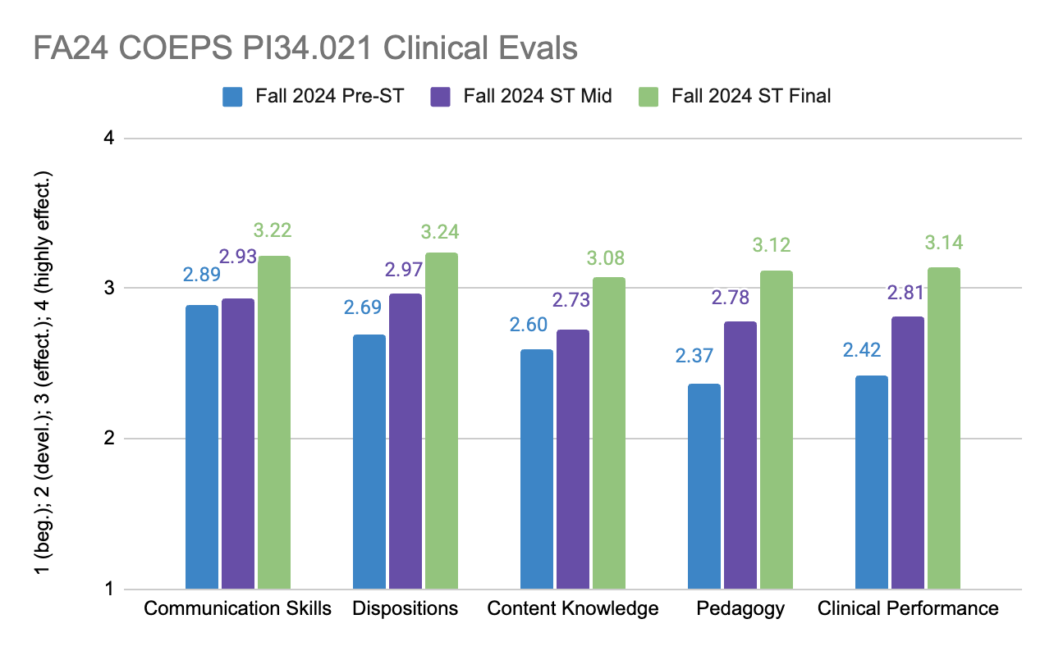

Figure 4. Spring 2025 Clinical Evaluations of PI 34.021 across all teacher preparation programs.
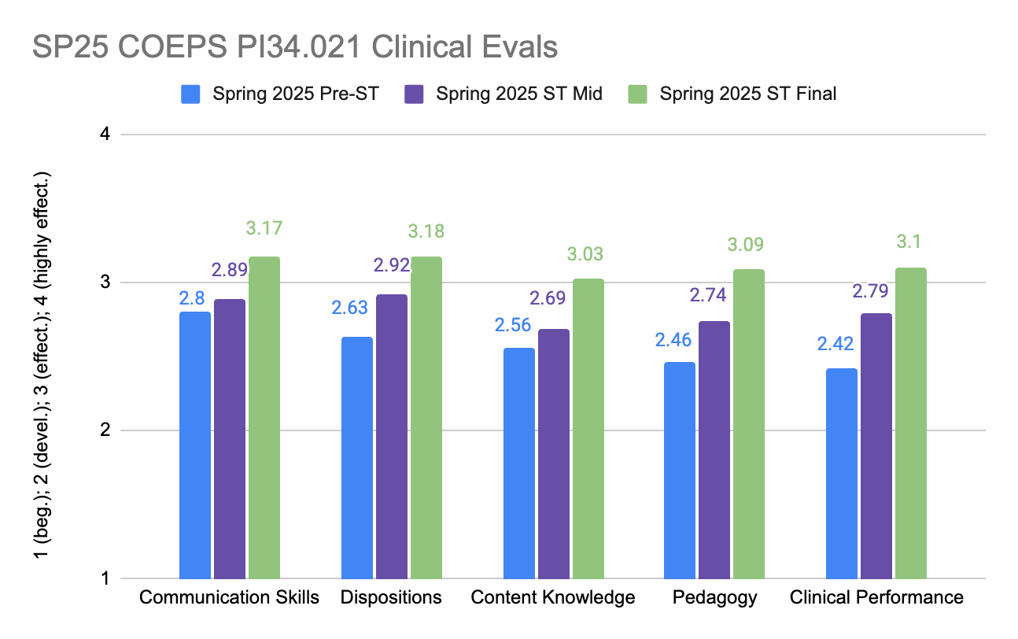

Figures 5 and 6 provide program-specific examples of the clinical evaluations data for the PI 34.021 Assessment System categories. Data and charts for individual licensure programs are available within the PI 34.021 Assessment System folder in our App E shared drive. The special education program data are very similar to the data across all programs, with clear progression from pre-student teaching to final student teaching, and stronger communication and professional disposition skills with slightly lower content knowledge ratings. The elementary/middle education program data were a little different with more consistent mean final student teaching scores across all the assessment categories (content knowledge a lot closer to communication and professional disposition skills), and larger improvements from mid-point to final student teaching scores. In special education, some mean mid-point evaluations were above a mean of 3.0 (effective) whereas in elementary/middle education mean mid-point scores were notably below 3.0. Overall, the data show that elementary/middle education candidates grow more sequentially from lower initial scores to higher final student teaching scores across the board.

Figure 5. Spring 2025 Clinical Evaluations of PI 34.021 for the special education teacher preparation program.
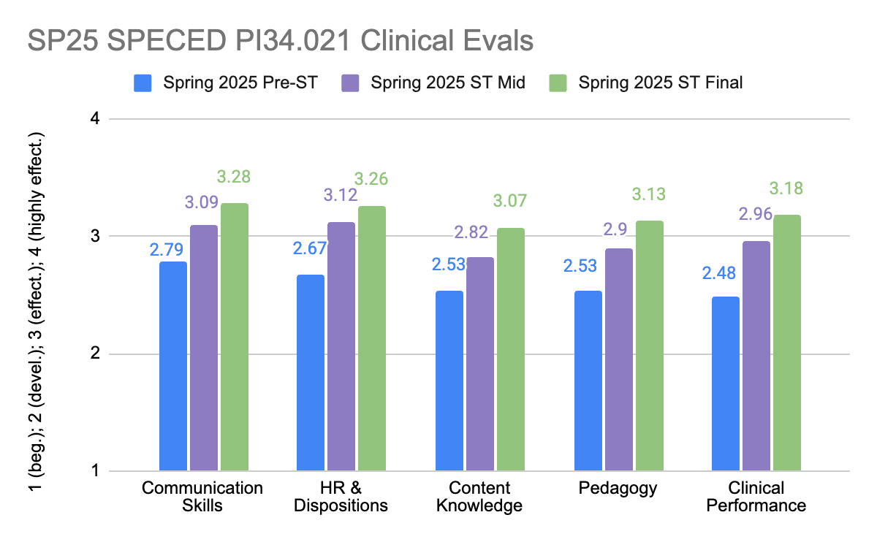

Figure 6. Spring 2025 Clinical Evaluations of PI 34.021 for the elementary-middle education teacher preparation program.
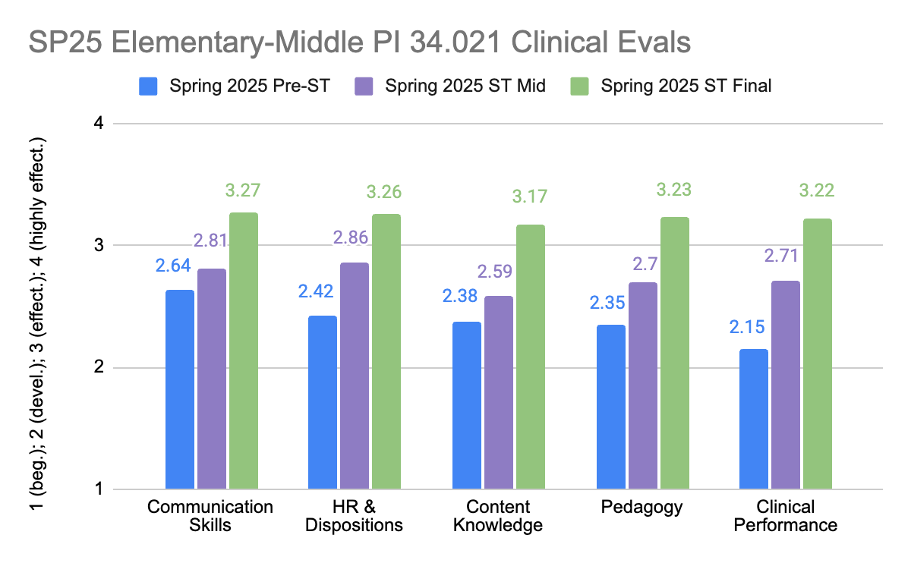

Educational Foundations Assessment of Communication Skills and Professional Dispositions

During Fall 2025, our Educational Foundations department implemented a new assessment within the EDFNDPRC 210 Introduction to Education and Teaching course. The purpose was to collect an early assessment of communication skills and professional dispositions that can be shared with program faculty so they are more informed about the emphasis placed on these skills during foundational coursework, and so they may follow up with further instruction and assessment during program-specific upper-level coursework.

The assessment instructed students to have a conversation with the cooperating teacher during their initial school placement and request feedback about their performance in their placement to date. Following the conversation, the students prepared a field journal that described their experience receiving feedback and connecting with their cooperating teacher about improving their teaching practice; and reflected on their professional communication skills.

Instructors rated the assessment as a usual assignment within their course LMS, then also completed a rubric that included detailed measures of communication skills and professional dispositions. The instructor ratings show that the majority of students are on track with emerging communication and professional disposition skills (figure 7). Their performance on the two components of the PI 34.021 Assessment System was similar with slightly more students performing at “highly effective” level on the communication skills measure than in professional dispositions. Results of the assessment can be segmented by the students’ teacher preparation programs and shared with program coordinators.

Figure 7. Communication skills and professional dispositions ratings of student educational foundations field journal assignments, n=112.
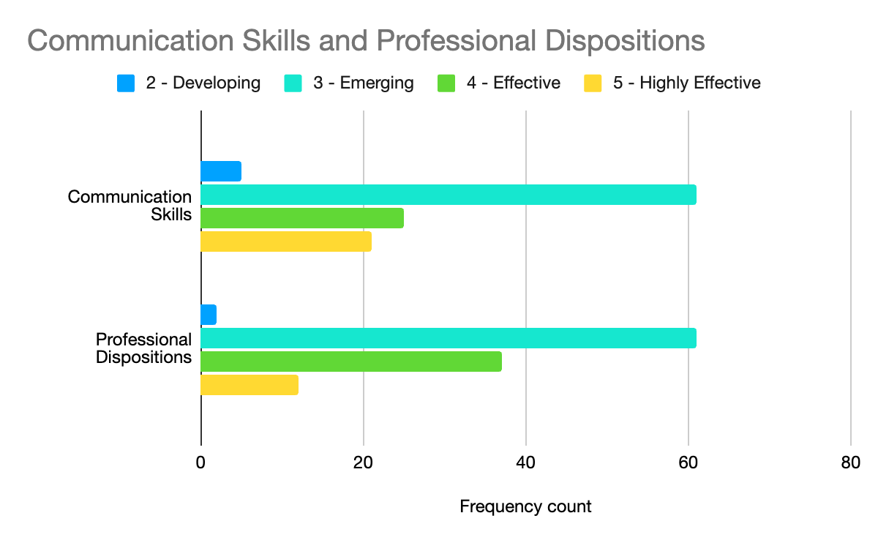

Administrator Programs:

Our faculty leading administrative programs have developed a practicum observation form that aligns with the PI 34.003 Administrator standards and the PI 34.021 assessment plan (Table 3). This year, we have assessment data to report for the reading specialist and the school business manager administrative programs. We have seen growth in enrollment in our reading specialist program due to UW-Whitewater’s new MSE Reading Instruction and Dyslexia Intervention program (40 students currently enrolled), which was launched close in time to the implementation of Act 20. UW-Whitewater’s School Business Manager program remains steady in enrollment with approx. 15-20 completers each year. This year, we launched principal, director of instruction, and director of special education & pupil services programs as post-master’s certificates or wrapped in with our MS in School Business Management & Leadership degree program. We do not yet have completers from those new programs. We have also launched a Career & Technical Education Coordinator certificate program, but do not have data to report yet for that new program, either. We have phased out the gifted & talented coordinator and teacher licenses because the faculty member who supported this program has left UW-Whitewater.

The following table outlines how our administrator program PI 34.003 standards-based evaluation tool is aligned with the PI 34.021 Assessment System. Figure 8 provides Spring 2024 - Spring 2026 data for our Reading Specialist and School Business Manager licensure programs.

Table 3. PI 34.021 assessments for UW-Whitewater’s administrator programs.

UW-Whitewater Administrator Programs
 | PI 34.021 category | Specific Items/Sections | Assessment
(a) | Communication skills | Question 8 | Administrator practicum observation form.
(b) | Human relations and professional dispositions | Questions 1, 2, and 3 | Administrator practicum observation form
(d) | Pedagogical knowledge | Question 4 | Administrator practicum observation form
(e) | Performance in clinical program | All questions | Administrator practicum observation form
(c) | Content knowledge |  | Maintaining a GPA of 3.0 in the subject area of the license.
Rating scale: 1, Beginning; 2, developing; 3, effective; 4, highly effective. Performance expectation = 3.

Reading specialist and school business manager evaluations were similar, and average scores for both programs were above the performance expectation of at least 3.0. Although evaluation scores were similar across the assessment categories, students tended to receive slightly higher ratings for pedagogical knowledge than the other assessment categories, in both programs. Comments provided for candidates in both programs supported high pedagogy ratings by emphasizing how the candidates were committed to understanding district practices, policies, and procedures, and that they were highly dedicated in terms of school and community involvement, motivated by a strong interest in making the best assessment-based decisions within their administrative roles.

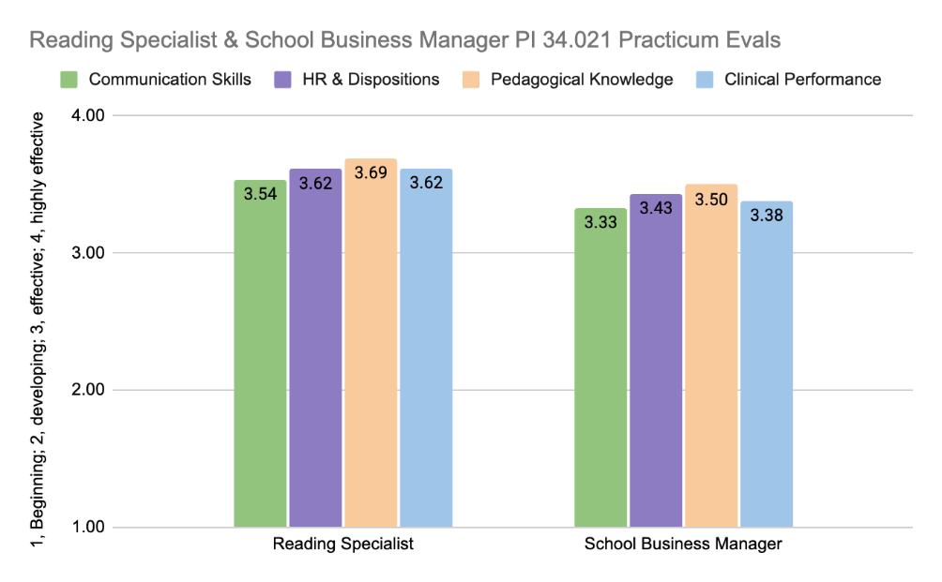
Figure 8. Reading specialist & School Business Manager PI 34.021 practicum evaluation ratings (Reading specialist n=13, SBM n=10, scale: 1=beginning; 2=developing; 3=effective; 4=highly effective).

Pupil Services Programs:

As outlined in the COEPS’s PI 34.021 Assessment System across all programs sheet, our pupil services programs have each identified measures of the assessment categories except for content knowledge within their practicum evaluation forms. Some of these assessments identify specific evaluation questions, while others are particular sections of the evaluation or the whole evaluation (for clinical performance). The following sections outline these assessments.

School Psychologist Program

The School Psychology program uses observation data from cooperating school psychologists to assess communication skills, pedagogical knowledge, and performance in clinical programs. We use a school psychologist dispositions observation form (also completed by the cooperating practitioners) to assess human relations and professional dispositions, and Praxis II pass rates and/or content GPA to assess content knowledge. Table 4 outlines the specific observation form categories/items, and Table 55 provides our proficiency standards used for (1)a,b,d, and e of the PI 34.021 Assessment System.

Table 4. PI 34.021 assessments for UW-Whitewater’s School Psychologist program.
School Psychologist
 | PI 34.021 category | Specific Items/Sections | Assessment
(a) | Communication skills | Consultation and Collaboration; Family, School & Community Collaboration sections
(d) | Pedagogical knowledge | Data Based Decision Making | Cooperating practitioner's School Psychologist Observation Form ratings.
(e) | Performance in clinical program | All sections
(b) | Human relations and professional dispositions | Complete form | Cooperating practitioner's School Psychology Dispositions Appraisal, completed during practicum.
(c) | Content knowledge |  | Passing the subject area test approved by the Superintendent (i.e., Praxis II). Maintaining a GPA of 3.0 in the subject area of the license.

Table 5. Proficiency criteria for the school psychologist practicum evaluation forms.
School Psychologist Observation Form
 | N/O: The supervisor has not had the opportunity to observe this skill
0 | Student was unskilled initially and remains so; reflects the most severe supervisory concern
1 | Student has made insufficient progress toward this competency skill
2/3 | Student is on-track for attaining this competency skill; more supervised experience needed
Proficient - 4 | Student has achieved this competency at a proficient level
5 | Student has shown exceptional skill worthy of note
School Psychology Dispositions Appraisal Form
 | N/O No opportunity to observe/don't know
1 | Needs substantial improvement to be at level appropriate for end of 1st year/start of practicum
2 | Needs some improvement to be at level appropriate for end of 1st year/start of practicum
3 | Exhibits level appropriate for end of 1st year/start of practicum
4 | Exhibits level appropriate for end of 2nd year/start of internship
Proficient - 5 | Exhibits level appropriate for end of 3rd year/entry into profession

Figure 9 illustrates communication skills, pedagogical knowledge, and clinical performance for the 2024-25 academic year. Results demonstrate progression from fall to spring semester toward the performance expectation of 4.0 (student has achieved competency at a proficient level) in all three areas of assessment. Figure 10, which shows professional dispositions assessments for school psychologists, also demonstrates improvement from fall to spring placements, and an average final score that is between the performance expectation for the start and completion of their 3rd year internship.

Figure 9. School psychologist communication skills, pedagogical knowledge, and clinical performance for the 2024-25 academic year.
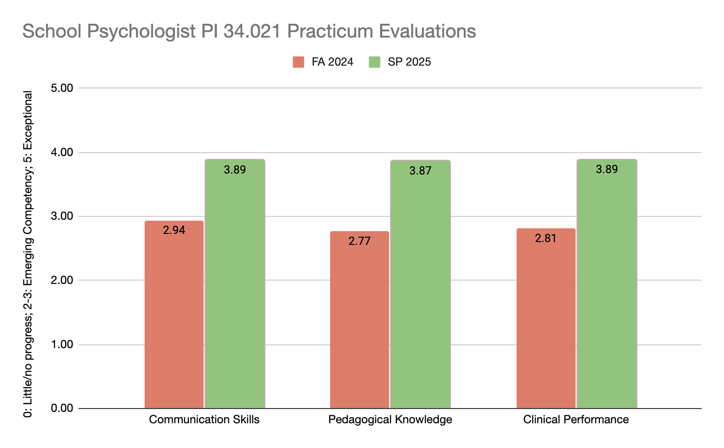

Figure 10. Mean school psychologist professional dispositions evaluation scores for the 2024-25 academic year.
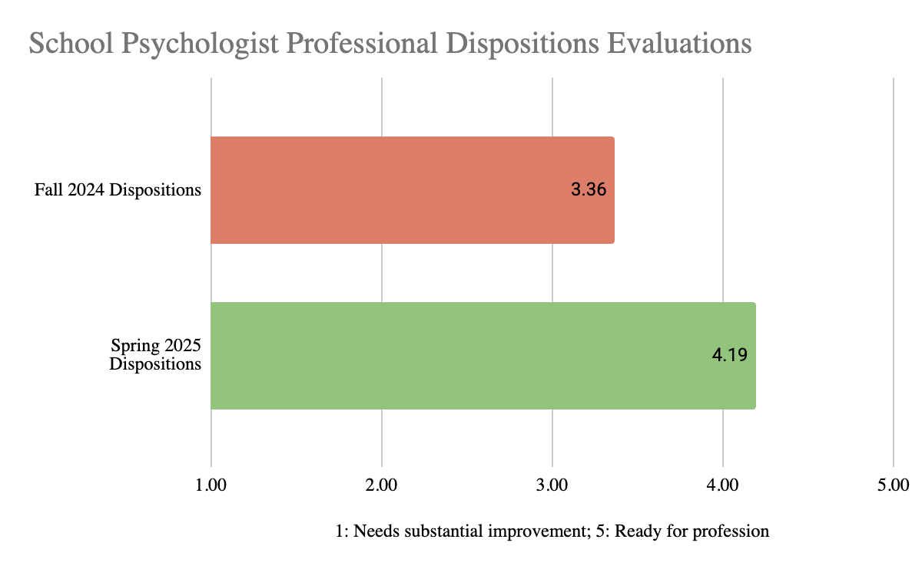

School Social Worker

UW-W’s School Social Work program uses observation data from cooperating school social workers to assess communication skills, human relations and professional dispositions, pedagogical knowledge, and performance in clinical programs. Table 6 outlines the specific observation form categories/items and the proficiency expectation for (1)a,b,d, and e of the PI 34.021 Assessment System.

Table 6. PI 34.021 assessments for the school social work program.
School Social Worker
Rating scale: 1, poor; 2, fair; 3, good; 4, very good; 5, excellent
Proficiency expectation: 3.5, good - very good
 | PI 34.021 category | Specific Items/Sections | Assessment
(a)& (d) | Communication skills & pedagogical knowledge | Content Area 5: Effective Prevention and Intervention with Individuals, Families, Schools, and Communities | Cooperating practitioner's evaluation on the School Social Work Practicum Evaluation Form.
(b) | Human relations and professional dispositions | Content Area 2: Social Work Values, Ethics, and Professionalism; Content Area 7: Diversity on the School Social Work Practicum Evaluation Tool | Cooperating practitioner's evaluation on the School Social Work Practicum Evaluation Form.
(e) | Performance in clinical program | All content areas | Cooperating practitioner's evaluation on the School Social Work Practicum Evaluation Form.
(c) | Content knowledge |  | Successfully complete the approved content based portfolio and maintain a GPA of at least 3.0 in subject area coursework.

Our school social work candidates met or exceeded our standards of proficiency in the Assessment System categories during spring and fall 2025 semesters (figure 11). The spring cohort scored a little higher than the fall cohort, and both cohorts scored slightly higher in human resources and professional dispositions as compared with the other assessment categories. The social work program holds strong emphasis in the areas of community building, building collaborations, ethics, and professional dispositions; so, evaluation scores align with the goals of the program.

Figure 11. Average scores for SP 25 & FA 25 PI 34.021 evaluations in the school social work program (SP25 n=15; FA25 n=14). 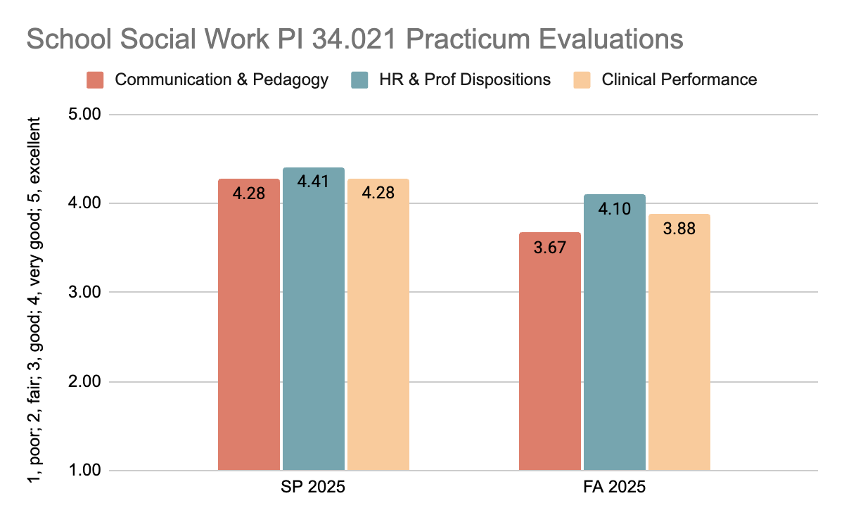

School Counselor

The UW-W school counselor programs use two different observation forms to assess communication skills, human relations and professional dispositions, pedagogical knowledge, and performance in clinical programs. Table 7 outlines how the observation forms for each school counselor program align with the PI 34.021 assessment categories, and how proficiency is measured within each observation form.

Table 7. Summary of internship evaluation forms for PI 34.021 for the post-master’s Educator to Counselor and MS School Counseling programs.
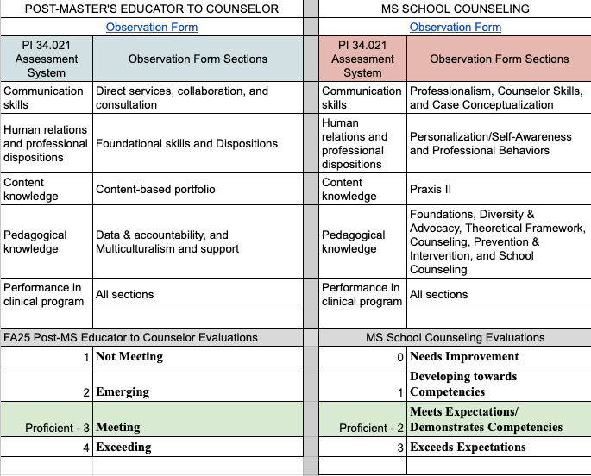

Figures 12 and 13 show that on average, students are meeting the performance expectations by the end of their internships. Students tend to consistently score highest in human relations and professional disposition, and their scores on the other components of the Assessment System vary by semester and are closer to the performance expectation.

Figure 12. PI 34.021 assessments for post-master’s Educator to Counselor program during FA 2025 semester, n=18.
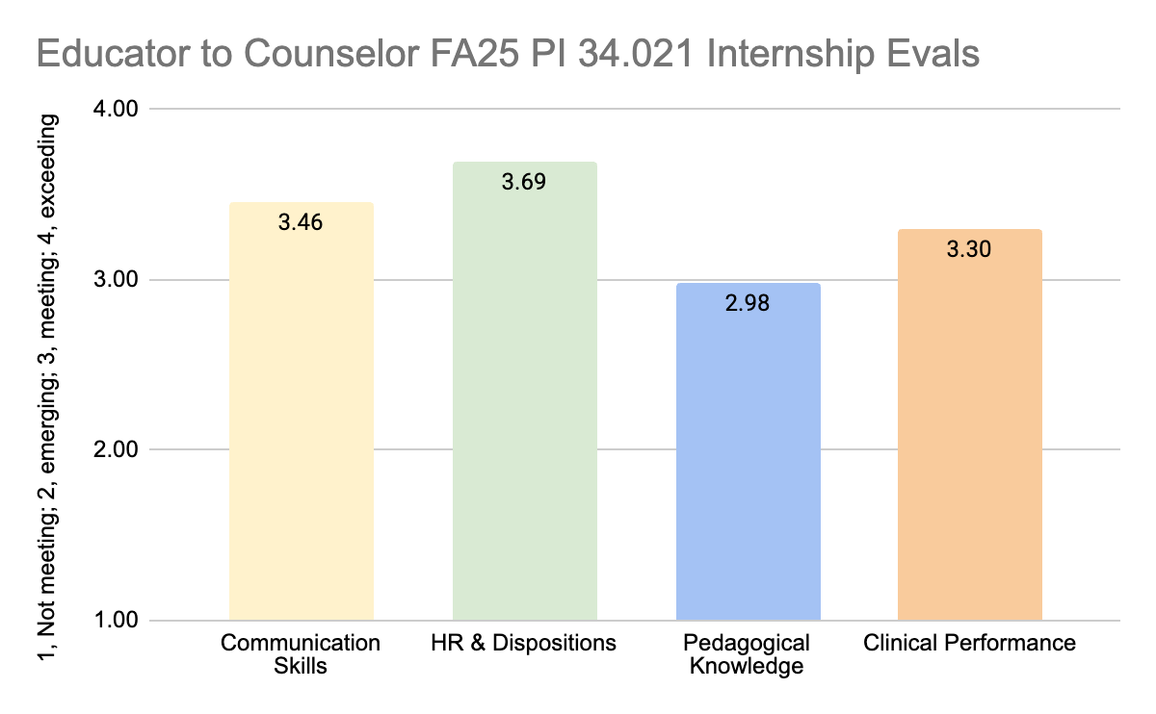

Figure 13. PI 34.021 assessments for the MS School Counseling program for SP25 and FA25 semesters, n=10.
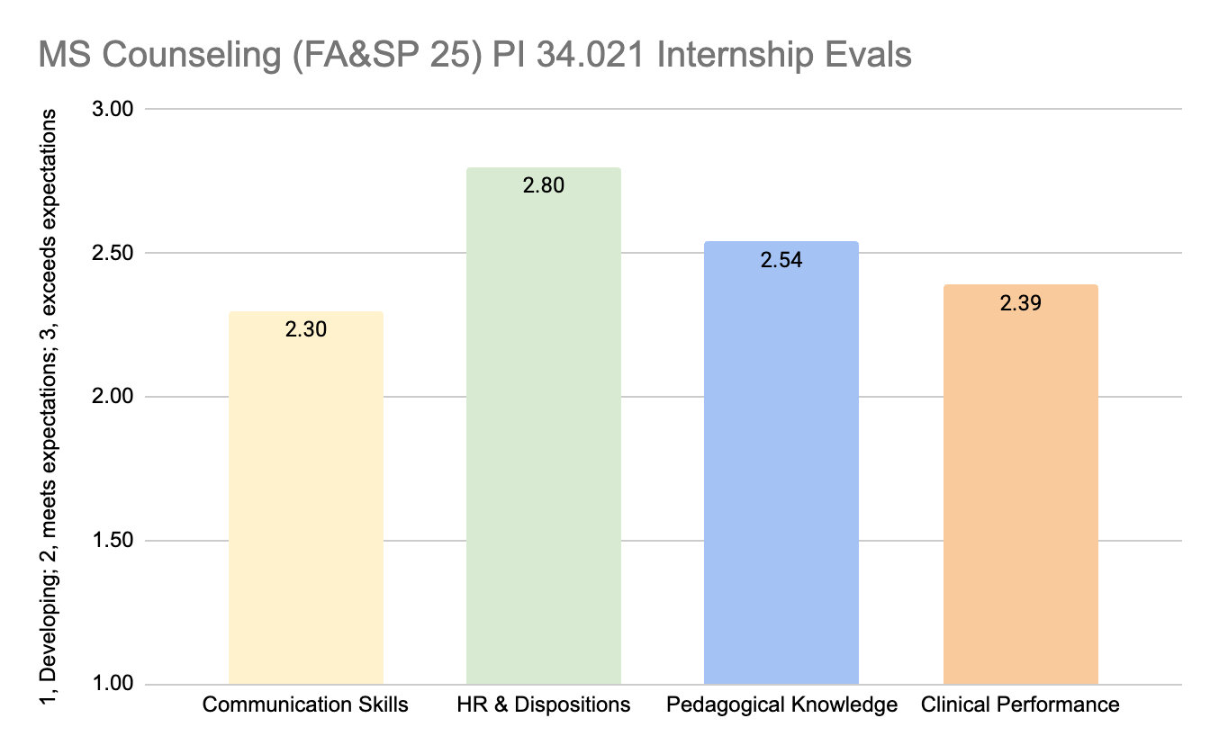

B. Collaboration with stakeholders PI 34.014 and PI 34.024
Although there are a wide variety of methods used to gain stakeholder feedback across our programs, the following 5 initiatives serve to help us assess the performance of our students and our programs (PI 34.024), and that integrate the insight our faculty gain through their engagement in networking and professional development (PI 34.014).

- Faculty Networking and Professional Development Activities
(PI 34.014) Our faculty in the COEPS are highly engaged in professional networking and seek professional development opportunities that allow them to stay current in the profession, reflect on current trends in teacher preparation, and continually assess the performance of our candidates while considering potential improvements/updates to our programs. For example, many of our program coordinators and faculty are involved in 5+ professional networking and development activities. A recent survey asked them to detail the trends they are observing through professional development opportunities, and how those experiences have helped them conceptualize and improve our programs. Our faculty have observed a broad variety of trends, ranging from content-area specific priorities such as educator wellness, science of reading, effective math teaching practices, to more general observations such as a shift from what was taught to what was learned, more need for teachers prepared to support diverse students such as language learners, the shift to performance based assessments, and increasing opportunities for collaboration between schools and universities for mutual support. Nearly all of our faculty coordinators described adaptations made to courses of their programs that were informed by observations made through networking and professional development.

- Deans Advisory Board and program-level advisory boards
We bring teachers, employers, experts and partners together for the specific purpose of assessing, developing, and improving our college and programs. Our Dean’s Advisory Board meets annually, please see the board membership lists, meeting agenda, slides, and notes in our Appendix E PI 34.013 folder. This year, we shared updates and recognized recipients of our Telfer Endowed Faculty Fellowship and Incentive which recognizes faculty members who make, or have the potential to make, distinguished and significant impact to their professions. An example recipient of this award is Dr. Betters-Bubon who engaged in the Neurosequential Model of Therapeutics (NME), a brain-based model for understanding the impact of trauma, based on the timing of trauma, and has integrated this model into school counseling coursework. We also recognized student scholarship recipients, and student participants and leaders of our Future Teacher Program. Following these panels, we brainstormed new ways to offer opportunities to engage our students and staff in such meaningful opportunities that ultimately benefit our college and schools across the region.

- Cooperating Teacher Feedback
Feedback collected from our cooperating teachers also provides perspective about candidate performance at the point of program completion. For example, review of the open-ended comments within the final student teaching provides an assessment of some common strengths and challenges among our student teachers as a whole (Table 8). As these prevalent comments show, our completers demonstrated a wide variety of strengths, and the challenges noted tended to be improvements some students require that match the qualities most candidates are frequently praised for. Aside from gaining confidence in the classroom, the most common areas for improvement tend to be classroom management, conflict resolution, behavior management, professionalism in general, professional communication skills, and challenging themselves to take on uncomfortable tasks (addressing tough situations, calling parents, etc.).

Table 8. Common strengths and areas for development across student teachers noted by cooperating teachers.
Strengths | Area for Development / Improvement
Excellent organizer
Strong teaching skills | Addressing tough situations instead of avoiding them
Committed to meeting student needs | How to address students who don't understand what they are presenting
Dedication to teaching
Enthusiastic
Excellent behavior management
Great teacher all-round
High confidence | Need to assert themselves of the classroom
Innovative approach to assignments
Quiet confidence | Needs to work on projection (teacher voice)
Strong communicator | Working on word and subject choices with older kids
Strong professional values
Strong student connection | Self-regulation
Technologically friendly/savvy
Classroom management | Conflict management
Commitment to improvement | Needs to step outside of comfort zone
Work ethic
Content area expert
Created a great learning environment
Dedicated
Develop strong student relationships | Needs to build report with students
Gains student trust
Innovative solutions to type of workload
Positive attitude
Professional manner | Needs work on professional practices (being to work on time)
Reflective of their skills
Responsive to feedback
Utilizes different types of assessment
Shown growth
Shows initiative
Well prepared
Works well with others

- Office of Clinical Experiences Advisory surveys and meetings
Our Office of Clinical Experiences annual surveys and advisory meetings allow us to collect feedback and industry trends from a wide variety of administrators and to follow-up with specific discussions to gain better context from regional K-12 administrators. In this year’s survey (completed February, 2026), which was completed by 101 administrators, we asked about the strengths administrators notice in staff who completed their preparatory programs at UW-Whitewater, and about which areas they felt our completers could use additional preparation. These were open-ended questions which we categorized into themes.

The most prominent strength of our completers identified by administrators was their readiness to teach (figure 14). Comments in this category represented an appreciation for new staff who could leap into their positions, were recognized from the start for their well-rounded preparation and confidence, and who demonstrated leadership with minimal need for supervision. This strength was followed by a recognition of the strong content knowledge UW-Whitewater completers hold. Other prominent strengths were the ability to collaborate, communicate, and build relationships with both staff and students; to meet the needs of the individual student and diversify instruction; and pedagogical preparation and knowledge. In our OCE advisory meeting, participants shared that they appreciate the preparation of our students and welcome the opportunity to engage with COEPS because they see our commitment to high-quality educator preparation and the level of care and concern, we commit to developing and protecting the profession.

The most prominent suggestions for how we (COEPS) may augment our preparatory programs pertain to classroom management, conflict resolution, and managing challenging behaviors. Related to these was the prominent note that new teachers need to be more proactive and confident in communicating with parents. To follow up on these suggestions during the in-person meeting, we had faculty members who teach classroom management share a little about their teaching approaches in this area and lead a discussion about how to better collaborate (districts and COEPS) to better prepare candidates in these areas. We discussed ideas for better integrating school-based experiences into our coursework and involving teachers and administrators more in our regular coursework.

The next group of suggestions pertained to pedagogical preparation including planning for instruction, assessment, understanding different learners and differentiating instruction. Interestingly, these skills were mentioned with about the same frequency as areas for improvement as they were noted as strengths of our completers. In our follow-up discussion, district administrators emphasized the importance of special education preparation for all teachers and identified secondary education as a particular area for attention, as well as more opportunity in general to practice sequential lesson planning in school settings. Reading instruction was also prominent within the suggestions, however, these comments were less specific to UW-Whitewater and general in terms of the introduction of Act 20 and the importance of having all teachers trained in the science of reading.

Figure 14. Areas of strength and those needing more preparation of UW-Whitewater completers identified by regional school/district administrators (n=101).
Strengths | # Times mentioned | Areas needing more preparation | # Times mentioned
Readiness to teach | 19 | Classroom management | 26
Content knowledge | 12 | Communicating with parents | 16
Collaborative with staff | 9 | Conflict resolution | 10
Meet the needs of each individual student | 9 | Behavior management | 9
Pedagogical knowledge | 9 | Reading instruction | 8
Building positive relationships | 7 | Differentiating instruction | 7
Adaptable | 5 | Instruction planning | 6
Communication skills | 5 | Assessment | 6
Reading instruction | 4 | Understanding different learners | 4
Assessment | 3 | Special education services | 3
Behavior management | 3 | More classroom experience | 3
Classroom management | 3 | Lesson planning | 3
Connect with students | 3 | Communicating with staff | 3
Instructional planning | 3 | Willingness to share ideas | 2
Professional | 3 | Standards-based grading | 2
Range of experiences | 3 | Professional learning communities | 2
Willing to learn | 3 | Preparation for the realities of the job | 2
Collaborative | 2 | Practice co-teaching | 2
Initiative takers | 2 | Organizational skills | 2
Instructional skills | 2 | Meeting the needs of each individual student | 2
Organizational skills | 2 | Math instruction | 2
Passion for educating | 2 | Managing the workload | 2
Responsible | 2 | Managing student emotions | 2
Understand school systems | 2 | Leadership skills | 2
Understand what effective teaching is | 2 | Incorporating AI | 2
Variety of experiences | 2 | Having tough conversations | 2
Building strong relationships | 1 | Establishing routines | 2
Can-do attitude | 1 | Establishing clear expectations | 2
Care for children | 1 | Dedicating time to teaching | 2
Commitment | 1 | Culturally responsive practices | 2
Contribute to the school community | 1 | Content knowledge | 2
Create supportive classroom environments | 1 | Confidence | 2
Data-informed practices | 1 | Communicating with colleagues | 2
Dependable | 1 | Collaborating with staff | 2
Eager to be an educator | 1 | Classroom budgeting | 2
Effective at paperwork | 1 | Attention to detail | 2
Effective instructional strategies | 1 | Social and emotional learning | 1
Engaged | 1 | Seamless transitions | 1
Equity lens | 1 | Overall professionalism | 1
Good work ethic/habits | 1 | More urban school experience | 1
Inclusion | 1 | More experience with IEPs | 1
Knowledge about special education services | 1 | Managing emotions | 1
Often dual certified | 1 | Instructional practices | 1
Professional | 1 | Instructional design | 1
Problem solving skills | 1 | Helping struggling students | 1
Ready to teach | 1 | Getting involved beyond the classroom | 1
Responding to diverse needs | 1 | Experience with specific curriculum | 1
Team players | 1 | Early experience in the classroom to see if this is the right profession | 1
Time management | 1 | Cross content connections | 1
Understand curriculum | 1 | Content-area literacy | 1
Understand different types of learners | 1 | Communication with families | 1
Voice their opinions | 1 | Collaboration skills | 1
Well-rounded teachers | 1 | Classroom community building | 1
Willingness to participate | 1
Work ethic | 1

- One-year-out Completers Survey allows us to gain feedback from recent completers about how we might improve our current programs and offerings.
Our AY 2023-24 completers who worked in WI schools in AY 2024-25 were asked to provide feedback about our educator preparation programs. Although we received a relatively low number of responses (likely due to out-of-date email addresses in our list), respondents represented a variety of teacher, pupil services, and administrator program completers.

We asked about satisfaction with various aspects of our programs, and mean satisfaction ratings were highest for programs overall, coursework sequences, and quality of instruction (figure 15). Satisfaction ratings for the balance of theory and practice, and for how prepared completers felt for teaching were a little lower, however, mean scores were all well above 3.0 (satisfied).

Figure 15. One-year-out completers’ satisfaction with various aspects of our programs, n=15.
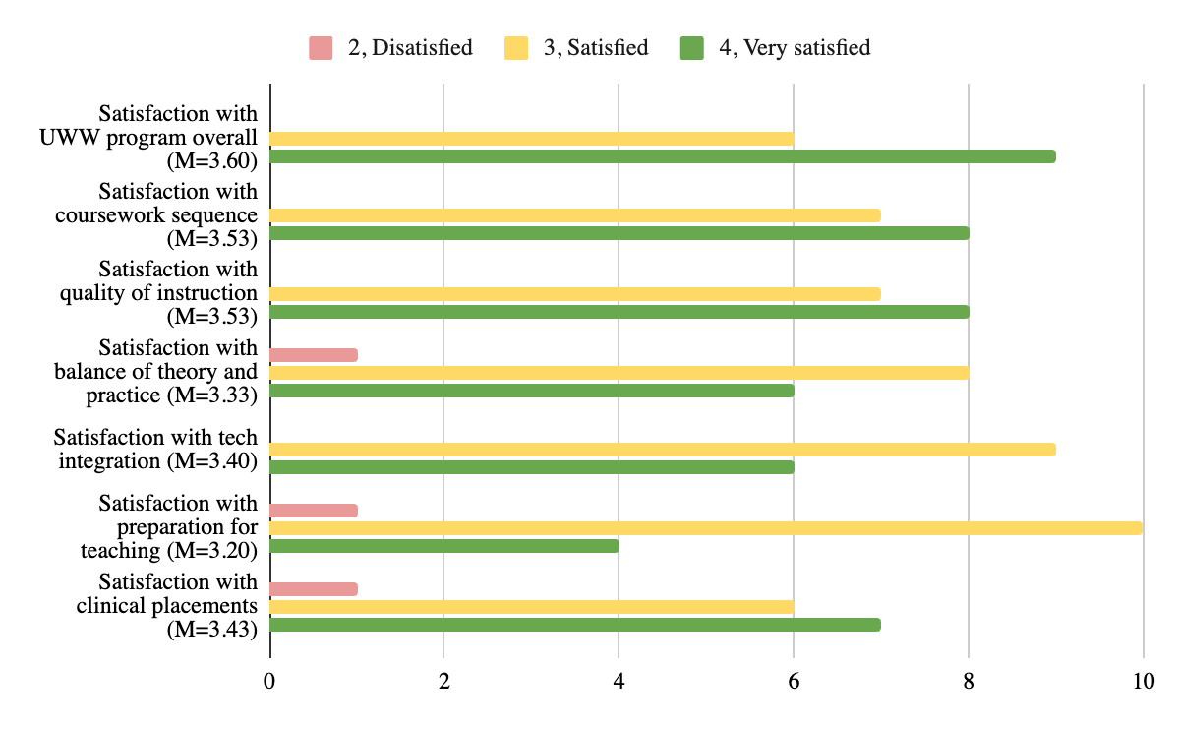

Completers were also asked to rate how well their UW-Whitewater coursework prepared them with respect to particular skills and knowledge areas. We asked about four specific aspects of communication skills (figure 16): written communication skills; verbal communication skills; communication skills enabling interactions to support learners; and professional communication skills (networking and community connections). Respondents rated their preparation in all aspects of communication skills highly (above or very close to 4.0 (very well).

We also asked about several other key educator skills including the ability to create productive learning environments, classroom management, conflict resolution, content and pedagogical knowledge, and integrating technology into teaching (figure 17). Respondents indicated they felt our programs prepared them very well for creating productive learning environments and in content knowledge (mean scores above 4, very well), and well in conflict resolution, pedagogical knowledge, and integrating technology (mean scores above 3.5). Ratings for preparation in classroom management were lower with a mean score close to 3.0 (moderately well).

Figure 16. Communication skills preparation ratings of one-year-out completers, n=14.
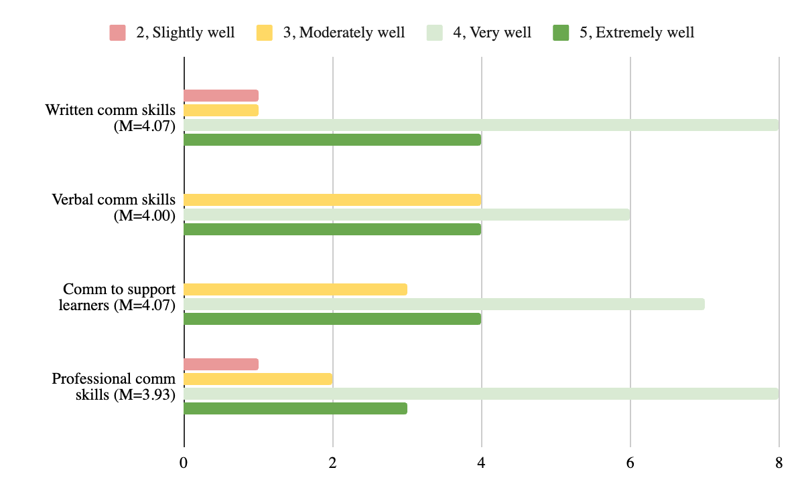

Figure 17. One-year-out completers’ ratings of their preparation in various educator skills, n=14.
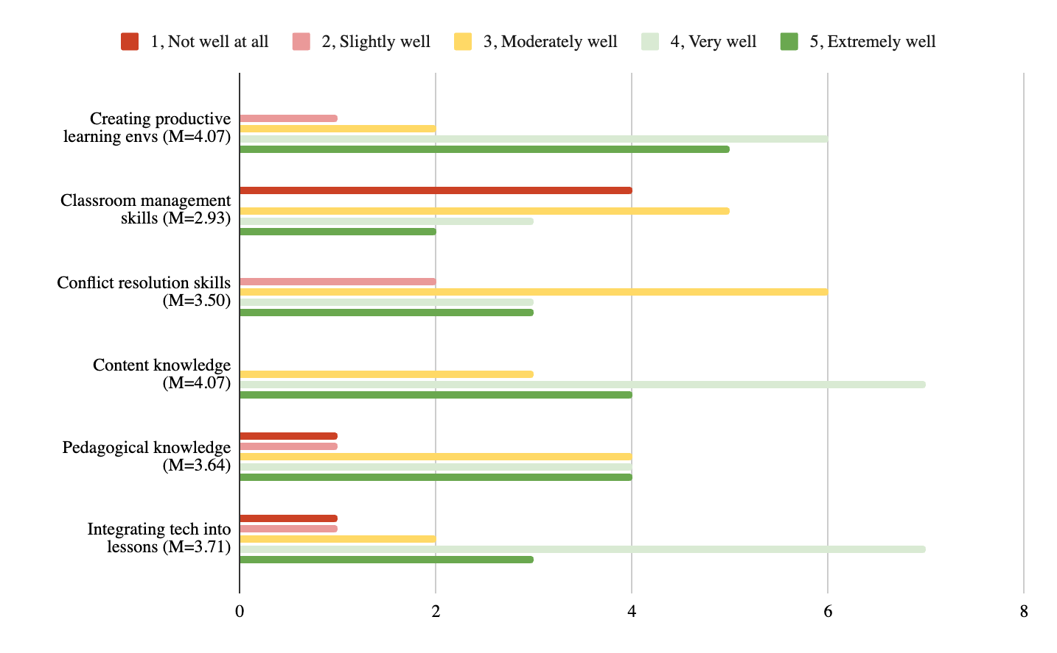

C. Candidate proficiency in the standards in Subchapter II.

Teacher Preparation Programs

The performance expectation for teacher candidates is to reach an average score of 2.5 or higher as evaluated by cooperating teachers during a clinical experience within the WTS evaluation (rated on the survey scale of 1, beginning; to 4, highly effective). As a whole, UW-Whitewater met this expectation across the reporting year (figures 18 and 19). In both Fall 2024 and Spring 2025 semesters, students scored highest in standards 3 (learning environment), 9 (professional learning & ethical practice), and 10 (leadership & collaboration), with average below the performance expectation in pre-student teaching, and above the performance expectation in student teaching. Average scores tended to be a little lower in standards 2 (learning differences), 5 (application of content), and 8 (instructional strategies); with average scores starting below the performance expectation in pre-student teaching and developing above the performance expectation in student teaching.

Figure 18. Fall 2024 Clinical Evaluations of PI 34.002 Teacher Standards across all teacher preparation programs.
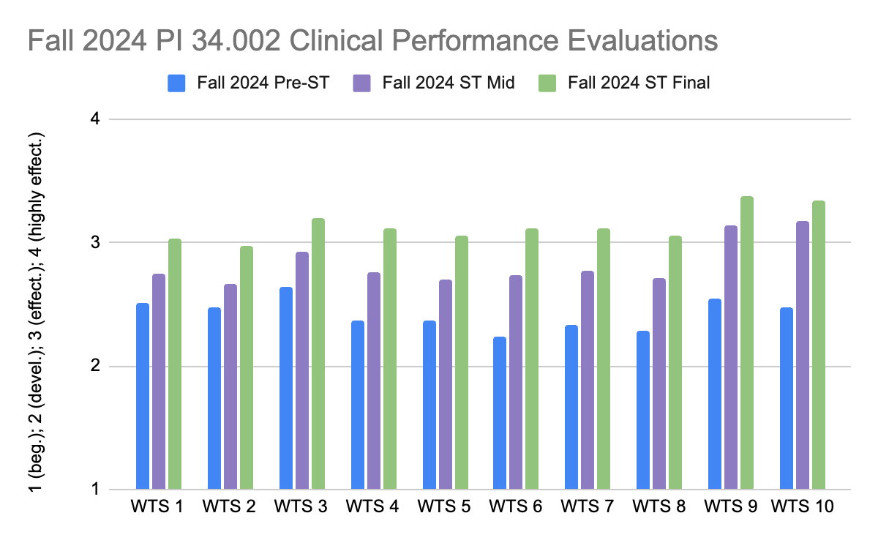

Figure 19. Spring 2025 Clinical Evaluations of PI 34.002 Teacher Standards across all teacher preparation programs.
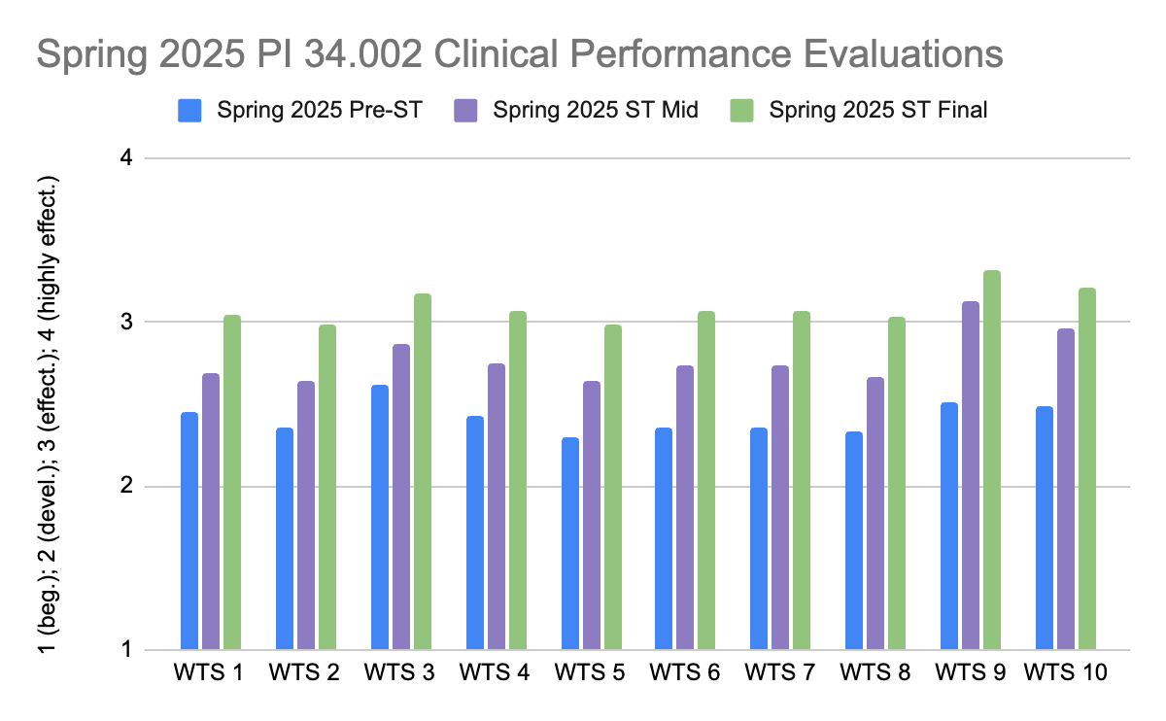

Figures 20 and 21 illustrate spring 2025 PI 34.002 performance evaluations in the special education and elementary/middle education programs as examples of program-specific findings. Special education students developed from below the performance expectation in 6 standards to above the expectation in all 10 standards, excelling in standard 9 (professional learning and ethical practice) in particular by the end of student teaching. Elementary/middle education students began below the performance expectation in all standards in pre-student teaching, developed to above the expectation in all standards on average, and excelled in the same standards as data for the college as a whole (standards 3, 9, and 10).

Figure 20. Spring 2025 clinical evaluations of PI 34.002 Teacher Standards for the special education teacher preparation program.
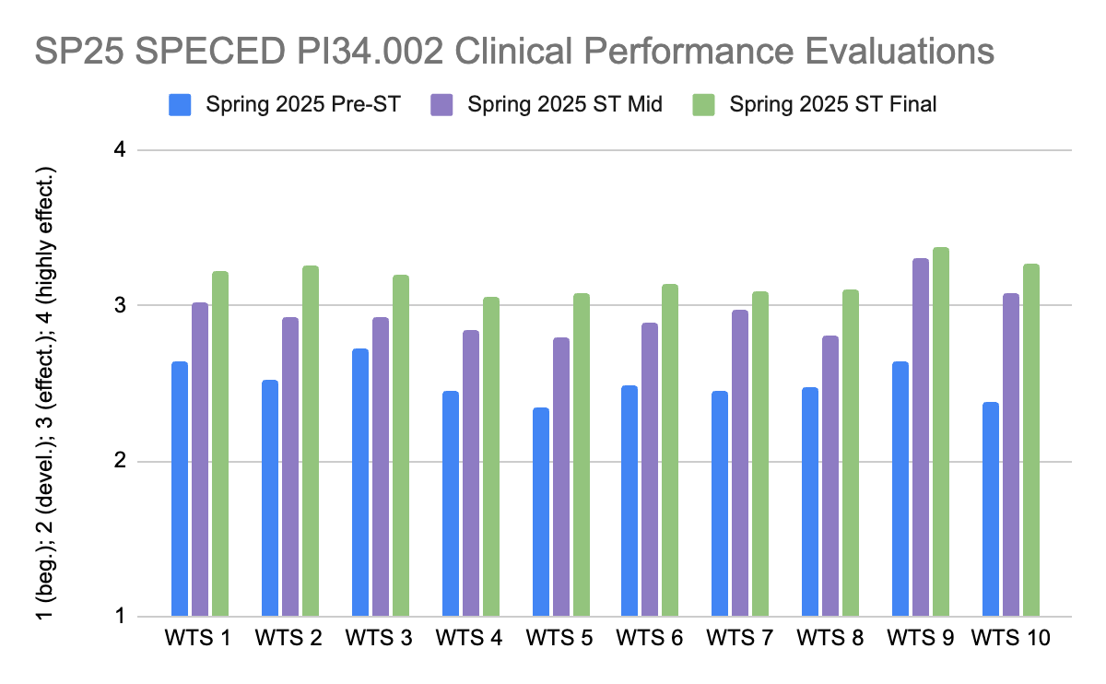

Figure 21. Spring 2025 clinical evaluations of PI 34.002 Teacher Standards for the elementary-middle education teacher preparation program.
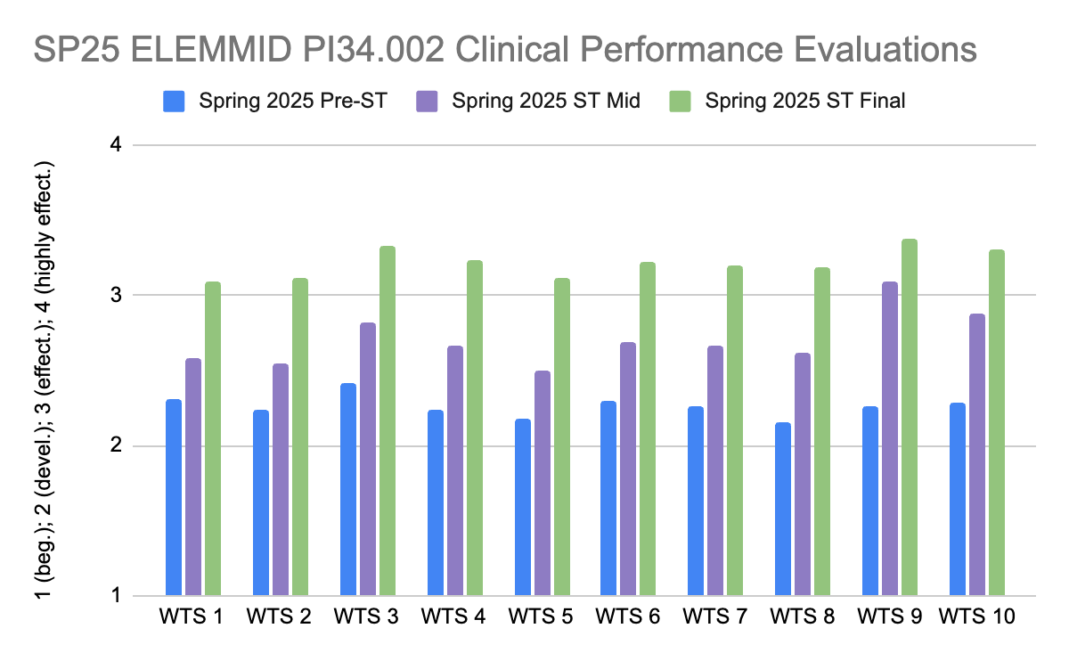

Administrator Programs

The administrator practicum evaluation form, which is completed by our school-based supervisors, measures student knowledge and proficiency in the PI 34.003 standards. The evaluations are completed in each practicum placement. Evaluation scores of 3.0 (effective) or higher are the expected level of performance.

Reading specialists met the proficiency expectation across all the administrator standards (Figure 22). They scored highest in the teacher standards, which is wonderful to see considering the impact reading specialists may have on reading curriculum, assessment, and instruction; and the support they provide to teachers. They scored a little lower in the areas of operations and management (standard 9) and school improvement (standard 10); however, written comments emphasized the candidates’ determination to learn about district operations in order to ensure a model of teaching and intervention that best support student learning, and their commitment to improving reading instruction and supports in their districts.

Figure 22. Average PI 34.003 scores or FA2024 - Spring 2026 for reading specialists.
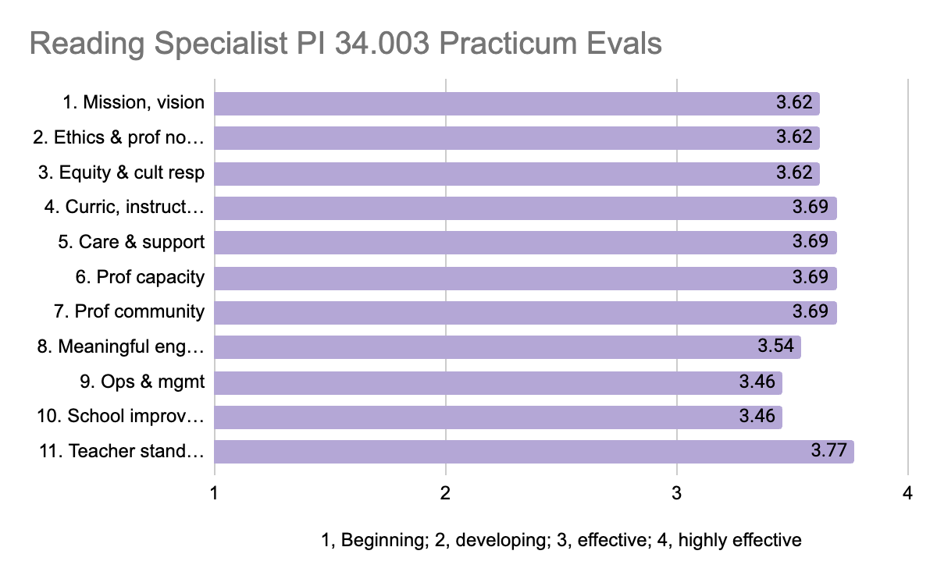

School business manager candidates also met the performance expectation across all administrator standards (figure 23). Their scores were similar across the standards, being slightly higher in the areas of ethics and professional norms (standard 2) and professional community (standard 7). Several comments support these higher ratings, such as, “[student] has been an active participant in the budget process of the district for the past year and has gotten to know our bldg and grounds manager as well as our technology department and knows the efforts we all make for good decision making of the resources within each budget”.

Figure 23. Average PI 34.003 scores or FA2024 - Spring 2026 for school business managers.
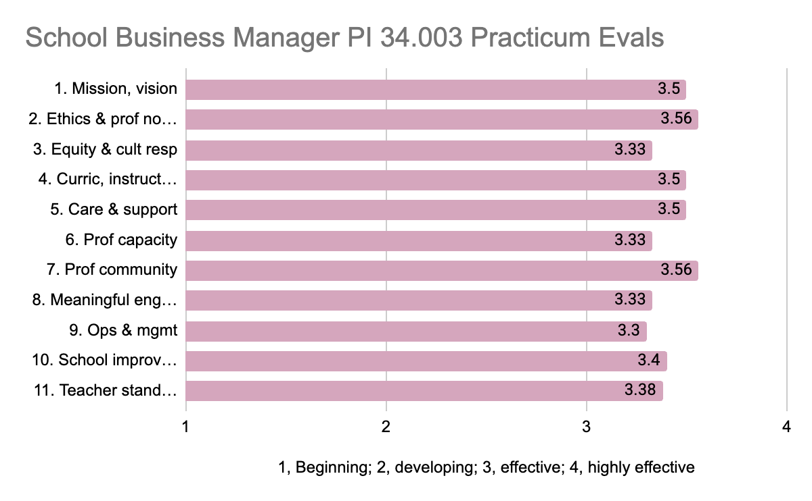

Pupil Services Programs

Our pupil services programs all directly measure the PI 34.004 standards within their practicum evaluation forms. Performance expectations are determined for each program and students are required to meet the expectation by the completion.

School Psychologist

School psychologist candidates are expected to reach an average score of 3.5 or higher as evaluated by the cooperating school practitioner during a practicum experience on the survey scale of 0, little or no progress; to 5, exceptional. Candidates in the program demonstrated substantial improvement in their scores from Fall 2024 to spring 2025, with initial scores below the expectation in all standards in fall and considerably above the expectation in spring (figure 24). Our school psychologist candidates were particularly strong in standards 1 (teacher standards), 2 (pupil learning & well-being), and 4 (professional ethics) by program completion.

Figure 24. Average scores for FA2024 and SP2025 of PI 34.004 standards-based practicum evaluations.
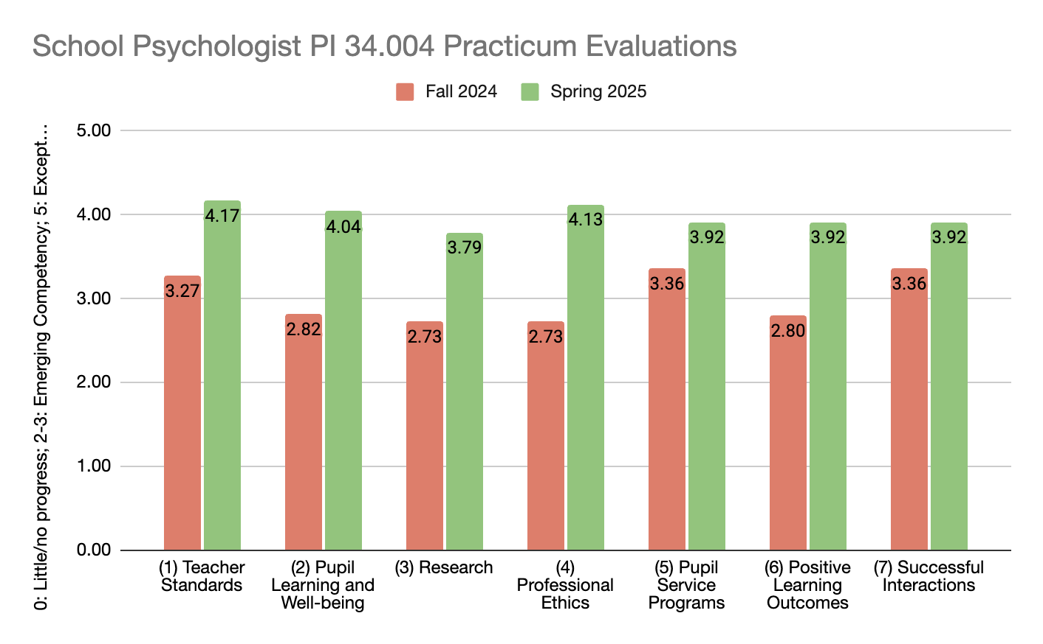

School Social Worker

School social work candidates scored at or above the performance expectation (3.5: good-very good) across all of the pupil services standards during spring and fall 2025 semesters (figure 25). During both semesters the highest scores were in standard 3, professional ethics and standard 7, successful interactions. Scores were slightly lower in the area of research.

Figure 25. Average scores for SP 25 & FA 25 PI 34.004 standards based evaluations in the school social work program (SP25 n=15; FA25 n=14).
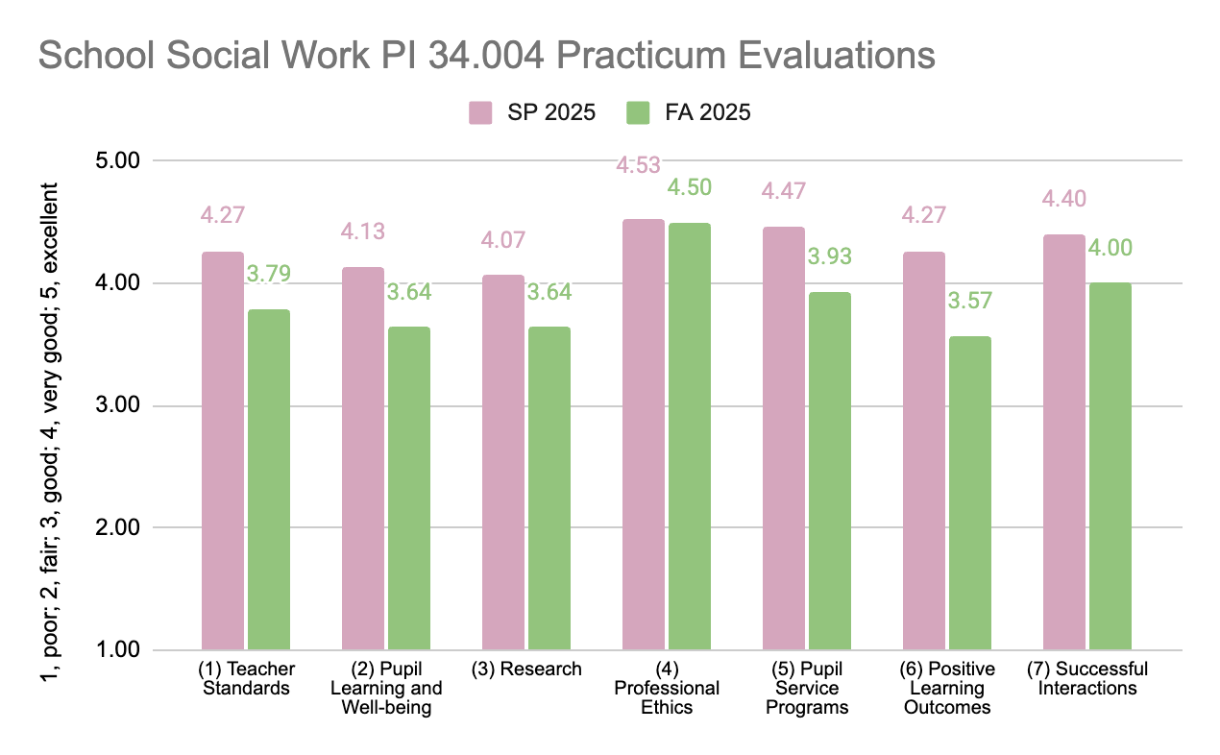

School Counselor

In our school counselor programs, students, on average, meet performance expectations in the PI 34.004 standards (figures 26 and 27). In both programs, candidates were rated highest for Pupil Services standard 7 (successful interactions) and consistently slightly lower for Pupil Services standard 5 (pupil services programs). Considering how central a focus within the program communication skills, collaboration, and professional dispositions are; high scores on standard 7 are anticipated.

Figure 26. Average scores for SP 25 & FA 25 PI 34.004 standards based evaluations in the school social work program (SP25 n=15; FA25 n=14).
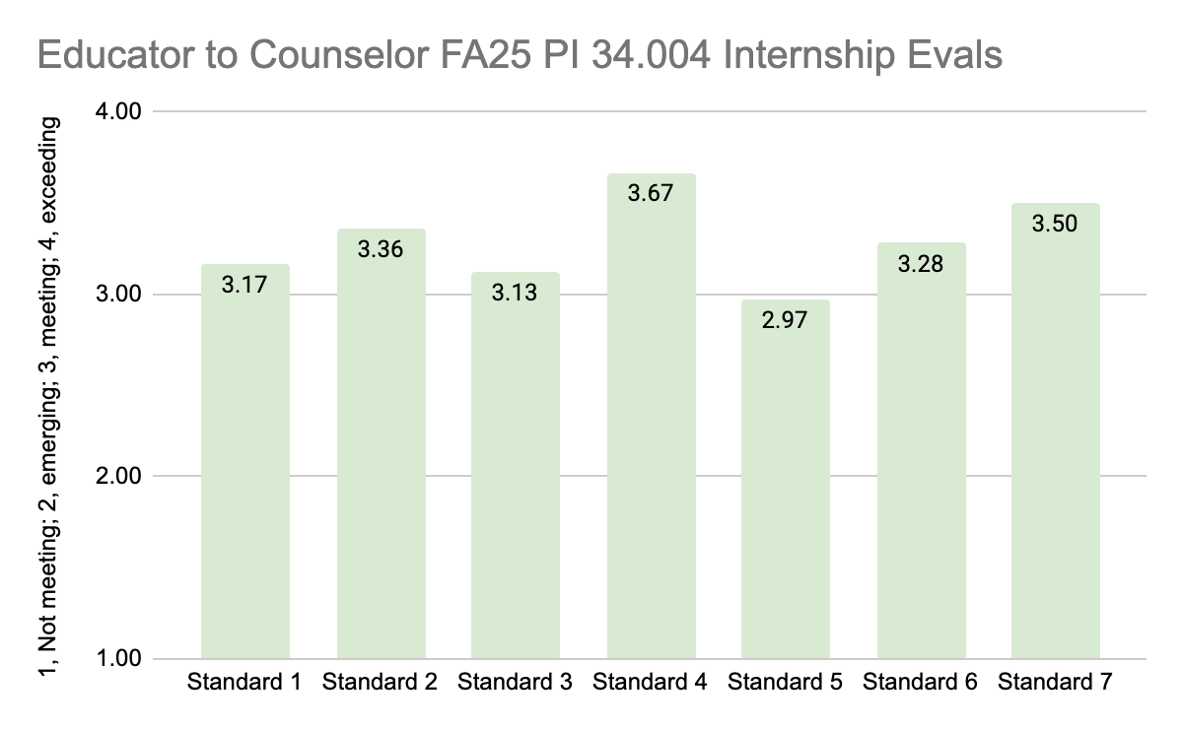
Figure 27. Average scores for SP 25 & FA 25 PI 34.004 standards-based practicum evaluations in the MS School Counseling program.
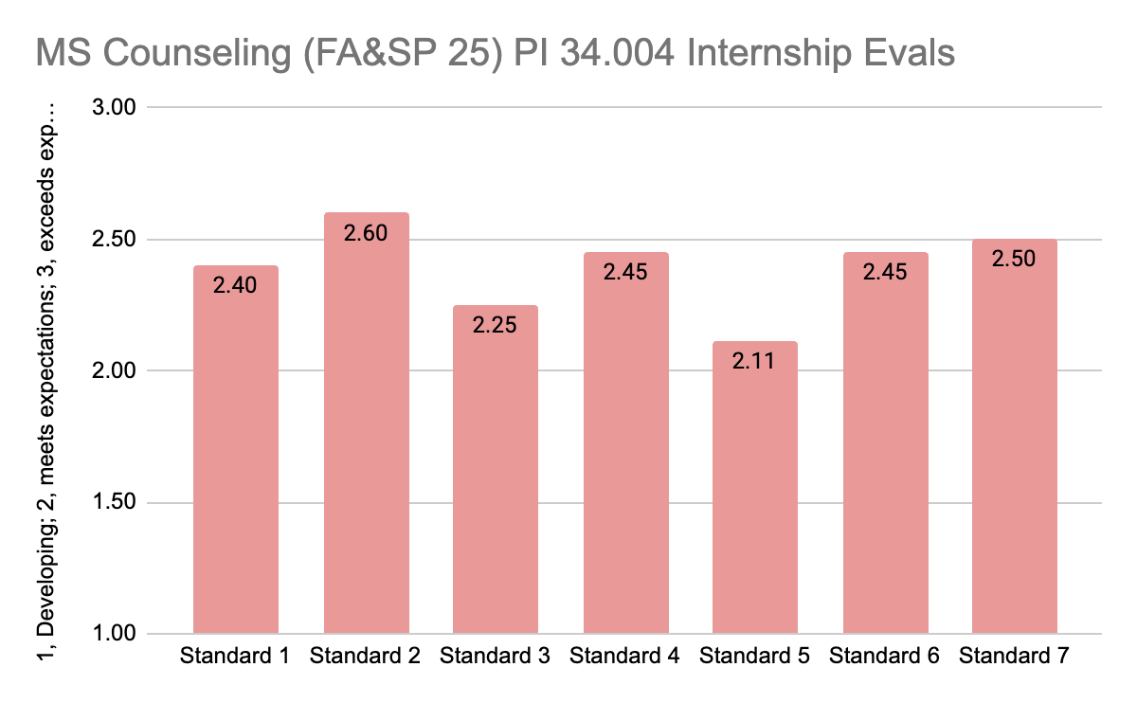

D. Requirements in subchapter III (program approval and standards).

UW-Whitewater attained full program approval in 2025, and this is our first Continuous Review Report. At this time, we are licensing 420 educators per year in a wide range of high-need licensure areas. Our assessment data reported in the above sections demonstrate that UW-Whitewater completers are well prepared and highly valued by their districts when they enter the workforce upon completion of our programs.

We currently do not intend to submit PI 34.011 experimental or innovative program proposals as we have been successful in attaining regular approval for all of our new programs. To support completers who may be returning students with histories of academic challenges, we have attained approval for alternative measures to completion for 17 programs (see column H in this sheet) and will continue to submit alternative measures as programs undergo revisions or new programs are proposed.

E. Requirements in subchapter IV (program support).

PI 34.013 Organization and administration of educator preparation programs

We have been heavily engaged in planning and preparation for renovations to our main building, Winther Hall. There is much excitement on our campus and across our community for the opportunities our upgraded facilities will bring to our educator programs and K-12 school partners! We have initiated our move to temporary offices and classrooms and anticipate moving into the new Winther Hall in 2028.
Our college’s faculty and administrative team collaborate with many partners at a variety of levels. We learn from these groups about the performance of our candidates to develop, evaluate and revise our programs. Some of our closest partners include:
- UW-Whitewater colleges - in support of our secondary programs, FOTE to K-9 program, K-12 art, music, and theatre programs, pupil services and administrator programs.
- WTCS - we collaborate with the technical colleges for our FOTE to K-9 and EC programs and continue to discuss additional partnership opportunities.
- CESAs - we engage regularly with our local CESA 2 and other CESAs in efforts such as organizing career fairs, planning for Act 20 implementation, etc.
- Universities of Wisconsin - we chair the Deans & Directors Educator Prep group who collaborate to advocate for educator candidates, school/district-based partners, and teaching as a profession across the state.
- Wisconsin Professors of Literacy Committee - our faculty engage in this state-wide group to support the development of strong reading instruction in WI schools.
- Wisconsin Association of Colleges for Teacher Education - our dean is past-president of this group, and associate dean is stepping in as replacement secretary to support advocacy initiatives for educators and ed preparation programs across the state.
- UF Collaboration for Effective Educator Development, Accountability, and Reform (CEEDAR) Center - our faculty have collaborated in the design of standards and programs that support high-leverage practices, especially in special education.
- American Association of Colleges for Teacher Education - we engage in trainings, attend, and present at national conferences to build connections and new collaborations with educators across the country.

PI 34.014 Faculty

Within recent years, we have adopted a new system at the college level for tracking faculty qualifications and compiling this documentation in our Appendix E folders. Hiring documents are now saved in common folders in our secure network drives and new faculty are added to the Current EPP Instructional Staff sheet as they are hired. While we have had an approved exceptions to faculty qualifications process in the past, we no longer utilize exceptions and have been successful in hiring qualified faculty (in accordance with PI 34.014(2) in all our searches. If we encounter issues recruiting qualified faculty in the future in specialized areas with low numbers of qualified professionals, we will propose a new set of rules for exceptions.

PI 34.015 Facilities, technology, instruction resources, and support & PI 34.016 student services

UW-Whitewater recently combined the university’s LEARN Center (instructional support) and technology support center into one unit, called Center for the Advancement of Teaching, Learning, Scholarship, and Technology (CATLST). This integrated unit supports our educator candidates and programs comprehensively including technology instruction and equipment rentals for students, support and professional development for faculty, classroom technology, media management, etc. A major focus this year has been to verify that all course LMSs, university webpages, and email communications meet digital accessibility standards. The CATLST, in collaboration with the COEPS faculty technology committee have been working diligently to ensure faculty understand and are supported in their efforts to make courses and communications accessible.

In addition to UW-Whitewater’s CATLST support, our college is funding professional development for several faculty members who teach licensure program courses to work with the Universities of Wisconsin Office of Online & Professional Learning Resources (OPLR) to redesign online courses into state-of-the-art formats that maximize student engagement and learning. This initial group of faculty members will be able to apply their upgraded online course styles to their other courses and share the templates and concepts across their departments. The goal is to increase the consistency and quality of online courses and digital learning components of in-person and hybrid courses across all our programs. COEPS is committed to stand out as the premiere online educator preparation program!

To evaluate the impact of our programs with respect to subchapter IV, we surveyed our student teachers (exit survey) for their feedback in several key areas. Figures 28, 29, and 30 illustrate some of the key survey findings (n=48). Our students felt highly supported throughout their academic programs with respect to academic advisement (M=3.76), academic support (M=3.80), and career planning (M=3.44); however, the ratings were a little lower for job information (M=3.09 on scale from 1, very unsupported; to 5, very well supported). Students would like more information provided by the university about school-based job opportunities and how/when to apply for positions.

The survey also asked students to indicate how well they feel their program has prepared them for teaching with respect to the PI 34.021 Assessment System components and other critical teaching skills. Figure 29 shows that student rated their preparation in content knowledge very highly (M=3.81); and their preparation in terms of human relations & professional dispositions as well as communication skills moderately-very highly (means of 3.56-3.81 on a scale from 1, not well at all; to 5, extremely well). Students also felt very well prepared in terms of their ability to integrate technology into their teaching, plan lessons, assess student learning, and support learners with disabilities (means of 3.63 to 4.04 - figure 30). Their ratings were a little lower for how their programs prepared them in terms of classroom management (M=3.08) and conflict resolution (M=3.13).

Figure 28. Student exit survey ratings of perceptions of student support.
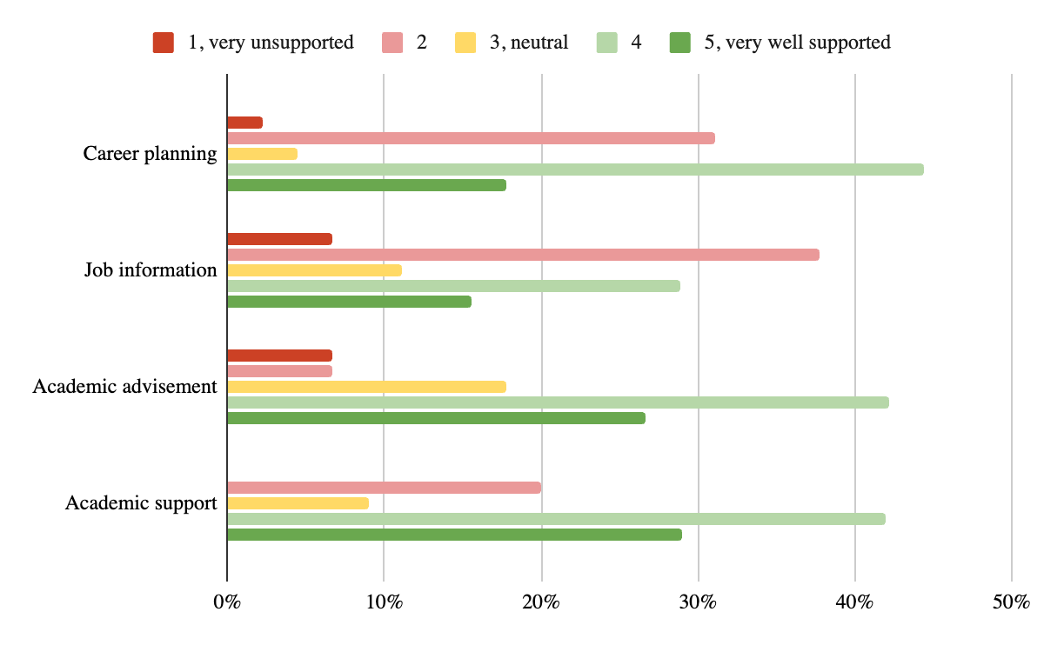

Figure 29. Student exit survey ratings of preparation related to communication skills, human relations & professional dispositions, and content knowledge.
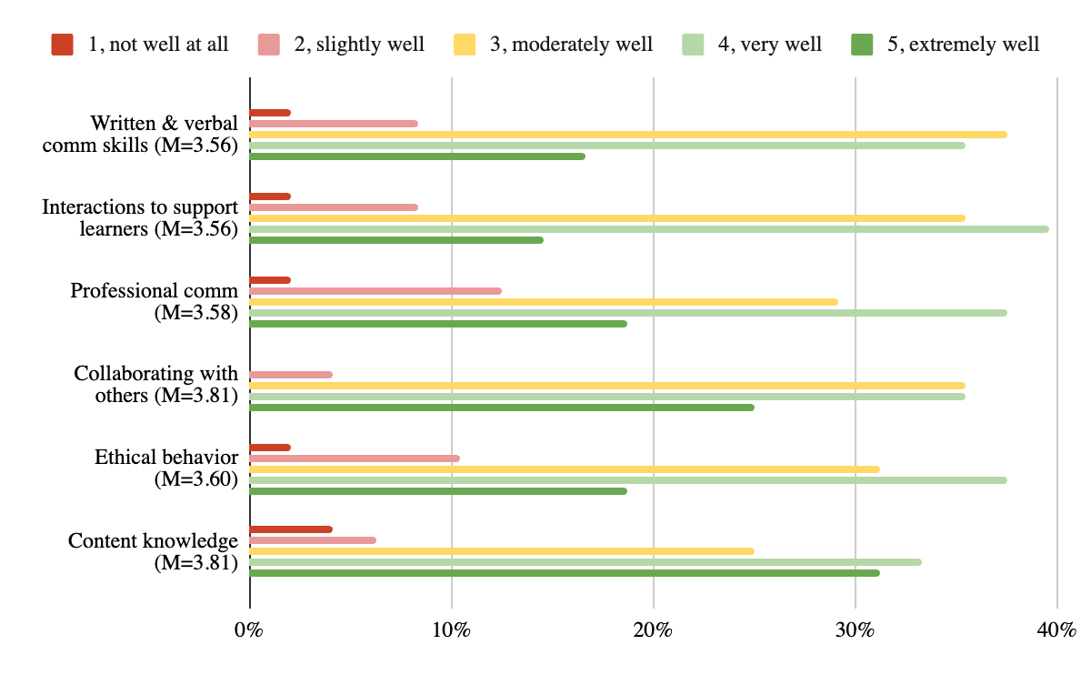

Figure 30. Student exit survey ratings of preparation related to technology integration, pedagogical skills, and classroom management.
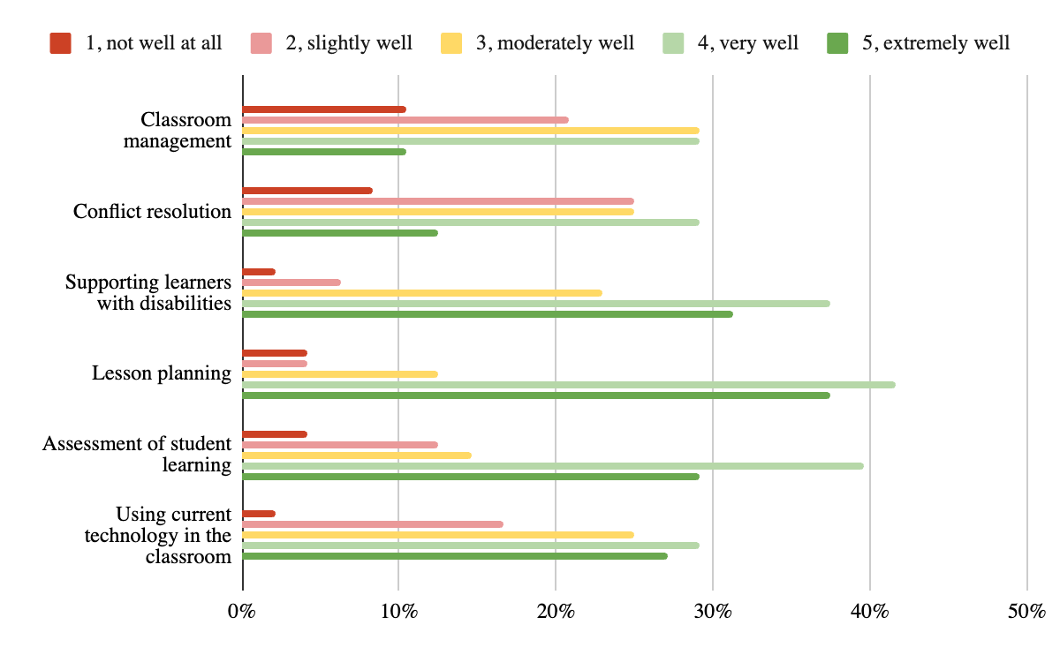

PI 34.017 Program performance

- Please see the pass rates reported in section 1.A. Evaluation of Content Knowledge, above.
- Program modifications due to content or assessments are documented in the LPs for All Programs sheet. This year, we made content modifications to the EC regular education, EC special education programs, and updated the assessments in the k-12 special education program. We also received approval for 7 new licensure programs.
- Table 9 details the proportion of AY 2023-24 completers of each of our educator programs that obtained employment with a WI school or district during AY 2024-25. Our library media specialist, pupil services, and administrative programs resulted in the highest proportion (75%+) of completers working in WI schools/districts. Our K-12 special education program also resulted in a high proportion (70%) of completers working in WI schools. Half to two-thirds of the completers of our largest programs (elementary/middle education, special education, physical/health education, early childhood education) and other classroom teacher programs obtained employment in WI schools.
Table 9. AY 2023-24 completers who worked in WI schools/districts in AY 2024-25.
 | # Candidates Endorsed | # Candidates Licensed | # Working in WI schools in area of license, (% candidates endorsed) | # Working in WI schools outside of area of license (% candidates endorsed)
Art Ed | 10 | 8 | 5(50%) | 2(20%)
Bilingual & Bicultural Ed | 5 | 5 | 5(100%) | 0
Business Ed | 12 | 10 | 7(58%) | 0
ECE | 45 | 41 | 30(67%) | 4(9%)
ELEMMID | 105 | 99 | 67(64%) | 10(9.5)
English Ed | 11 | 10 | 6(55%) | 0
English as Second Language | 1 | 1 | 0 | 0
HPEA | 41 | 39 | 20(49%) | 5(12%)
Gifted & Talented | 14 | 11 | 10(71%) | 0
Library Media Specialist | 12 | 11 | 10(83%) | 0
Math Ed | 8 | 8 | 5(63%) | 0
Music Ed | 16 | 15 | 10(63%) | 0
Reading Teacher | 1 | 0 | 1(100%) | 0
Science Ed | 5 | 4 | 3(60%) | 0
Social Studies | 23 | 21 | 13(57%) | 2(9%)
Spanish | 1 | 1 | 1(100%) | 0
Special Education (Cross-Categorical) | 46 | 41 | 32(70%) | 3(7%)
Speech Language Pathologist | 16 | 12 | 6(38%) | 0
School Business Manager | 26 | 25 | 20(77%) | 1(4%)
School Counselor | 16 | 15 | 12(75%) | 0
School Psychologist | 7 | 7 | 7(100%) | 0
School Social Worker | 20 | 15 | 15(75%) | 0
Reading Specialist | 2 | 2 | 2(100%) | 0

PI 34.018 - Student recruitment, admission, and retention

New pathways to licensure that do not require the same statutory requirements as EPPs, the revised background check rule for admission, and our growth in graduate programs (especially leading to additional and supplemental licensure) have increased the time and attention needed for recruitment and admission into post-bac and graduate programs. Program coordinators work hard to monitor admissions requirements, however, there is a high volume of ‘unique’ circumstances that require consultation and attention from our college advisors and administrative team. Licensure-specific admissions requirements also make it challenging for our School of Graduate Studies staff to support the admissions process for our students as they do for other colleges. We are currently conducting an emergency search for a staff member to help with recruitment and admissions in our post-bac and graduate programs.

PI 34.019 Conceptual framework, PI 34.020 performance based program, and PI 34.021 assessment system

Please see the data and trends reported in sections 1.a and 1.c, above.

PI 34.022 Statutory requirements

We continue to gain more approvals for coursework meeting statutory requirements as more programs go through the approval process. We have updated our tracking of statutory requirements and continue to use the statutory requirements checksheet in the admissions process. All of our early childhood, elementary/middle, special education, and reading programs include approved coursework meeting Act 20 as outlined in column N of the LPs for All Programs sheet.

PI 34.023 Clinical program

We continue to successfully place 100% of our students in all of their clinical placements. During 2024-25, our Office of Clinical Experiences supported:
- 198 student teachers
- 80 internships (DPI WIP program)
- 530 pre-student teachers
- 48 teachers completing student teaching on the job
- The first Warhawks Teach @ residency program
- 184 short-term substitute license applications

Management of placements is becoming more challenging as we increase the variety of our preparation program offerings and attract a more diverse body of candidates. We have recently purchased clinical placement software (Lumivero - Experiential Learning Cloud) to increase efficiencies in our placement processes and tracking of related documentation. We are in the training process for the software and hope to implement it before the fall 2026 semester.

PI 34.024 Educator preparation program evaluation

Please see the data and trends reported in sections 1.b, above.

2. Based on the response to question one, what learning or conclusions come from the data or trends you are seeing?

The data and trends outlined in question 1 have helped us understand and identify several priorities for our educator preparation programs moving forward. These include:
- We need to continue to prioritize opportunities that allow our students to experience more time in the school classroom/setting. All our points of feedback (exiting students, recent completers, cooperating teachers, district administrators, etc.) emphasize that candidates need as much time and experience in school settings as possible, especially experience with classroom management and conflict resolution.
- Classroom management is a challenge for student teachers and new teachers. Beyond additional school-based experiences we can provide within EPPs, we need to continue to collaborate with our school-based partners to more strongly contextualize educational preparation and to better support a seamless transition into full-time teaching.
- It is problematic that only 75% of our elementary/middle education students are attempting the FORT before graduation. Our faculty have many systems and efforts in place to encourage students to take the test following their reading coursework, however, new and additional efforts are needed.
- There is a clear progression in candidate performance across the PI 34.021 Assessment System and the subchapter II standards from pre-student teaching to final student teaching evaluations, and from early practicums to final practicum experiences. On average, our candidates are meeting performance expectations across all measures.
- The size of our EPP and variety of programs present challenges in terms of coordinating all of the licensure program requirements (admission, measuring content knowledge, tracking clinical evaluations, statutory requirements, clinical placements, licensure endorsements). Continuous changes in requirements and reporting add to the challenge (even just the progression from year 1-4 annual reports to comprehensive review, to this first CRP). We continue to modify our approach to this work and adjust our roles to meet requirements; however, a period of consistency would be helpful.
- The integration of technology into educator preparation continues to be an area of focus for our college. Our technology committee and program coordinators continue to work to build tech integration throughout the curriculum of our programs and to provide candidates with the opportunity to experience the opportunities and challenges new technologies present to K-12 teachers and practitioners.
- We continually work across departments to integrate learning regarding professional dispositions progressively throughout our EPPs and to improve our systems for identifying, tracking, and supporting students who demonstrate concerning dispositions. However, the feedback we receive from all stakeholders indicates that communication skills, professional dispositions, and collaboration are notable strengths of UW-Whitewater students.
- While our students across all programs indicate that they feel prepared to support students with disabilities as educators, our school-based partners suggest that new teachers could benefit from additional preparation in supporting students with disabilities. Our OCE advisory group specifically identified secondary education programs as needing more preparation for teaching and supporting students with disabilities.
- The WTS standards-based student teacher evaluation form should be revised. It is too long and we would likely receive more qualitative feedback with a shorter list of items to rate. Also, our adoption of a shortened pre-student teacher evaluation form has created challenges monitoring development of student performance from pre-student teaching to student teaching. A common standards-based pre-student teaching and student teaching form that is shorter and that directly measures the PI 34.002 standards while also measuring assessment system components will be beneficial.

3. What plans or changes are you making to address the implications of what you are seeing or what you are learning?

To address the trends that we’ve identified and learning we have outlined in question 2, we plan to prioritize the following efforts:
- Continue to work on establishing residency and apprenticeship programs, and other online programs that support practicing teachers, full-time workers, and LWS candidates. We believe that these types of programs augment student learning, smoothen the transition from student to teacher, and help to increase teacher retention in schools.
- Continue to work with elementary/middle education coordinators, faculty teams and advisors to increase the proportion of students who attempt and pass the FORT before graduation / coursework completion. Our policy is to require students to attempt FORT prior to student teaching. Implementing this policy is challenging because we tend to avoid causing student delays over a licensure requirement that is not set by UW-Whitewater or DPI. However, allowing such a large (25%) proportion of our students to graduate without attempting the FORT is problematic.
- Engage the TELCE committee in the revision of our WTS standards-based student teaching evaluation to create a shortened, common evaluation for pre-student teaching and student teaching performance on the PI 34.002 standards and PI 34.021 assessment system.
- Hire a full-time staff member to support recruitment and admissions in post-bac and graduate programs. This new hire will help to monitor statutory requirements as well as specific requirements of licensure programs such as initial licenses, teaching experience, etc. We will apply the common admissions, statutory, and licensure requirements tracking sheet we currently have for all graduate students to post-bac students and ease the endorsement process for our licensing examiner.
- Launch the OCE clinical placement software to facilitate our placement processes, communications with school/district administrators and teachers, tracking of forms, and assessments.
- Continue to collaborate and lead efforts at all levels (local, state, regional, national) to establish opportunities for student teachers and practicum students to be paid for their placements, and ideally to support cooperating teachers/practitioners.

4. What goals do you have for your educator preparation program(s) moving forward?

We have several goals for our educator preparation programs moving forward:
- Continue to progress through LP approvals for our current programs including those that are affirmed and not yet approved, and those with standards that have been updated.
- Attain approval for our new programs in the works, including a graduate art education program, graduate early childhood regular education, revised science education programs, post-bac secondary education programs, world languages minors as initial licensure programs, and others.
- Continue to build opportunities to offer our programs as residency and apprenticeship programs, to LWS candidates, and in formats that maximize student experience in schools.
- Continue to advocate for financial support for student teachers and practicum students. We recently submitted a pre-proposal for financial support for pupil services practicum experiences in rural areas which was not funded. We will continue to seek such grant opportunities and advocate when opportunities arise for funding for clinical placements.

