Wisconsin Sound Beginnings Camp 2026 is almost here!
Be sure to review this information as you prepare for your arrival.

Check in and Out Information
Activity | Date | Time | Location | Notes
Check-In | Friday, June 12, 2026 | 9:00 – 11:00 am | Ma’iingan Hall
Check-Out | Sunday, June 14, 2026 | 1:00 – 2:00 pm | Ma’iingan Hall
Calculate your travel time using our maps and directions.

Introduction
We are excited to meet all of you in person! Coming to a full weekend to join others, to play and learn together, can bring up various emotions. Excitement, nervousness, worry, etc. This is very understandable. We hope this packet answers questions and offers ideas for how to prepare, both you and your children.
Families will be joining us from across Wisconsin with children ages 0-5 who are DHH. We look forward to this wonderful gathering together! Our staff, including Support Parents and Deaf/Hard of Hearing Ambassadors and Mentors, will be sharing personal stories that may feel vulnerable. We hope you will be open to sharing too. We trust that everyone will be non-judgmental in people’s choices and open to ideas and shared learning experiences together. We hope by the end of the weekend, you feel connected and energized.
Schedule of activities: throughout the weekend children will be in close proximity to their caregivers. Staff will be wearing black t-shirts, and are available to help, so please feel free to ask.
There will be two photo release forms for you to sign when you check-in.
Included in this packet you will find bios and pictures of all the staff/volunteers, a campus map, a schedule of events for the weekend, a description of the family suites at Pulliam dorm, and a packing list.

Important Phone Numbers
Person | Phone Number | Notes
Lauren Burke | 608-280-1148 | Camp Coordinator
Chrissy Vorreyer-Davis | 304-240-2320 (text only) | Camp Coordinator
Chris Kometer | 414-807-0498 | Camp Coordinator
Health Staff/Athletic Trainers | 920-723-8736  920-723-8726  920-723-8724 | Athletic Trainers/Health Staff available on campus during camp.
University Housing | 262-472-4200 | Mon-Fri 8:00am-9:00pm  Sat-Sun 9:00am-7:00pm
UWW Campus Police | 262-472-4660 | Non-emergency number for after 11:00pm needs.
Emergencies | 911 | Medical, safety, or environmental emergencies.
Fort Memorial Hospital | 920-568-5000 | Nearest hospital to campus.  611 E. Sherman Ave., Fort Atkinson, WI 53538

Parking
Parking is included in the camp fee, so you do not need to register your vehicle to park. Please feel free to park in the lot closest to the Residence Hall.

Camper Safety

Health Service:
Parents/Emergency Contact will be called for advice and recommendations if the problem does not require immediate medical attention. Should you require medical attention, the camp health supervisor will assess appropriate measures to take. UW-Whitewater camps have the full cooperation of Fort Memorial Hospital and emergency room personnel. For participants taking medication, please complete the health form prior to arrival. When possible, the Athletic Trainers and health staff will contact parent(s)/guardian(s) before seeking treatment.
You will be required to provide health information in the registration. Athletic Trainers and health staff will refer to the registration whenever medical treatment is necessary; this is the only guide a health care provider will have in case of an emergency.

Injuries during Camp:
Should an injury occur the event director will seek medical attention from UW-Whitewater Athletic Trainers or call 911 in a medical emergency.
After the registrant is being cared for, the event director will report to the Youth Compliance Coordinator with details on the injury. The event director will distribute the Injury Claim Form to the injured participant and their family. Forms and information can be found under Camps and Clinics Forms by clicking the link above.
The Youth Compliance Coordinator will notify UW-Whitewater Risk Management of the incident/injury.
The injury claim form is submitted to Gallagher by the parent; Gallagher then submits the injury claim form to HSR (Claims Company for accident policy).
HSR will contact UW-Whitewater Risk Manager to authorize the incident via phone or email.
Upon confirmation of the covered claim, HSR will add the injury to their claims system so that corresponding medical bills will be eligible for coverage.

Dining/Nutrition Services:
For any questions related specifically to dining, please text 262-400-3077. Any special diet needs and questions can be accommodated/answered by Summer Manzke, Campus Dietitian, at Summer.Manzke@compass-usa.com or 920-650-4239.

Inclement Weather:
In the event of inclement weather, Camp Directors will move campers to identified safe spaces on campus. Campus police and Continuing Education support each camp in communicating potential storms and developing a plan to ensure participant safety.

Excessive Heat:
Participants are advised to bring fans. Note: The gymnasiums are also not air-conditioned. Greenhill Center of the Arts, Moraine Bookstore, Upham Hall, University Center and dining halls are air-conditioned. During periods of heat, directors will provide a cool area for participants and will take all the necessary precautions to avoid heat fatigue. This may include cancelling awards ceremonies in the gymnasium. Participants are advised to bring fans, as many of the residence halls are not air conditioned.

Camp Packing List:

Ma’iingan Hall – Suite Bedrooms
- Pillows with pillow cases for all attendees
- Twin sheets (fitted and flat)
- Blankets or additional bedding for each bed
- Porta-crib, pack-and play, toddler travel beds - there is space for 1 portable crib in each bedroom.
- Favorite blankets, stuffed animals, toys, etc.
- Tablet or laptop – no TV in suites, wifi available

Ma’iingan Hall – Suite Bathroom & Entry Area

Toiletries (toothbrush, shampoo, soaps, etc.)
- Towels needed for the weekend (ex. Large towels, hand towels, and washcloths)
- Hand soap
- Plates, bowls, cups, utensils needed for snacks
- Snacks, food for early mornings or downtimes
- Phone chargers
- Games, toys, activities for down time in your room
- Families can bring their own small coffee pot if they would like

Ma’iingan Hall – Shared Floor Living Space and Kitchenette
- Plan to label any foods that will be placed in the floor shared refrigerator
- Staff will provide soaps, sponges, and paper towels so families can clean any dishes needed

Clothing

Clothing for outdoor and indoor learning and playing
- Extra clothes in case of rain, waterplay
- Pajamas
- Comfortable shoes
- Sun hats, sunglasses

Personal Items:
- All toiletries needed (ex., shampoo, conditioner, soap, lotion)
- Toothbrushes, toothpaste
- Sunscreen
- Any personal medications
  - If medications need to be refrigerated, please let a Camp Coordinator know; a mini fridge can be loaned out for use in your suite
- Hand sanitizer, wet wipes
- Diapers, wipes
- Basic first aid kit
- Baby monitor
- Charging equipment and/or batteries for hearing technology

Exploring Campus:
- Stroller, wagon - there will be a lot of walking between different places on campus
- Baby carrier
- Water bottles for filling and keeping hydrated
- Snacks - families will need to bring and provide their own snacks during the weekend. Meals will be provided (Breakfast, Lunch, and Dinner).
- Sunscreen, hats, shoes for running and playing
- Backpack for carrying materials to different locations across campus

Camp Schedule:
ALL EXPERIENCES ARE OPTIONAL BASED ON THE NEEDS OF YOUR INDIVIDUAL FAMILY

Friday, June 12, 2026
Time | Activity | Location
9:00 – 11:00am | Check-in, Move into Dorm | Ma’iingan Hall
11:00 – 12:00pm | Welcome and Family Activity | Ma’iingan Hall Courtyard
12:00 – 1:00pm | Lunch | Esker Dining Hall
1:00 – 2:00pm | Family Activity Options:  - Mingling and Connecting  - Nap Time Opportunity  - Parent-Child Literacy Opportunities  - Family art activities | Ma’iingan lobby and floor lobbies
2:00 – 3:30pm | Parent Program - Parent panel  Children - Activities with adult staff/volunteers | Roseman Hall
3:45 – 4:45pm | Parent Program - 15 Principles of Reading to Deaf Children Presenter: Brian Cheslik  Children - Activities with adult staff/volunteers | Roseman Hall
4:45 – 5:30pm | Rest, break, mingling/connecting opportunities | Ma’iingan Hall
5:30 – 7:30pm | Dinner: Pizza  Family Activities & Playground | Starin Park – Upper Shelter

ALL EXPERIENCES ARE OPTIONAL BASED ON THE NEEDS OF YOUR INDIVIDUAL FAMILY

Saturday, June 13, 2026
Time | Activity | Location
7:30 – 8:30am | Breakfast | Esker Dining Hall
9:00 – 10:15am | Parent Program - REAL Beginnings: Learning and Literacy using the Bilingual Stories Bookshelf App  Presenter: Stacy Abrams  Children - Activities with adult staff/volunteers | Roseman Hall
10:30 – 12:00pm | Parent Program - Author and Advocate Spotlight  Presenter: Dr. Jasmine Simmons  Children - Activities with adult staff/volunteers | Roseman Hall
12:00 – 1:00pm | Lunch | Esker Dining Hall
1:00 – 2:45pm | Family Activity Options:  - Nap time opportunity  - Resource Spotlight – Lobby  - Parent-Child Literacy Activities  - Family Art Activities | Ma’iingan Hall
3:00 – 4:30pm | Parent Program: DHH panel  Children - Activities with adult staff/volunteers | Roseman Hall
4:30 – 4:45pm | Group Photo | Waterfall outside of Roseman Hall
4:45 – 5:30pm | Rest, break, mingling/connecting opportunities | Ma’iingan Hall
5:30 – 7:30pm | Dinner & Family Fun Night – Bowling, Games, Activities | University Center

Sunday, June 14, 2026
Time | Activity | location
7:30 – 8:30am | Breakfast | Esker Dining Hall
9:00 – 10:30am | Parent program: Parent Sharing Circles  Moms group  Dads group  Extended family members group  Children - Activities with adult staff/volunteers | Ma’iingan Hall
10:30 – 11:30am | Closing Gathering & Slideshow | Ma’iingan Hall
11:30 – 12:30pm | Lunch | Esker Dining Hall
12:30 – 2:00pm | Pack up dorms | Ma’iingan Hall
2:00PM | Check out, Move out | Ma’iingan Hall

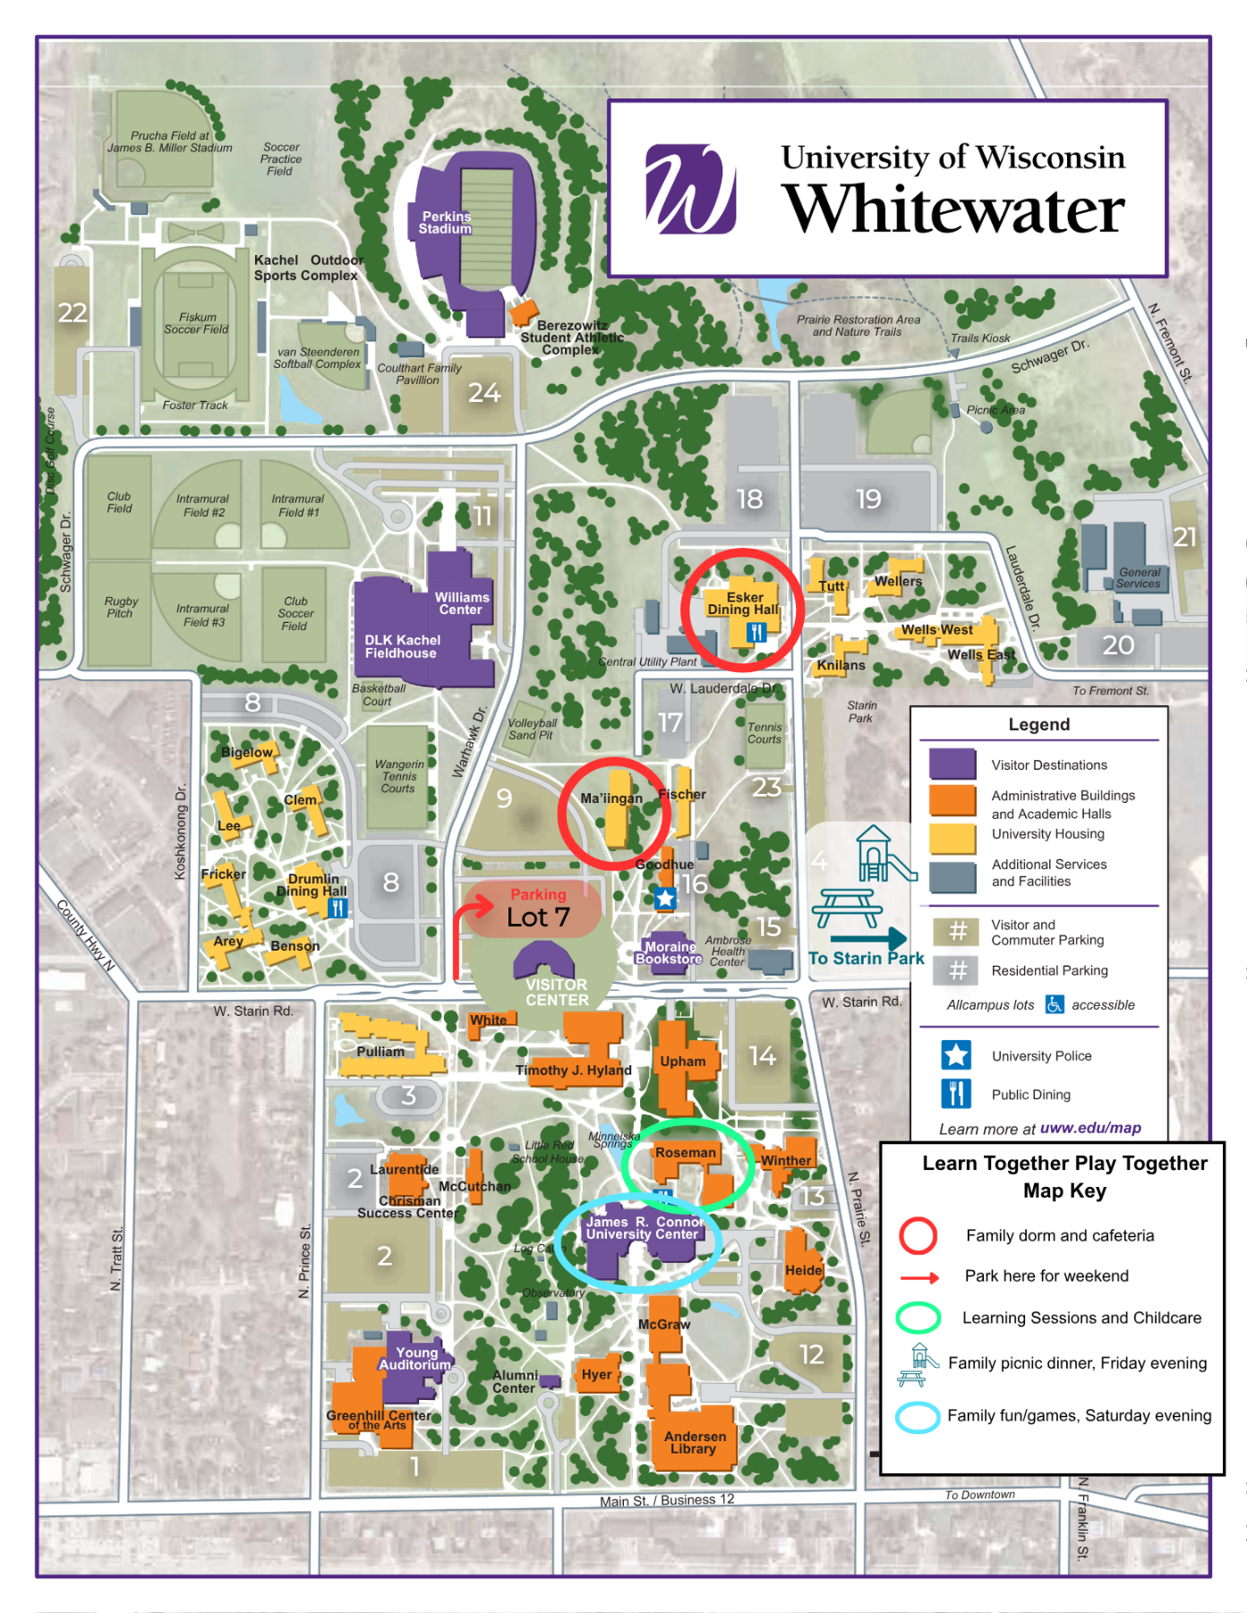

Ma’iingan Hall
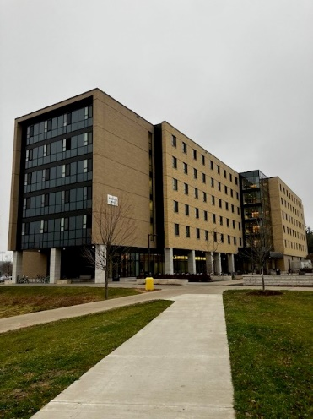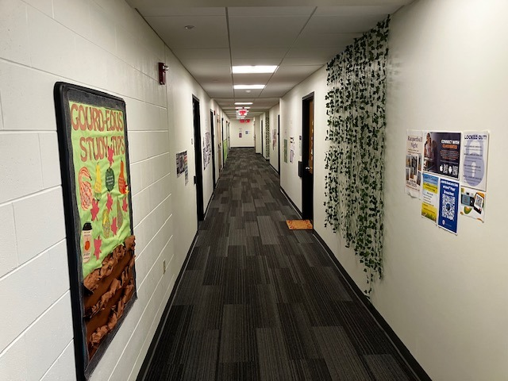
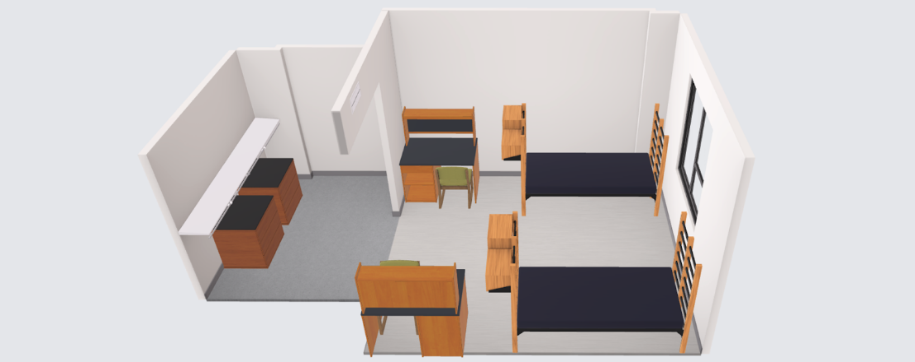
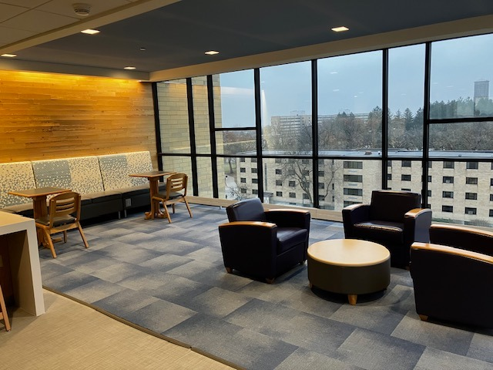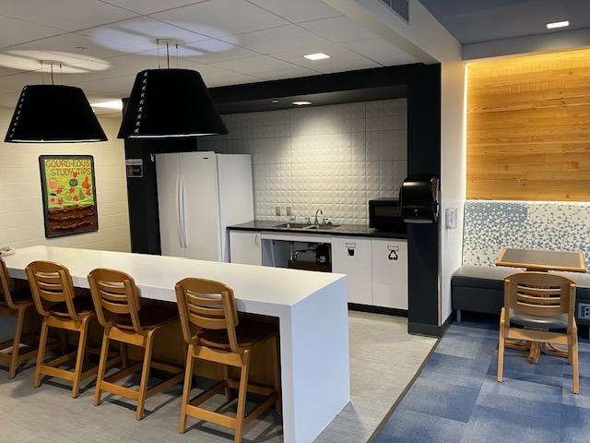

- Each family suite has 1 main door (families will be given a key).
- Inside each suite, there are 2 individual bedrooms, each with 2 twin size beds, 2 desks, and 2 dressers.
- Each suite has its own private bathroom with toilet, sinks, and a shower.
- Each suite has a long/large counterspace with sinks as you enter. A good space for storing snacks/belongings.
- Suites do not contain a TV, refrigerator, or microwave.
- At check-in, families will receive a key to their family suite.
- The visitor’s parking lot is located near Ma’iingan dorm. Rolling carts and wagons will be available for families to use to help unload. Staff will also be available to help.
- There is an elevator to reach the 2nd, 3rd, and 4th floors where all families will be staying.
- Each floor has its own lobby and shared space with a full size refrigerator, a microwave, tables and couches. Families can label their refrigerated foods and share the floor refrigerator.
- There will be no other camps or students on the 2nd, 3rd, and 4th floors. Only families and staff/volunteers for our camp will be using the shared lobby spaces during our weekend.
- The building is air-conditioned.
- The downstairs main lobby has many spaces for families to connect with one another. See pictures below.
- A large courtyard with seating and space to play is located right outside the building.
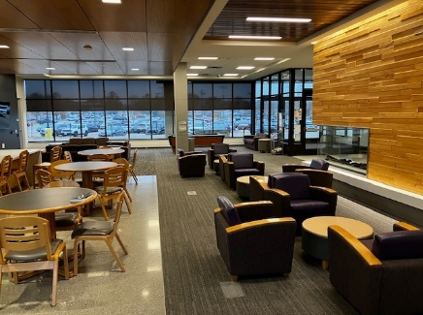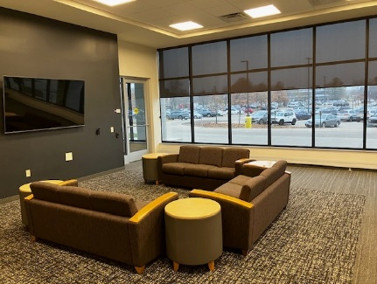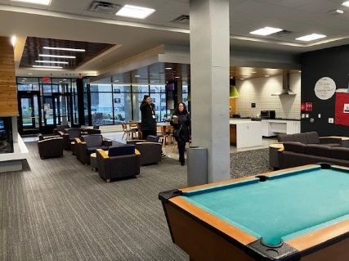

Meals
- Meals will be provided throughout the weekend at no cost to families.
- Breakfast will be provided at Esker dining hall on Saturday morning 6/13 and Sunday morning 6/14. The dining hall is located less than a 5 minute walk from the dorm building.
- Lunch will be served at Esker dining hall on Friday 6/12, Saturday 6/13, and Sunday 6/14.
- Dinner will be served at Starin Park (pizza and dessert picnic) on Friday 6/12 and at the University Center on Saturday 6/13.
- Please bring strollers or wagons for getting to different locations across campus.
- Families are encouraged to bring your own snack options for your little ones to eat throughout the weekend. Campus does not have baby/toddler options to purchase. While meals are provided, we are not able to provide any snacks in between designated meal times. Families will have access to a full size refrigerator to use throughout the weekend - Each floor has it’s own lobby and kitchenette including a refrigerator. Plan to label foods in the shared space. Please plan to bring snacks, early morning bites, or late night nibbles that best meet your families needs. Please bring snacks with you throughout the weekend activities so you have items ready when your child needs a quick snack boost.
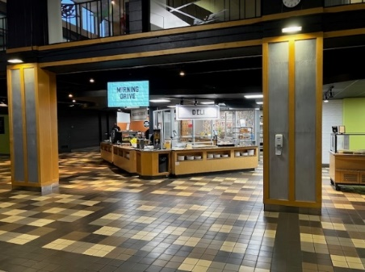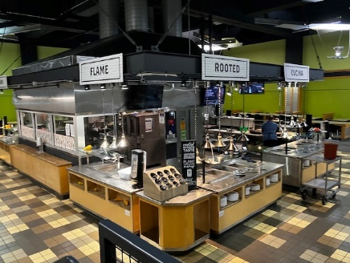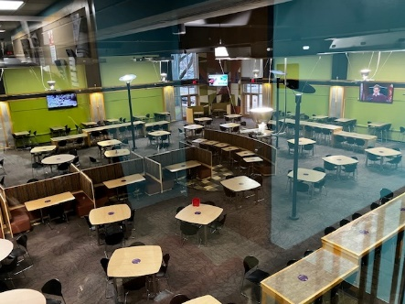

Participant Code of Conduct
As a participant, I agree to the following statements. I will…
• Respect differences of all participants and will not discriminate against anyone else on
the grounds of gender, race, sexual orientation, ability, or other identity
• Report any incidents of bullying to adults immediately
• Support and encourage all other program participants
• Respect all staff, directors, and volunteers
• Follow online safety and internet use policies
Prohibited Conduct:
• Abusive language towards a staff member, volunteer, or another participant
• Bringing dangerous or unauthorized materials such as explosives, firearms, or weapons
onto to campus property
• Inappropriate or rude treatment of a peer, staff member, or volunteer
• One-on-one interactions with any program staff member before, during, or after any
program
• Verbal, physical, or visual harassment of another participant, staff member, or volunteer
• Actual or threatened violence toward any individual or group
• Conduct endangering the life, safety, health, or well-being of self and others
• Failure to follow any UW System or campus policy, including but not limited to sexual
assault/violence/harassment policies, dishonest academic behavior policies, or
emergency procedures
• Bullying or taking unfair advantage of any participant
• Failure to follow directions of supervisors/youth programming staff/event leaders
• Possession or use of alcoholic beverages or illegal drugs on campus property or
reporting to the program while under the influence of drugs or alcohol

