Peachtree User Manual

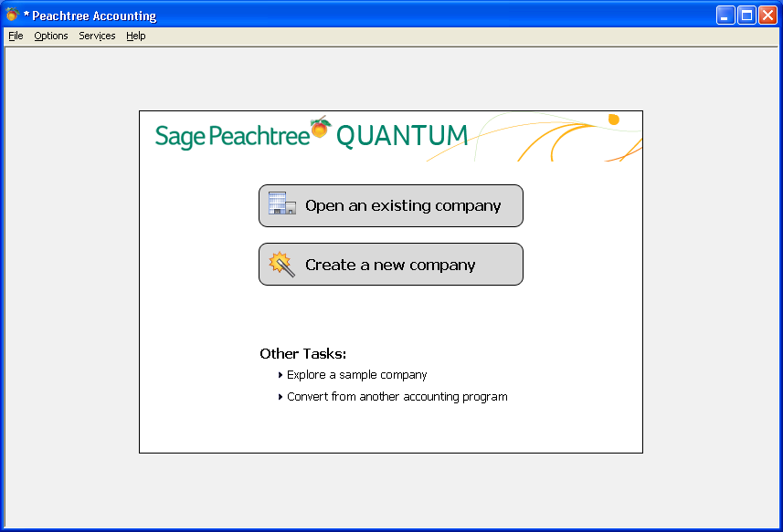

4/23/12

Topic Page

Login 3

Customize Your Dashboard 6

Maintenance (“Maintain” icon dropdown list) 10
1. Entering a new customer 10
2. Entering a new inventory item 15
3. Entering a memorized transaction 19

Tasks 22
4. Creating an invoice 22
5. Entering a receipt 28
6. Entering a credit memo 30
7. Posting 31

Reports 34
8. Cash Receipts Journal 34
9. Aged Receivables 37
10. Sales Journal 40

Write Off Bad Debt 42

Collection 43

Internal Billing/Chargebacks 44

Printing a Posted Invoice 49

Printing a Group of Invoices 50

Troubleshooting 51
Login

You should have received the Peachtree installation instructions. Once Peachtree has been set up on your desktop, you will be able to select the Peachtree icon (looks like a peach) to open the software.

Upon opening the software, you will see this screen:

Select Open an existing company. It will then take you to a list of companies to choose from. We have four companies set up for use: UW TEST for you to “play” while learning how to use the software or to experiment with, UW Whitewater for creating actual invoices for external customers, UW Billing/Chargebacks for creating actual invoices for campus departments or funding codes provided by your on-campus customers, and UW Student Organizations for student organizations that need to do billing for their customers. Be sure you are in the correct company for what you are trying to do.

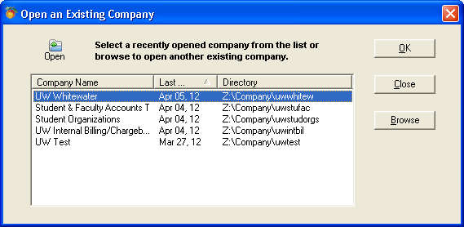
If you get to the screen that should list the companies and nothing is displayed, select the browse bar.

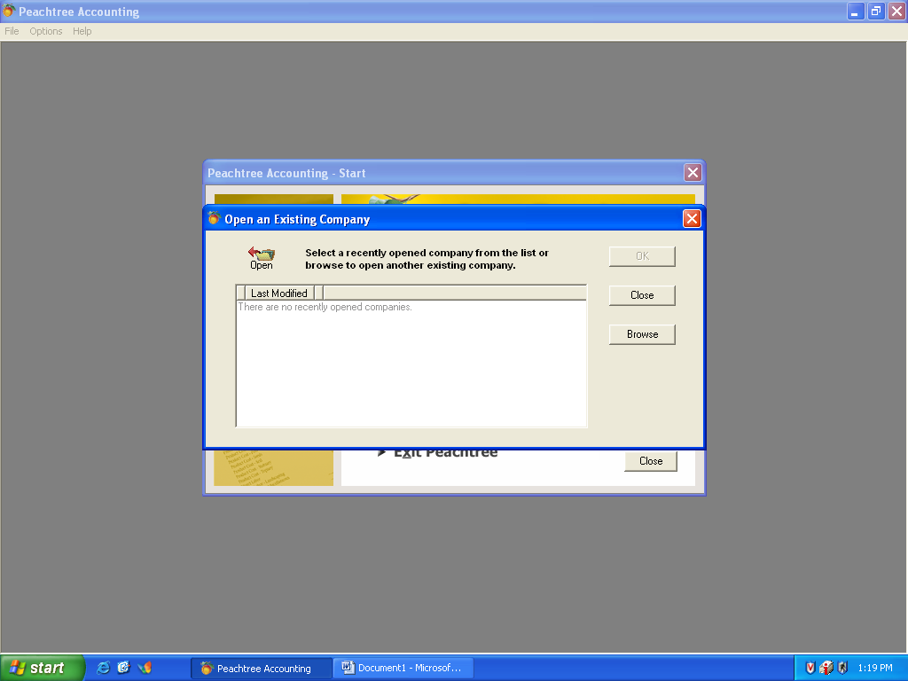

Once you have selected this, you will get a few more options to select. Under Drives, select the Z drive, then go up to Directories and scroll down to Company and click to open the list of companies available, select from the list.

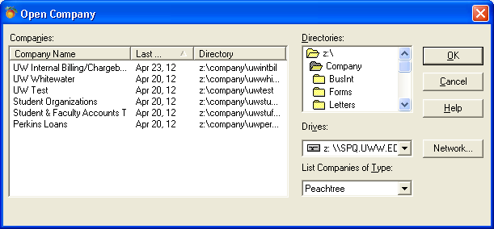

Once you have selected a company and used it, it should show up on your start-up list the next time you go into the software.

Login to the company selected. Be sure you have selected the correct company for what you want to do – UW Whitewater for external billing or UW Internal/Chargebacks for internal billing, as your login and password may work in both companies (depending on your needs). Your login and password will be the same for all companies you have access to. If you do not have access to a company you need, contact Financial Services

Once you have selected the company to log into, you will see the login screen:

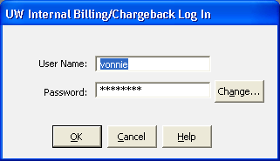

Enter your login and password and select OK, or press Enter to get to the next screen. The software is case sensitive, so be sure to capitalize login or password letters where required. To change your password, you need to type in your current password and then click Change.

When you first login you will see this screen pop up on top of the main screen. You can close this, or click on “Do not display this screen again” if you do not want to see it.

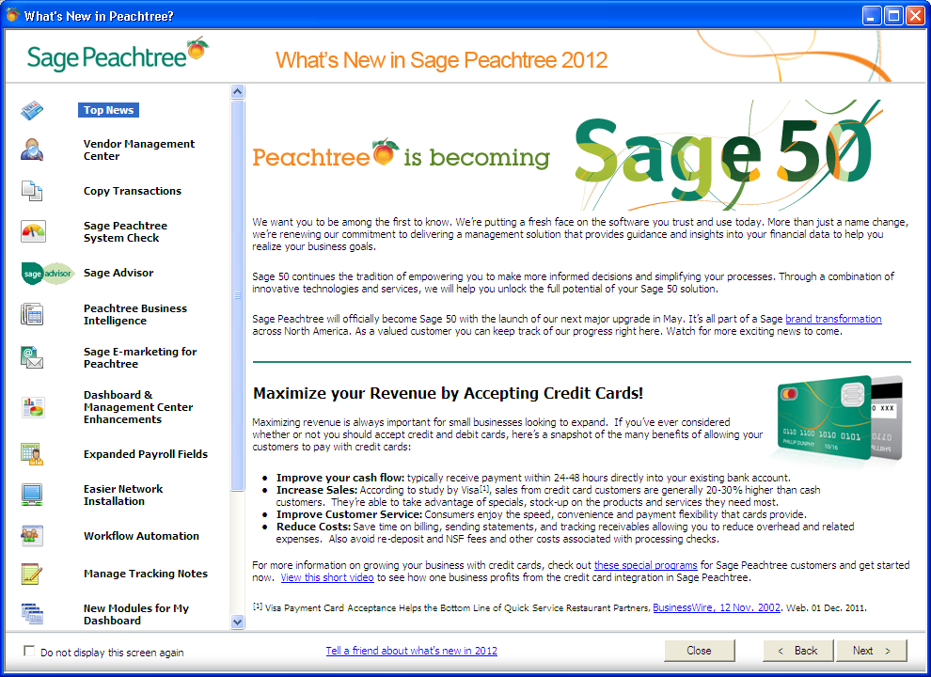

Customize Your Dashboard

Once you close the “Whats new” screen you will see your dashboard. This is a new function of Peachtree and allows you to navigate to only the things you want to see at a glance. You are able to customize this screen with the items you want to see immediately, or by selecting shortcuts for the tasks you use regularly. Once customized, it will be saved for that login. The screen below has been customized to show account balances, aged receivables, and customers who owe money. Keep in mind that what you select here will display for the whole company, you cannot customize these areas to show just your customers, so display only what is meaningful to you.

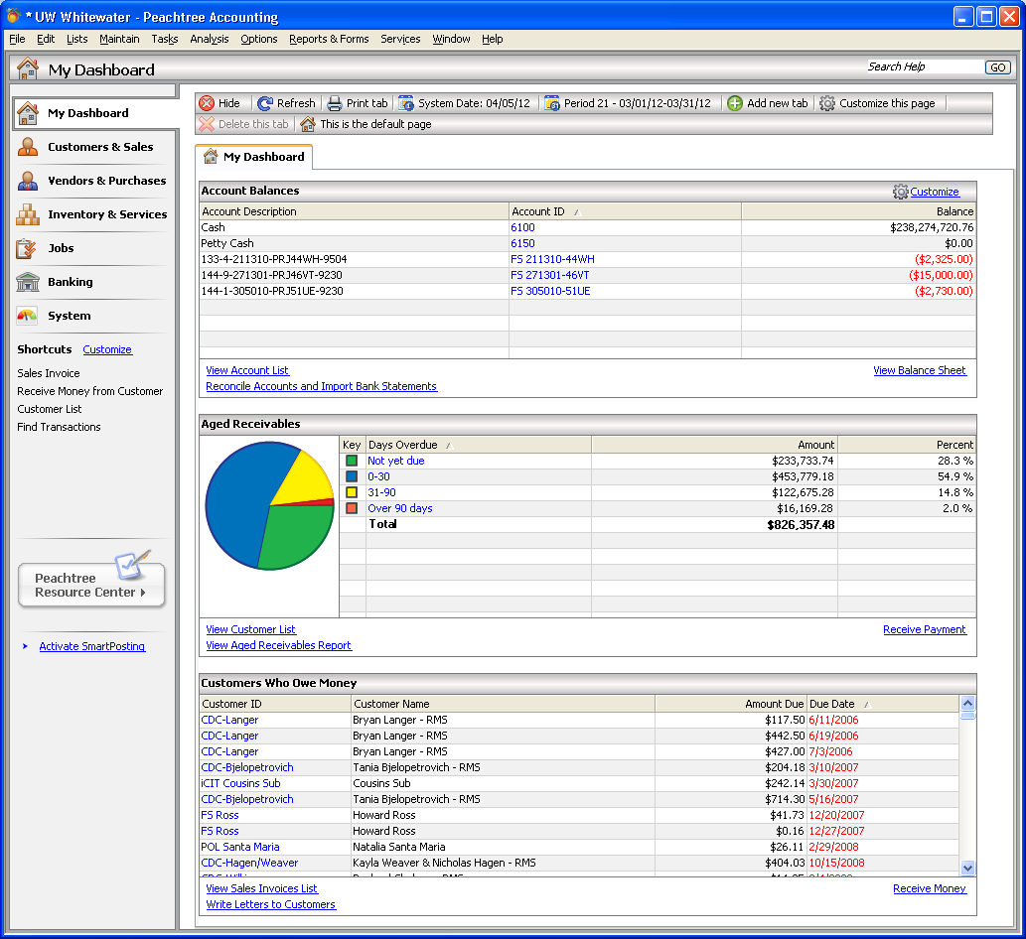

On the left you will see a list of standard functionality that the software allows, by clicking on the various processes - Customers and Sales, Vendors & Purchases, etc. The screen will change to show pictures of the flow of the information in that selection. One of these can be set as your default page, so every time you open the software this page shows up first. To set as default, right click on the mouse or press the “make this the default page” icon at top of page. Note that the default will be the same for all users of that login.
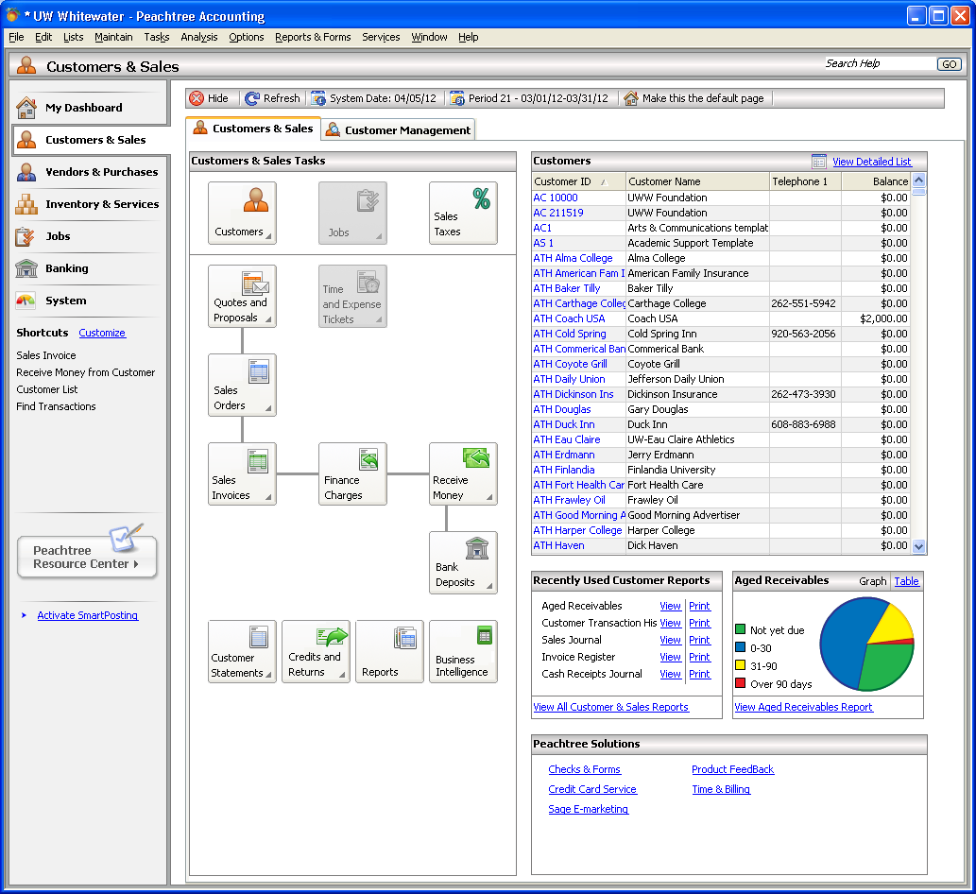

Additionally you can set up shortcuts to the typical tasks you perform by customizing that section of the page for that company. Click on Customize, and the list of shortcuts already set up will appear.

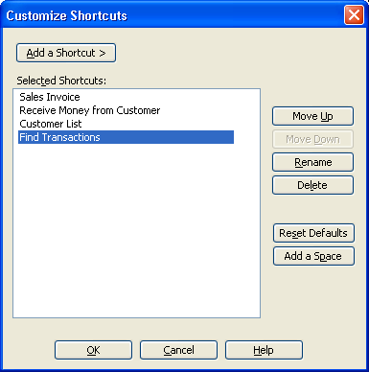
To add more shortcuts click on add a shortcut, and follow the path for Customer and Sales or the other choices to find the shortcuts available, and select the shortcut to be added. Once done selecting click OK and the shortcut will be added to the list on the left. You can select different shortcuts for each company, so you can customize to what you do in that company.

When on a navigation page for a group of transactions you can click on any of the boxes for the tasks and the system will take you to that task.

Below I have clicked on Sales Invoices, then New Sales Invoice and you can see that the invoicing screen has displayed. I can start entering an invoice just as if I had gone to that task any other way.

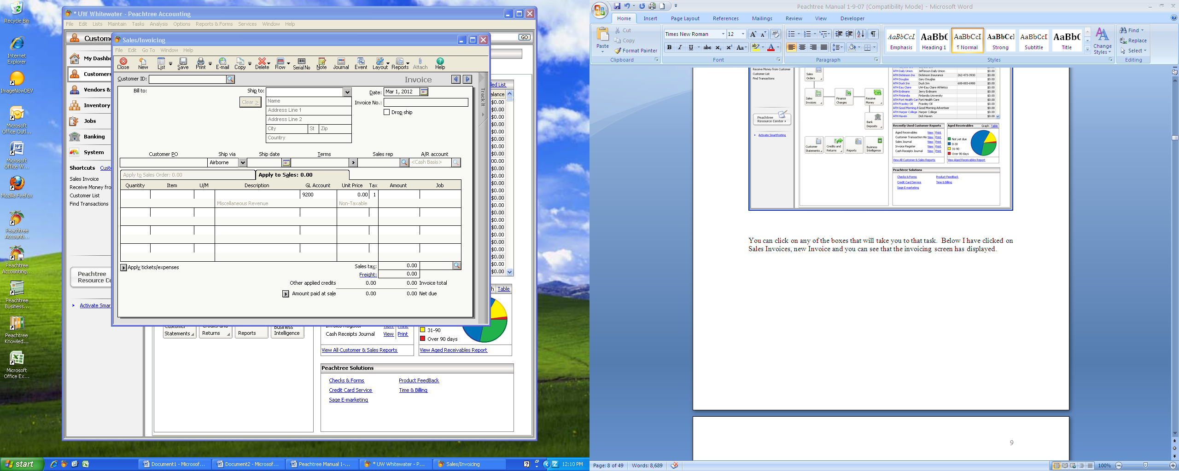

The navigation aid shows the workflow and allows you to get to some tasks quickly, so if you can’t remember how to get to what you want to do, you can click on the picture of what it is. For entering customers, click on the picture of customers, for invoicing, click on the picture of the invoices.

You can also still see the functional icons across the top of the screen, so if you are familiar with them, you can continue to use them. We will primarily be using Maintain, Tasks, and Reports & Forms. Help is always available if you have a question and is very easy to use.

Please use the UW Test company for “playing” with the software to learn what the software can do. Please do not “play” in the other companies, as you will be assigning invoice numbers or setting up fictitious information which clutters up the data bases.

NOTE: Each department using the software will be given a prefix for all of the items to be entered in the system for that department. Such as “UC” for the University Center. All customers of the University Center will start with “UC” and then be followed by the rest of the ID assigned by the department. Inventory items will work the same way, as will the chart of account, and reports. Your prefix is assigned by Financial Services and is always capital letters.

Maintain

From this icon’s dropdown list you will see Customers, Inventory Items, and Memorized Transactions. These are the three primary items you will be working with.

1. Entering a new Customer

Select the Customer item from the Maintain dropdown list or go to customers from other methods – shortcut, picture, etc. A template for each department has been set up to ensure default information is consistently used. As you set up a new customer you will need to select your department’s template (your prefix followed by a 1, ie. UC1 for University Center). From here you will add information to create the customer ID, leaving the prefix (without the 1) in place. The Customer ID field is only 20 characters, so you will need to determine how you want to assign these IDs. When you enter a Customer ID and save the information you have entered, the save will work like a Save As, and will add the customer to your list of customers rather than replacing your template. The next field in the template, Customer Name, allows you to enter the customer’s complete name that will be shown on the bill. This field is shown in drop down lists along with the customer ID whenever using the customer information; so keep that in mind when deciding how to assign customer IDs.

When you select your department’s template for setting up a customer (your prefix followed by a 1) the generic template will be shown. Default information has been set up in certain fields in the templates, and is needed to ensure reports extract information correctly. Do not change these defaults unless instructed to do so. You will need to complete information for each of your customers in some of the fields contained in the tabs across the top of the folder for the customer. The customer entry screen for the UC is displayed:

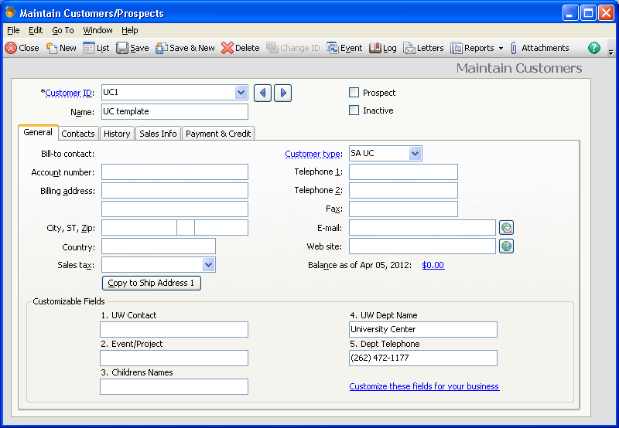

The General tab will provide basic customer name, address, and contact information. This is the information used for billing the customer, so be sure to complete all information necessary to assure the invoice is sent to the correct place. You should also indicate in the Sales Tax field if this customer is taxed on sales, and if so, using which county tax (based on your department’s location – Walworth or Jefferson). If it depends on what is sold, the inventory item will determine taxability of the item, but the tax indicator for the county here will help you in the invoicing process later. If this customer is exempt from sales tax, leave the field blank. Do not complete the “country” field, as USA will then be included in the mailing address and is not needed.

You will note that the Customer Type field is already completed. This information is a default for your department and will allow you to get reports specifically for your department, so do not change anything in this field.

Five custom fields have been set up for use by the departments, and one we use for the department’s telephone number for customer statements. Entries in these fields will be available to be shown on the invoice. Invoices are customized for the departments as needed, but you may find that you need something specific to a customer to be shown on an invoice, in which case these fields will be used. If you need to include something specific on one or all of your customer’s invoices that is not already provided for, please contact Financial Services to discuss what you need and how that can be accomplished.

The Sales Info tab will contain a default used for revenue coding. This is a generic default used by the system for all customers. No other information is necessary for entry on this tab. However, if you know that this customer’s payments on invoices will always go to the same revenue coding string, you can select that revenue string by clicking on the dropdown icon next to the GL Sales Account field to get a list of revenue codes.

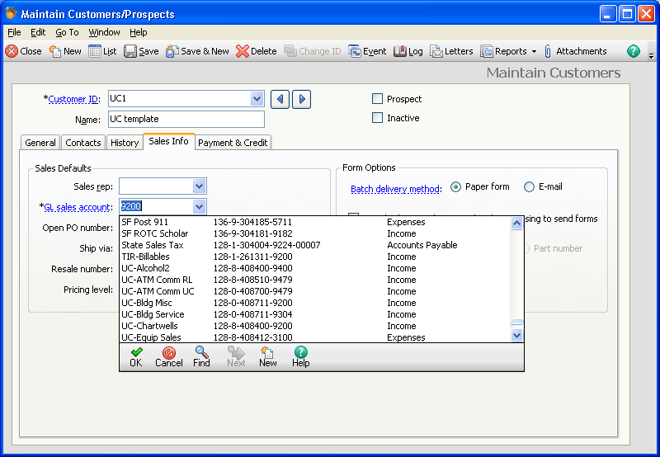

From the dropdown list, you select the appropriate code for this customer from your list of revenue codes. Be sure you have selected the revenue coding with your department’s prefix (for example: UC-Phone revenue string is shown in the next screen). This will assign this revenue coding to this customer, and will be the default for every invoice to this customer unless you change it when completing the invoice, which will be discussed later.

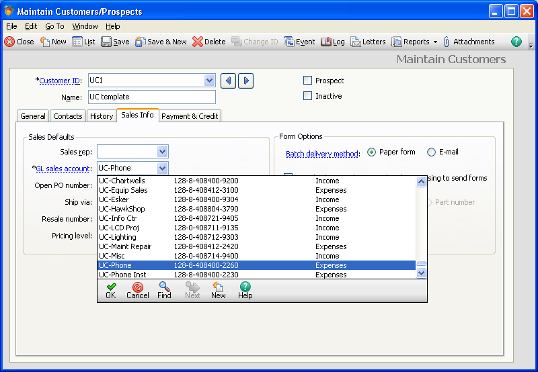

On this tab you will also select the delivery method for invoices and statements. If you want to mail invoices and statements by paper copy, do nothing as this is the default, but if you prefer to send them by e-mail, select that button. If you select e-mail, you must enter the e-mail address in the General tab. You can still select to print a paper copy when you prepare invoices.

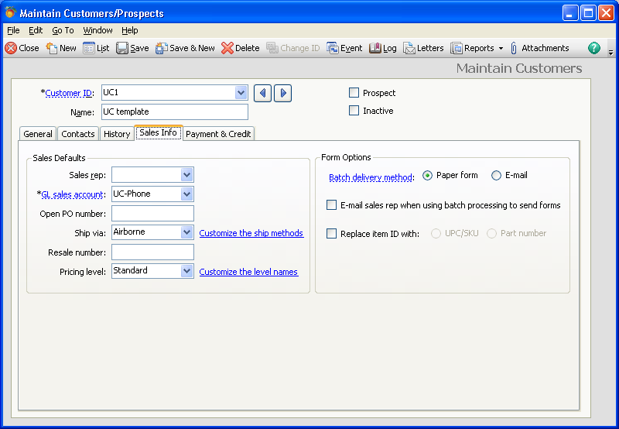

The Payment and Credit tab will allow you to use the default terms for this customer, or to select different terms. Our standard terms are payment due after 30 days, and no finance charges are applied. If you plan to charge finance charges on past due invoices, please contact Financial Services before doing so, as this will require an additional step for us when preparing statements.

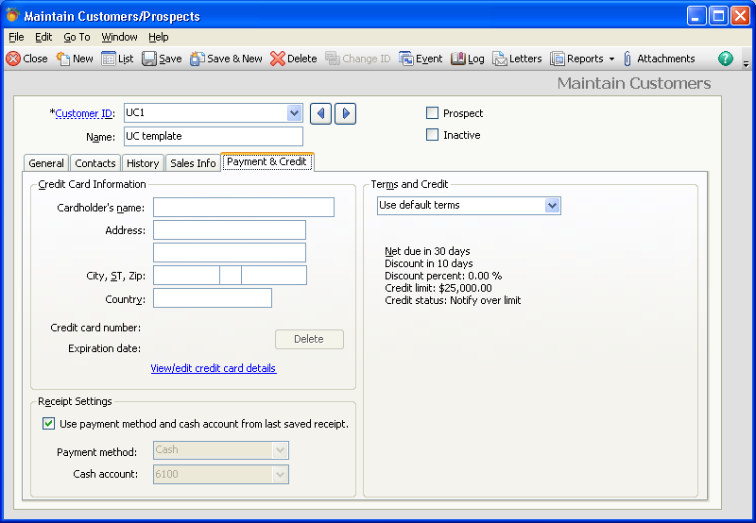

This tab will allow for the recording of a credit card number to be used to pay invoices. We do not use this function currently, so please do not enter information here, as credit card numbers need to be secured, and this data base is used across campus and these screens are accessible to all users.

The History tab will show history for this customer. You can see when the last invoice was prepared, or when a payment was made. No entries are made to this screen.

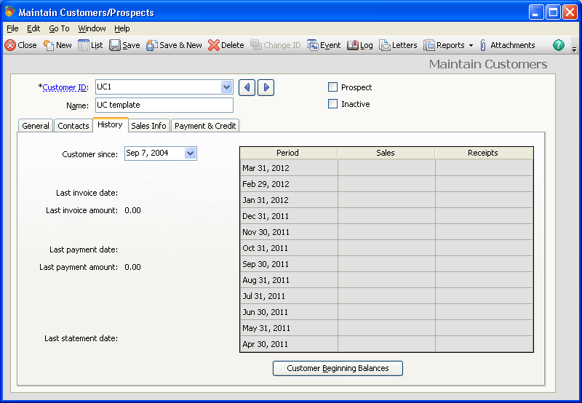

Once you have entered all of the customer’s information, and have given the customer a new Customer ID, you can save the information by pressing the Save icon. Do not save unless you have assigned a new ID number, as you will overwrite your department’s template.

User Tip: Inactivate customer - To inactivate a customer you no longer wish to use, check the inactive box and press Save. The customer will be inactivated, and no longer appear in your list if you have selected to hide inactive records.

2. Entering a new Inventory Item

From the dropdown list under Maintain select Inventory Items or go to Inventory & Services and select the Inventory items box. You will see the generic inventory item set up screen shown below. Your inventory items will be set up for you when you begin using Peachtree if you request Financial Services to do this. You will have access to set up new inventory items, and you will be able to edit inventory items that have been set up for your department. Once edited and saved, the changes will be used for any new invoices you do, but will not change old invoices.

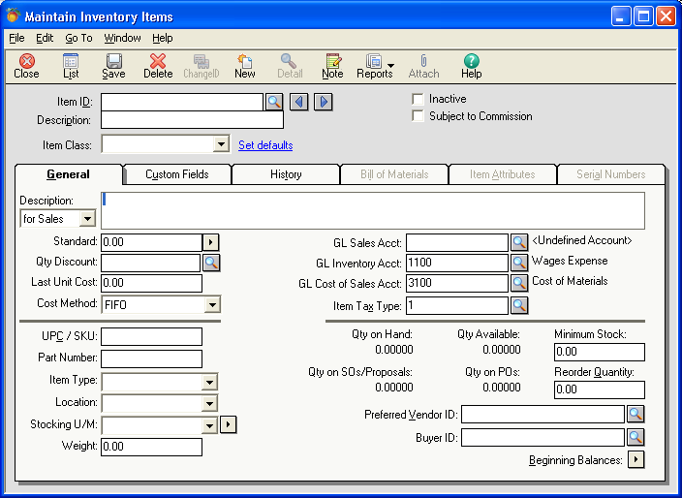

To Set up a new inventory item, assign it an inventory Item ID. This will start with your prefix, and then contain something that will be meaningful to you when looking at your list of items to identify this one item. To edit an inventory item, from the spyglass next to Item ID, select from the dropdown list to see the list of inventory items. Remember to select only from the items with your department prefix (“UC” is used here).

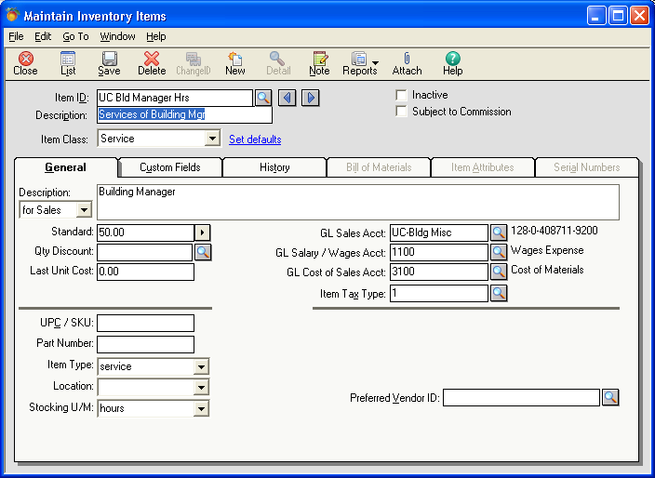

If you type your prefix in the Item ID field, the drop down list will go directly to your items from which to select. Remember, your prefix is capital letters only.

Shown is the inventory item UC-Bld Manager Hrs. You can see that the Item ID is expanded in the Description line to give a better description of the item. This description is shown in the dropdown list, so if you do not know the Item ID, you can select from the Description. Your description should be meaningful to you.

The folder for each inventory item has six tabs for specific information to be entered or edited for the item, some of which we do not use and will not be accessible to you. The General tab will show you what the item is, how it shows up on the invoice (Description for Sales), the price charged, how it is charged (month, each, ticket, per person, etc), revenue coding for the revenue generated by this item, and if the item is taxable or not. Most of our inventory items will have an Item Class of Stock or Service. When setting up a new item, you should change the item class to either of these, as it will eliminate a number of fields we will not be using. If you forget to do this, you can still use what you set up, but you will see extra fields. If you want to be able to extract a report on the numbers of this item you have sold, use the Stock item class.

The information for any items set up in advance for you were based on conversations with your department for each item, so changes should be carefully considered before being made. If you have any questions about the impact of a change, please test the change in the UW-Test database before making the change here.

The goal of setting up the inventory items is that it will limit the amount of keying you have to do when preparing an invoice. You should enter as much information as you want to see in the invoice in the Description for Sales line. For example, if you want
the invoice line to show that you are billing for telephone charges for a particular month, you should type “Telephone charges for the month of “ in the Description for Sales field. When preparing the invoice, you will then only have to add the name of the month to this description.

You should enter a price in the standard field if the item has a specific price. In the telephone charges example, the price would likely change each month so a price would probably not be entered. In the next screen, “The Nutcracker, Friday, December 16, 20011, 10:00 am” will show up in the invoice, along with the price of $6.00 per ticket. Multiple prices may be set up for an item by using the dropdown arrow next to the price amount. You will have the opportunity to select any of these prices in the invoicing screen. You may also leave this blank and assign the price when invoicing.

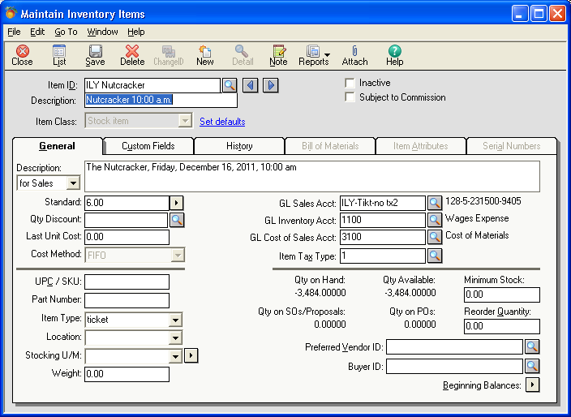

You must select a GL Sales Account for each inventory item you enter. This is the revenue string that will be used to code the deposit when the invoice is paid. This must be selected from your list of revenue accounts. Click on the spyglass next to the field to display the accounts available, and select your account from the list. Your account will start with your prefix. Do not select another department’s revenue coding, as any time the inventory item is used, the invoice will use the wrong revenue coding. If your GL Account is not on the list with your prefix, contact Financial Services to set up a new account. GL Salary/Wages Account and GL Cost of Goods sold are defaulted as shown, do not change them.

If this item is taxable, select the item tax type from the spyglass drop down list. 1 means it is non taxable, 2 means it is taxable. You will select the tax authority when completing an invoice. If the item is exempt, you do not have to complete this field, as non taxable is the default.

We will not be using the Custom Fields, Bill of Materials, Item Attributes, or Serial Number tabs. The History tab will show historic activity for this inventory item. No entry is required on any of these tabs.

Once complete, save the item. Make sure you have assigned a unique Item ID for each inventory item.

3. Entering a Memorized Invoice

Memorized invoices are a way for you to enter information once that will be used for repeating invoices. This is a great way to set up invoice templates that you use over and over again for a number of customers. Once the invoice is memorized, it is simply brought into the invoice screen when doing a new invoice, which will be discussed later. The process for setting up a memorized invoice is very similar to creating an invoice, and the screen looks much like the invoice screen.

To set up a new memorized invoice, select Memorized Transaction from the Maintain dropdown and then go to Sales Invoices, the basic screen will look like this:

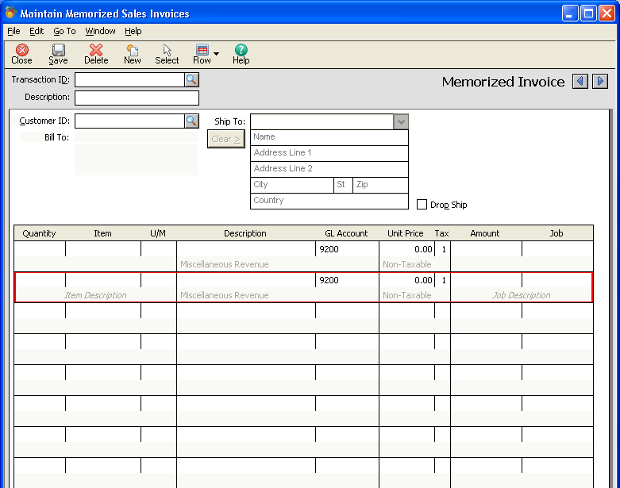

If you have an invoice that you already created and want to save it as a memorized invoice, go into the invoice, and select the dropdown next to the copy task. From that list you can select to memorize this invoice. You can also select to make this a recurring invoice or send to multiple customers by using the copy screen. Before doing this, play with the results in the UW Test company to see if you get the desired results.

Identify the Transaction ID you will give to this template, using your prefix and something meaningful to describe this template. You can expand on that using the Description field, as these two fields are always shown together in the drop down list.

Now you will enter information just as if you were completing an invoice.

If this memorized invoice will always be billed to a certain customer, you can enter that information by using the Customer ID from the spyglass dropdown list. For example, you set up a memorized invoice for a DVR client. You will always bill this client’s activity to the same customer - DVR, so you should select the Customer ID in that field. If you were doing a generic monthly billing as a memorized invoice, you may use this template for several customers, so no customer ID should be entered.

The next area is for the actual invoice items. Here you have some options. If you will be billing based on your inventory items, you can enter a number in the Quantity field and then select the inventory item from the spyglass dropdown next to the Item field. Once you are in the Item field the spyglass will appear. You can scroll down to find the item, or start typing your prefix to get to your list of items.

Based on what you select, a number of fields will be filled with information that is taken from the inventory item set up for the item you selected. The screen below shows the fields completed when CES Athletic Camp was selected from the memorized transactions list. You can see that several billing lines have been set up for typical items billed for an athletic camp. Each line will show:

- Description now shows what the invoice description will show,
- GL Account shows the default revenue from the chart of accounts that was selected in the inventory set up for this item, notice the full GL coding string is shown in the area below the Description
- Unit Price will show the price listed in the inventory for the item,
- Tax will show a 1 if this is a tax exempt item or 2 if sales tax is to be added to the invoice,
- Amount shows the Quantity times the Unit Price. If you do not enter a quantity or the item does not have a unit price, no amount will be calculated.

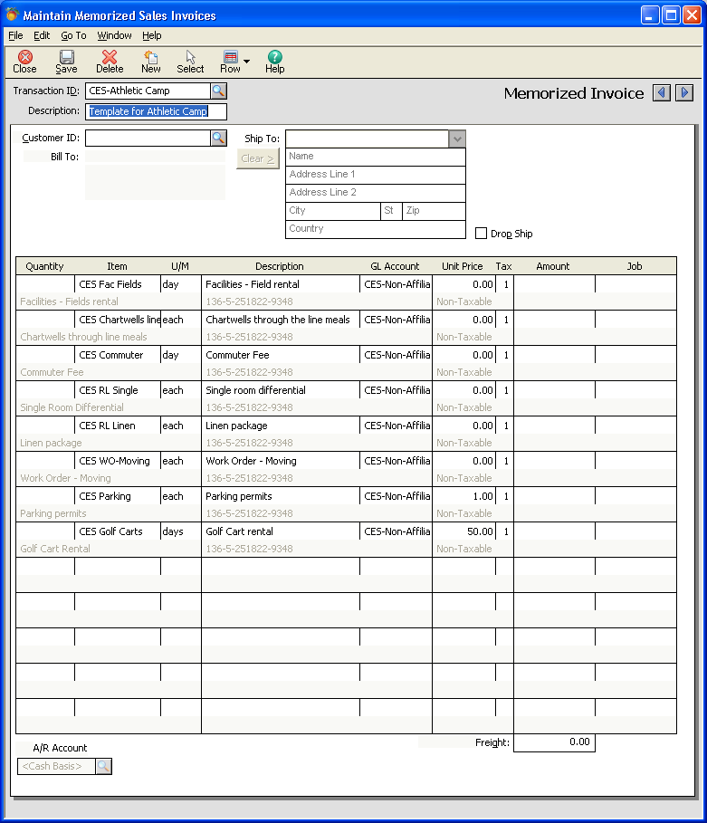

If you are setting up a memorized invoice that will not use inventory items, you can simply type in the Description field what you want to show on the invoice, using as many lines as needed. If there is a revenue string associated with what you have entered, select the GL Account (revenue coding from the dropdown list of coding), Tax Code if needed, and the Amount.

To save the memorized invoice it must have a Transaction ID. Again, it is important to ensure you use the prefix assigned for your department to differentiate your memorized invoices from other departments.
Tasks

Tasks are functions you want to do with the information that is maintained in the system, such as creating an invoice, entering a payment on an invoice, or posting items you have entered. From the Task menu, select each of these items.

4. Creating an Invoice

Much like the information just shown in the memorized invoice, you will be entering or selecting information to create your invoice. When completing the invoice you have some options - you can select a memorized invoice, bill using the inventory items, or bill by typing in the information in the description field.

To open the invoicing screen, from the Tasks icon, select Sales/Invoicing, or click on Sales/Invoicing picture on the navigation aid page. To use a memorized invoice, click on the dropdown arrow next to the List icon and click on Select, the screen below will appear for you to select which memorized invoice you want to use. Select your previously saved memorized invoice to use for the invoice.

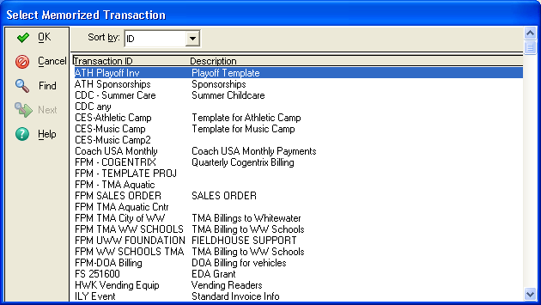

Once you select the memorized invoice, click OK and the memorized invoice is imported into the invoice screen. Anything you have imported is changeable in the invoicing screen, but will not be saved to the memorized invoice template.

Select the Customer ID if it was not part of the memorized invoice and enter other items not included in the memorized invoice template. In the event you want to add more detail to the description, the field can be edited just by clicking on it, and then moving to the end of the field to add information, or delete or replace information.

If you will be starting your invoice without the help of a memorized invoice template, you will need to select or type in all information on the basic invoice screen:

Select the Customer ID from the dropdown list. If you type your prefix in the field, the dropdown will go directly to your list. Once selected, your customer’s billing information will be filled in.

PLEASE NOTE: if this customer has had an invoice written off for non-payment, there will be a note stating this is the Ship To information. See Write Offs and Bad Debt section for how to handle this customer and invoice.

If you will be billing based on your inventory items, you will need to enter a number in the Quantity field and then select the inventory item from the spyglass dropdown next to the Item field. Once you click in the Item field the spyglass will appear. By starting to type in your prefix, the dropdown list will go to your department’s items.

Based on what you select, a number of fields will be filled with information that is taken from the inventory item set up for the item. The next screen shows the fields completed when “RP 2 x 8” was selected from the Item dropdown list. You can see that:

- Description shows what the invoice description will show,
- GL Account shows the default revenue from the chart of accounts that was selected in the inventory set up for this item, the complete GL coding string is shown just below the description. If this is incorrect, select another GL Account to get the correct revenue string,
- Unit Price shows the price listed for the item in the inventory,
- Tax shows a 1 if this is a tax exempt item or 2 if sales tax is to be added to the invoice,
- Amount shows the Quantity times the Unit Price. If you do not enter a quantity or the item does not have a unit price, no amount will be calculated.

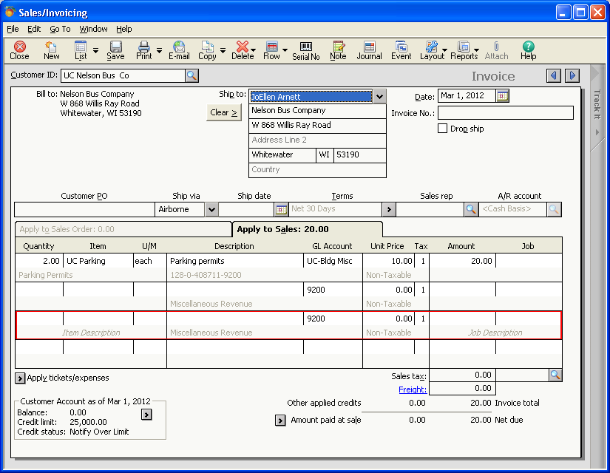

As you build your invoice you can continue to use inventory items, or can use typed descriptions or a combination of the two.

If you will be typing in a description for what you are billing, simply start typing your invoice information in the Description field. You will need to select the GL Account for the revenue coding from the drop down list, Tax if applicable (1 is exempt, 2 is taxable), and the Amount being billed.

As you complete a line, moving to the next field will add a new line to the invoice. To insert a row or delete a row, put the curser where a row is to be inserted or deleted to show where you want a change, then click on the arrow next to Row, and select add or delete.

If the items billed are taxable, you will also need to complete the Sales Tax Code field at the bottom of the screen. If you entered a tax code for this customer in the Customer set up field, the Sales Tax Code shown will be that code. The spyglass will give you a dropdown list of codes for the counties we use. It is important to ensure the correct tax information is shown so the Cashier’s office will be forwarding money to the appropriate county. If items are taxable and you do not indicate a code, the default is exempt, so tax will not be collected. If the items are not taxable, the invoice will not add tax even if a code is present.

Once you have completed the invoice, review it for accuracy. Each Description line shows the general ledger coding directly below it that will be used for the revenue. Be sure this coding is correct. When the Cashier’s office receives the payment, this is where the funds will be deposited, so if this is not correct, you will not receive your payments. If not correct, select another GL Account from the dropdown list to get the correct code.

To see how the invoice will look when printed, from the Print dropdown list (use the arrow at the side of the Print icon) select Preview. The system will bring up a screen from which to select the invoice template, the number of copies, and to confirm the next invoice number.

Do not stop in the middle of the printing process, as you will lock out other users.

Each department will have an invoice form(s) specifically designed for them, with their address and telephone number, and other specific information they have requested on their invoice. Your department’s invoice will have your prefix at the start of the name, so this should be the invoice template listed before you print:

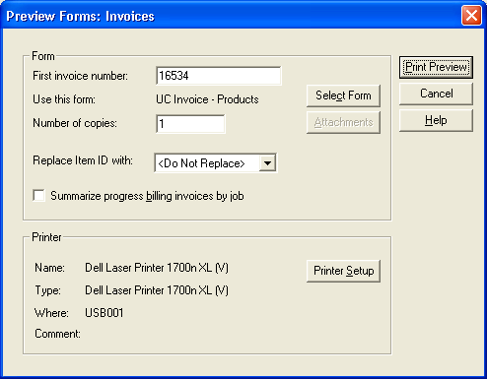

You can change any of the items in this screen to what you want to use to print the invoice. Then click on preview and the invoice will show on the screen. If it is not correct, go back and fix it by simply closing the preview screen.

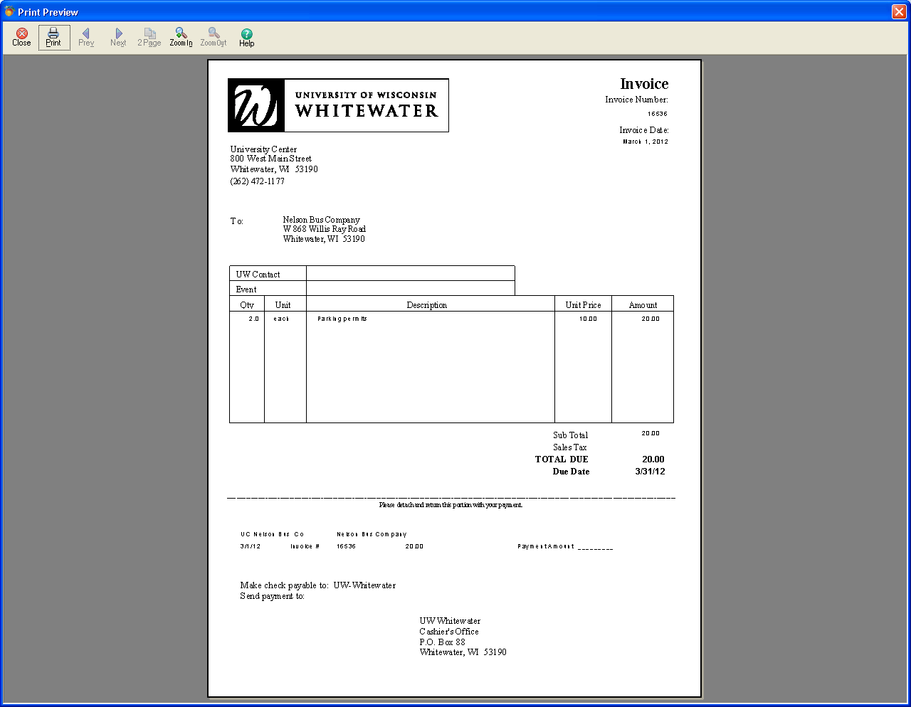

If it looks correct, click on Print on this screen.

The system will assign the invoice number once it prints.

If you are going to e-mail the invoice, close the review and click on the E-mail icon, and the following screen will appear.

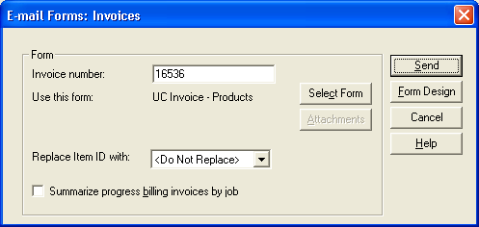

The next invoice number will be shown, and the form to be used for the invoice will be indicated. When you click on send, the e-mail box will appear with a standard message and the invoice attached. You will be able to review the e-mail before sending.

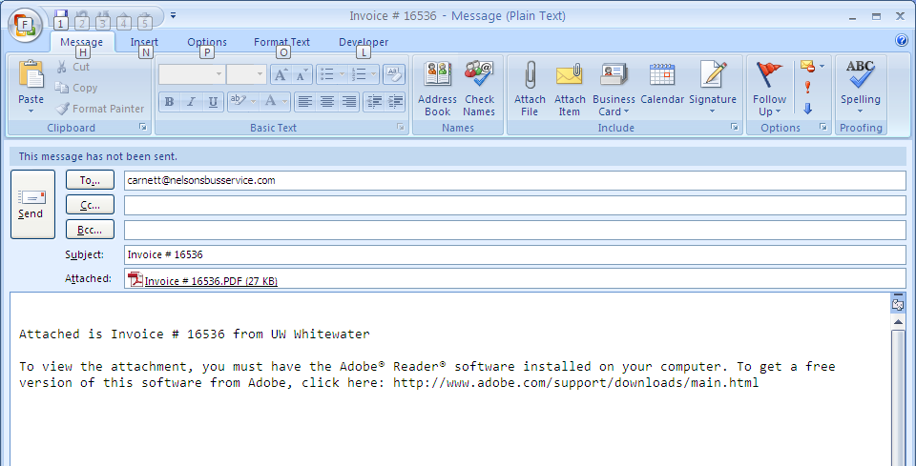

If you discover that you have made an error on the invoice after you print it or send it, you can go back into the invoice to fix the problem if doing it the same day. Financial services will post transactions early in the morning each day, so once you have saved or printed an invoice it will be posted the next morning and you will no longer have access to change it.

To edit an invoice, while in the Invoice task, select the List icon; a list of invoices will be displayed. Your invoice will be listed if you have the status as “Unposted”, if it is not on unposted, change the status so you can find your invoice. You will only have access to edit unposted transactions.

Click on your invoice.

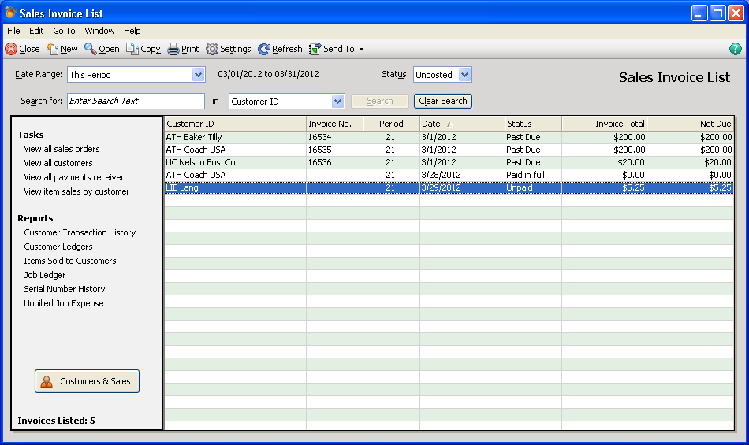

You will have access to the invoice and can fix the error until the invoice is posted. You should then print again. The system will go through the same screens as shown above for the print process.

Once Financial Services posts the days transactions, you will still be able to bring it up on your screen, but you will be unable to make changes, save it or print it. To bring it up on your screen, you use the same process as used to edit, but now you will have to modify the list shown above by selecting “posted” invoices in the Status field. Once that field is changed, invoices in the current period will be displayed.

If you need to look up an older invoice or one in another period, you can also change the period you are searching in to a specific period or to “All Transactions” by changing the information in the Date Range field. The system will bring back a list matching your criteria and you can pick your invoice from there.

If you need to print an invoice that has already been posted, the instructions are shown in a later section.

5. Entering a Receipt

The Cashier’s office will have access to record receipts on payments. All of our invoices will indicate that payment is to be sent to the Cashier’s office directly. If you receive a payment on an invoice, do not process a deposit for it; simply send it directly to the Cashier’s office for processing.

From the Tasks icon select Receipts. The system will bring up the receipt screen shown:

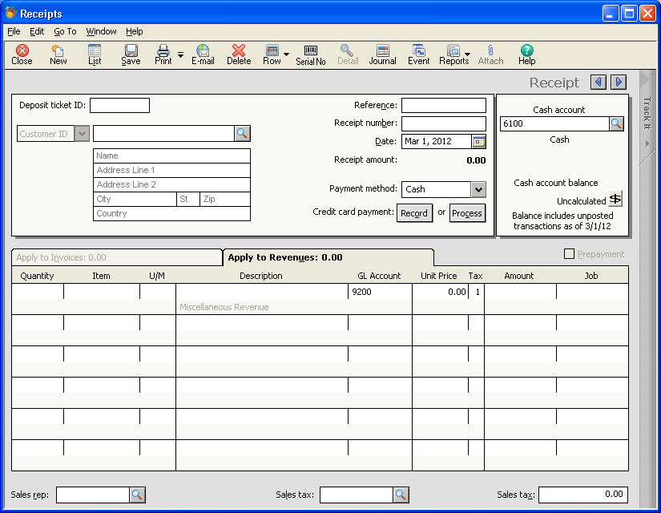

To bring up a list of open invoices, enter the Customer ID from the invoice stub or search for it from the dropdown list. Once selected, the system will bring up all open invoices for the selected customer.

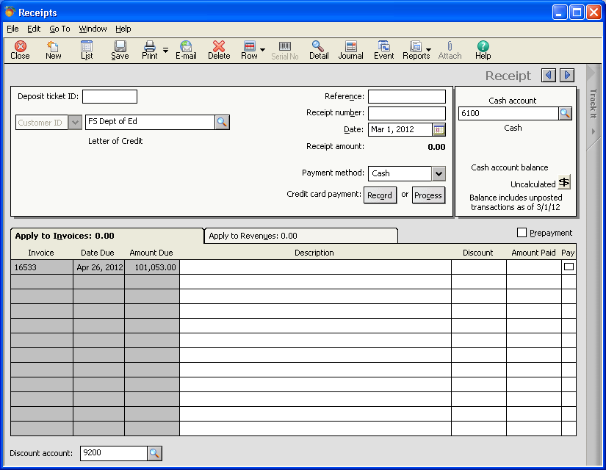

To make a payment on an invoice, check the Pay box for the invoice. A check mark will appear in the box and the amount of the invoice will appear in the Amount Paid column.
If a partial payment is made, simply change the Amount Paid field to show the amount being receipted for payment.

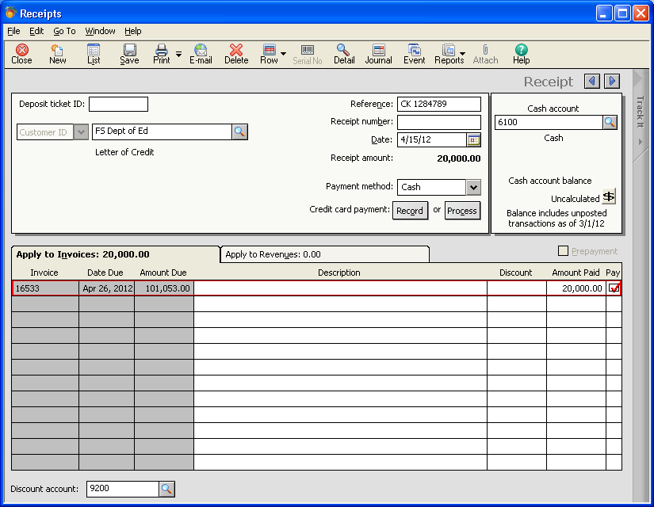
The Cashier’s Office will be able to enter specific information into the Deposit ticket ID field, the Reference field, and the Receipt Number field. The system will not save an item unless the Reference field is completed. Be sure the Date field is correct before checking the box, as a change in the date will clear some of the remaining fields.

Once information is entered, Save the receipt. Receipts should be posted when the entry process is completed. You should post receipts before running the Cash Receipts Journal so that no changes can be made to the receipts.

6. Entering a Credit Memo

If you discover that you have issued an invoice that needs to be modified due to a billing error, you can enter a credit memo to be attached to that invoice. To enter the credit memo go to Tasks and click on Credit Memos. Credit memos look a lot like the invoicing screen. You create the credit like you would an invoice, selecting your customer, inventory items, etc. When you select the customer, if there are invoices in the system for that customer, you will have the option to select the invoice to which to attach the credit memo. Find the invoice you want to attach the credit to by clicking on the dropdown arrow and selecting the appropriate invoice. Do not process a credit memo that is not attached to an invoice.

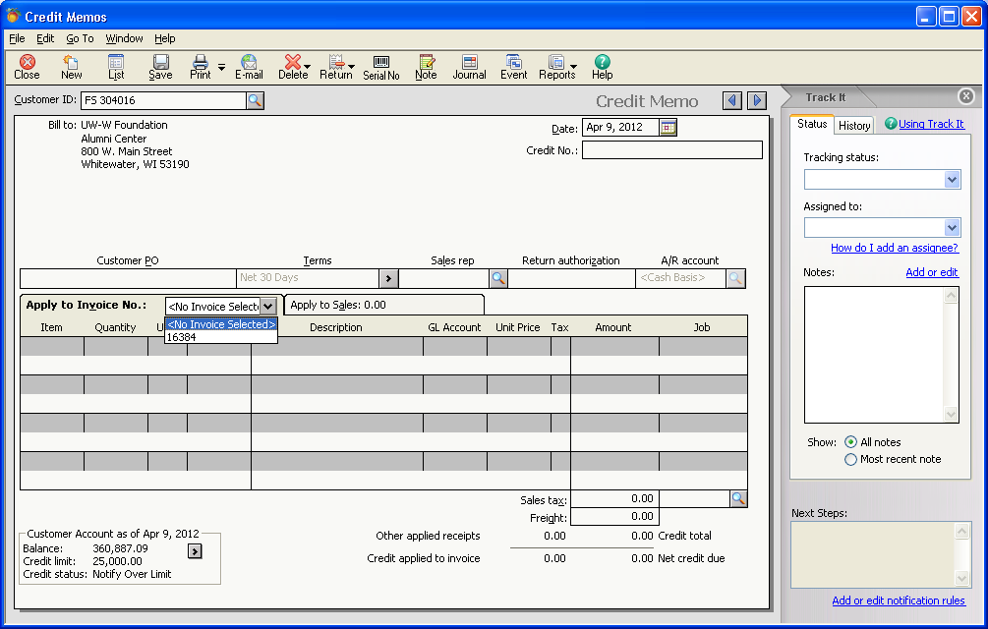

Once you have selected the invoice, the detail of that invoice will show up and you can determine what you want to credit based on quantities returned or by putting the amount of the credit on the original billed line. The amount should be indicated as a positive amount, as the system will apply it against the invoice as a negative number to reduce the invoice.

You cannot type in a description on the credit memo to explain the credit, so you will need to attach a note to the credit memo. To do this, click on the note icon to bring up that screen.

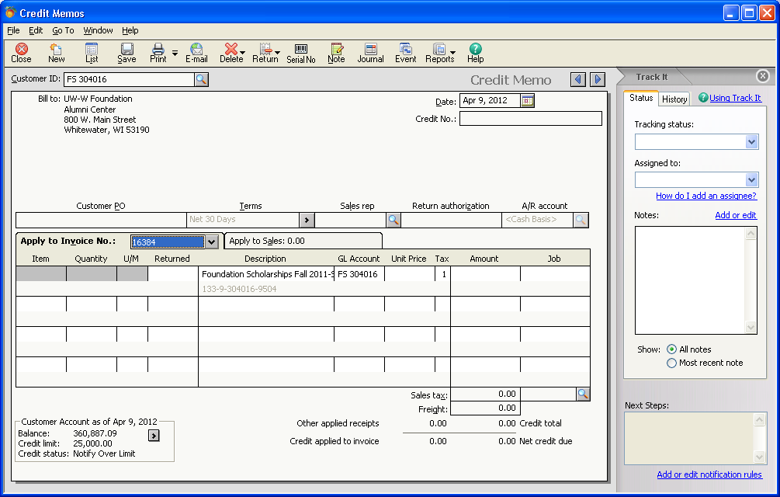

Type in your explanation for the credit being given and indicate whether the note should print before or after the credit memo lines by clicking on the toggle at the bottom of the note page.

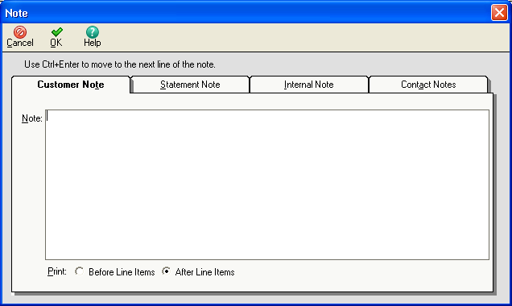

Once completed you can print or e-mail the credit memo just as you would an invoice. The numbering sequence for credit memos will be different than for invoice. Do not change the numbers the system generates for you.
7. Posting

Posting receipts or invoices can be done at any time from the Task icon by selecting System (at the bottom of the list) and then Post. The system will ask what you want to post.

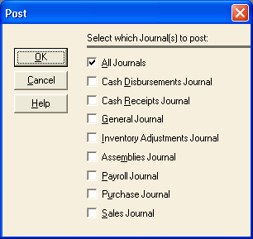

The Cashier’s office should only post the Cash Receipts Journal when they have completed the entry for the day. All journals will be posted at the end of each day or early the next day by Financial Services. If a journal has no transactions to post, the system will ignore that journal when the post process is done at the end of the day.

Reports

A number of reports have been set up for each department using the system. Each report extracts information using the Customer Type field that was shown in the customer set up screen. The report for each department only pulls that department’s customers.

To get to your reports, select the Reports & Forms icon, select Report Group from the dropdown list, and your department name from the list of groups that display. Reports currently available to each department include:

Cash Receipts Journal
Aged Receivables
Sales Journal

Your reports are also available to you from your desktop dashboard. See page XX for setting up your dashboard with this option. To select a report from your dashboard, select your department from the dropdown list of Category, then select the report you want to see.

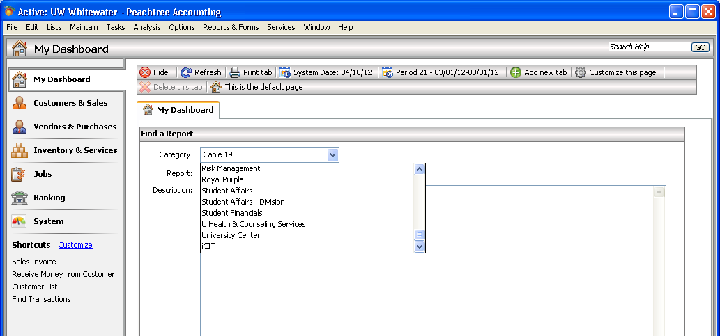

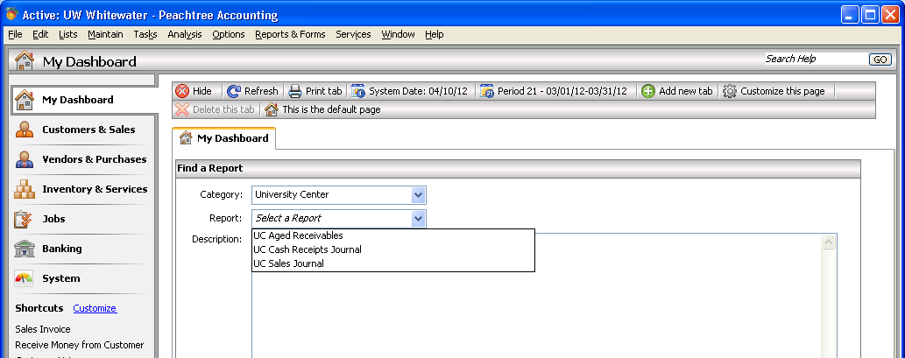

8. Cash Receipts Journal

The Cash Receipts Journals is selected from the Report icon, select Group Reports, your department’s group and then the Cash Receipts Journal. The cash receipts journal for UC is shown.

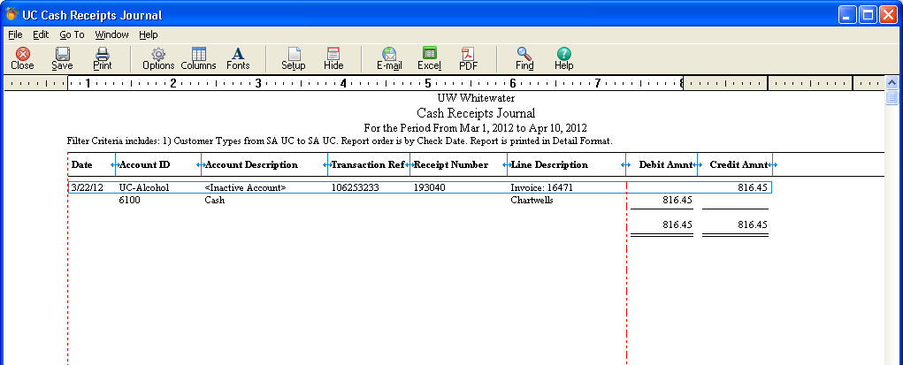

This will show all payments applied during the period of time selected. The defaults have been set up for this report to display the current month. To change the criteria, while in the report, select Options and a screen will show criteria that can be selected to get different results:

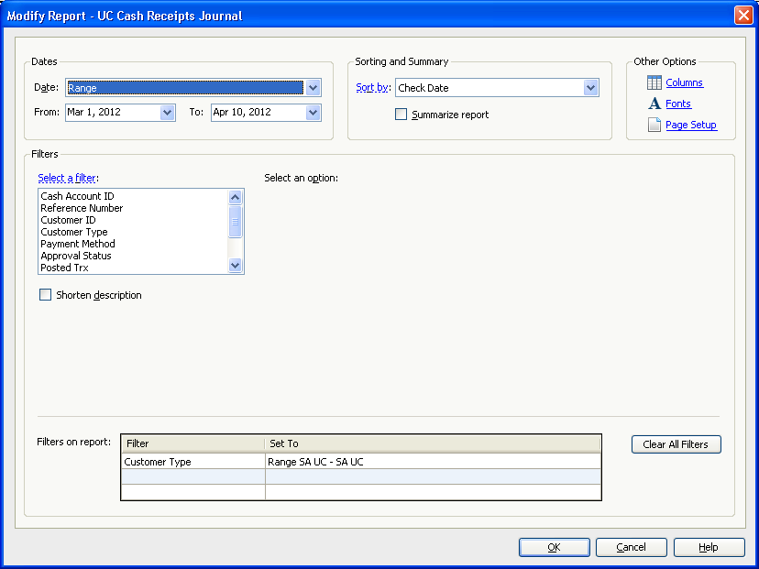

You can change fields you want to see, the date range of the period, arrange in a different order, etc. Your standard report has been set up for you, but this can be changed so that you always get the report the way you want it. By changing the criteria and selecting OK, the report will be refreshed to what you have selected. If you find a report that is exactly the way you want it, and it is different than the standard report we have set up for you, simply Save the report, and give it a new name starting with your department’s prefix.

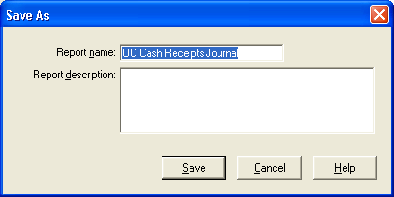

If you give it a name that has been used, it will ask you if you want to overwrite the other report. It is up to you if you do, but please be sure you are only overwriting your department’s reports.

While in the report, you can drilldown on the items in the report any time you see the spyglass appear while your cursor is on an item. In the following screen you can see the drilldown for the one payment shown on the report. The spyglass was placed over the transaction reference number and double clicked to bring up the receipt entry information for that item.

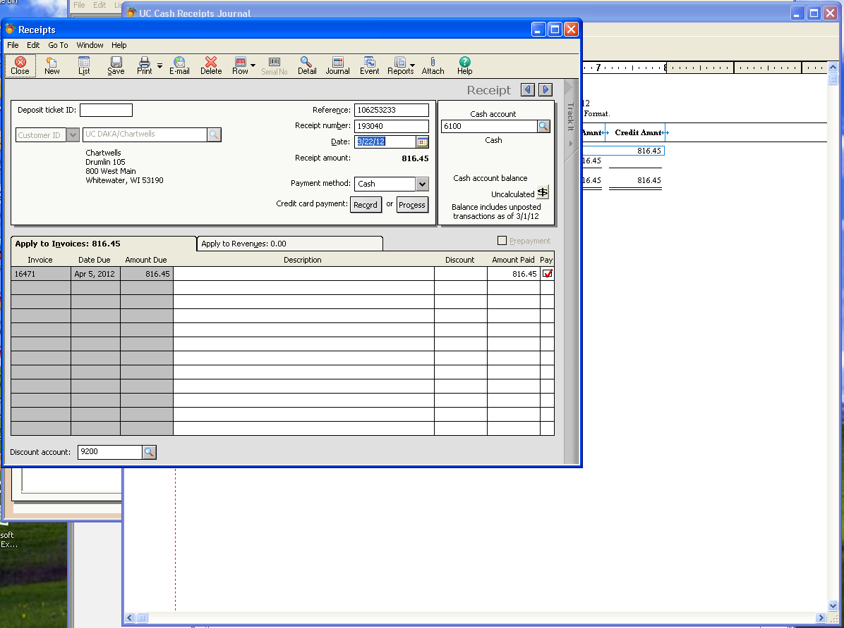

9. Aged Receivables

The Aged Receivables report is selected from the Report icon, select Report Groups, your department’s group and then the Aged Receivables report. The Aged Receivables report for the UC is shown.

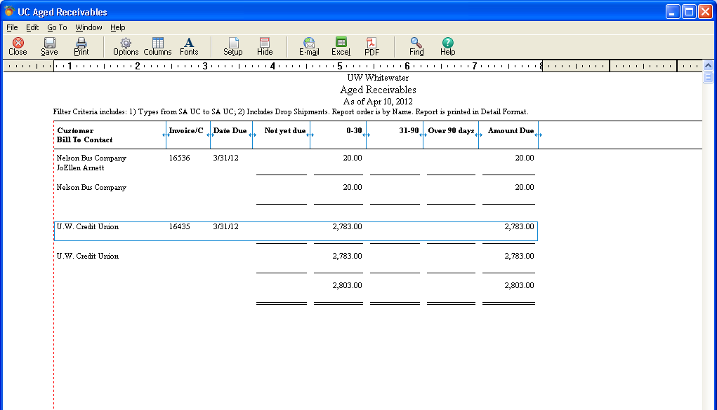

This report can be used to call your customers with overdue accounts, as the invoice and due date for each customer is shown, and if entered in the customer set up, a telephone number to call them. Each department is responsible for collecting their receivables, so I recommend you include telephone numbers in your customer set up to give you this tool.

This report shows all outstanding receivables as of the date indicated. The defaults have been set up for this report to display as of the current date. To change the criteria, while in the report, select Options and a screen will show criteria that can be selected to get different results:

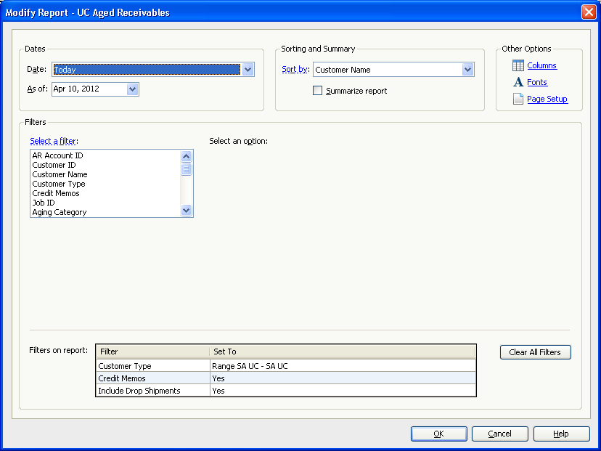

You can change the fields you want to see, the date, arrange in a different order, etc. Your standard report has been set up for you, but this can be changed so that you always get the report the way you want it. By changing the criteria and selecting OK, the report will be refreshed to what you have selected. If you find a report that is exactly the way you want it, and it is different than the standard report we have set up for you, simply Save the report, and give it a new name starting with your department’s prefix.

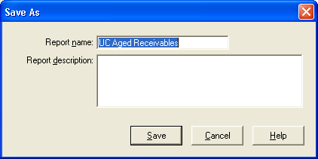

If you give it a name that has been used, it will ask you if you want to overwrite the other report. It is up to you if you do, but please be sure you are only overwriting your department’s reports.

While in the report, you can drilldown on the items in the report any time you see the spyglass appear while your cursor is on an item. In the following screen you can see the drilldown for the invoice shown on the report. The spyglass was placed over the Invoice number and double clicked to bring up the invoice information for that item.

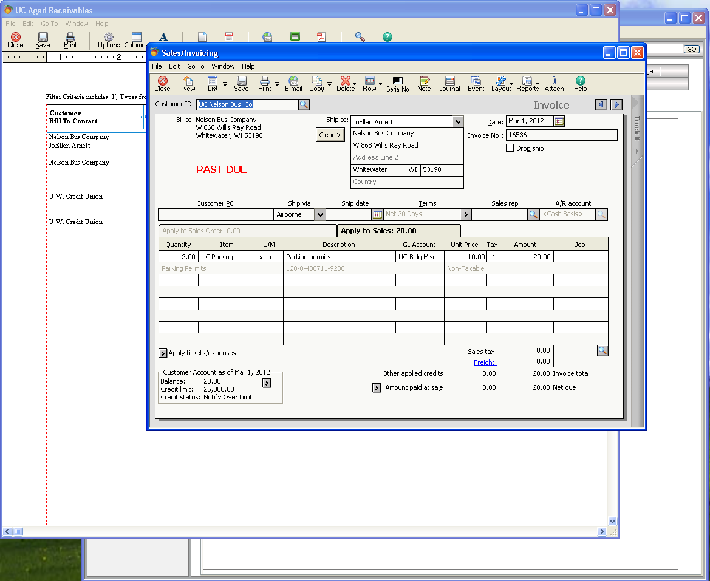

10. Sales Journal

The Sales Journal report is selected from the Report icon, select Report Groups, your department’s group and then the Sales Journal. A list of invoices you have prepared for the period selected will be displayed. In the following screen, all invoices for the SF department from June 1 through the current period – September - are displayed.

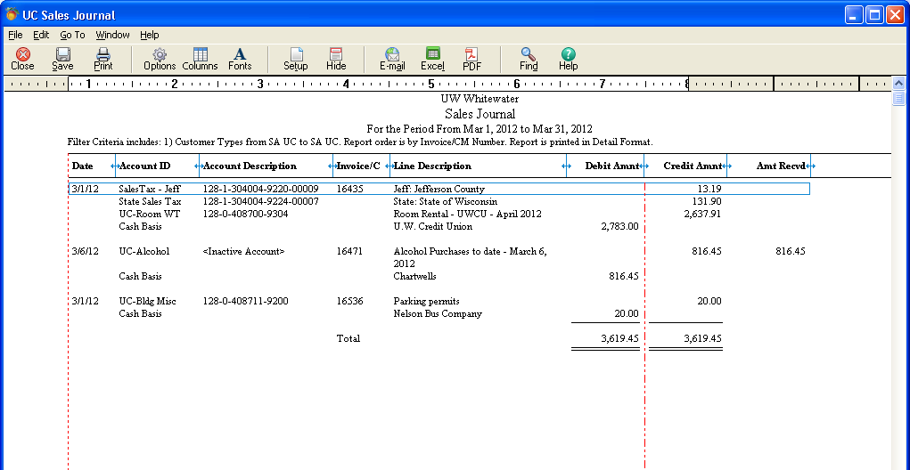

Again, if you use your cursor to place the spyglass over an invoice number, you can double click to see the invoice information. The screen that comes up will also show you if the invoice has been paid, or if it is past due. The example in the next screen is an invoice that is paid in full as is indicated in the upper right corner in red.

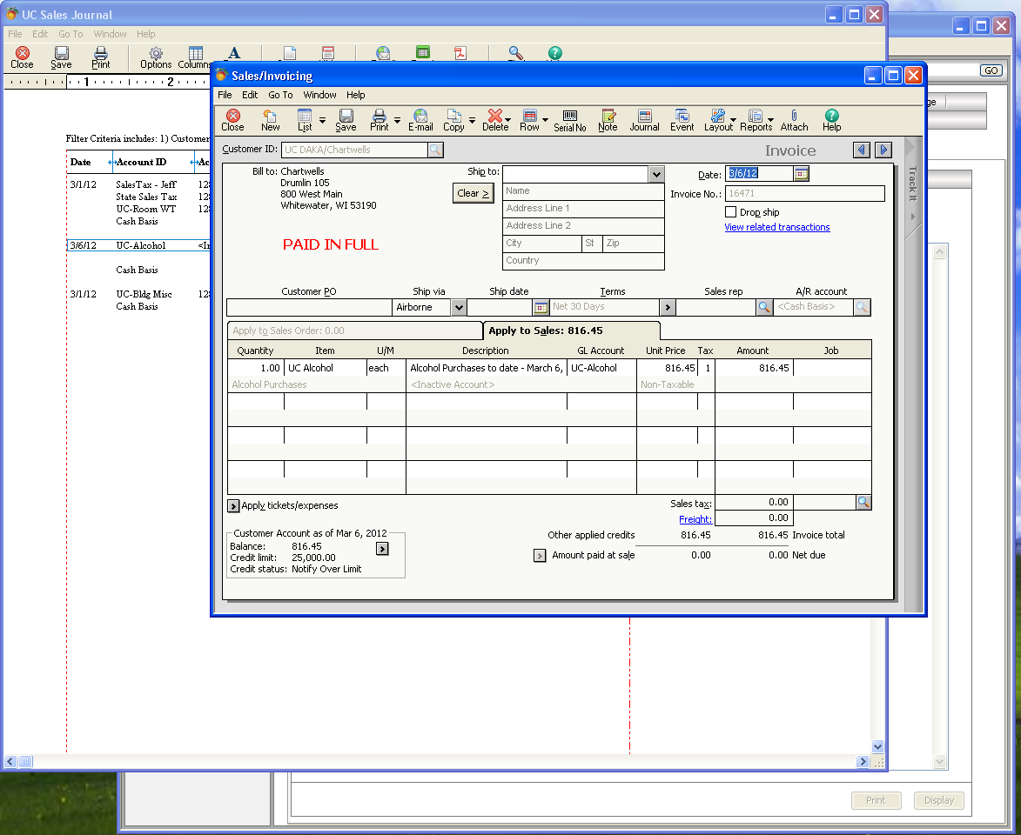

To change the criteria, while in the report, select Options and a screen will show criteria that can be selected to get different results.

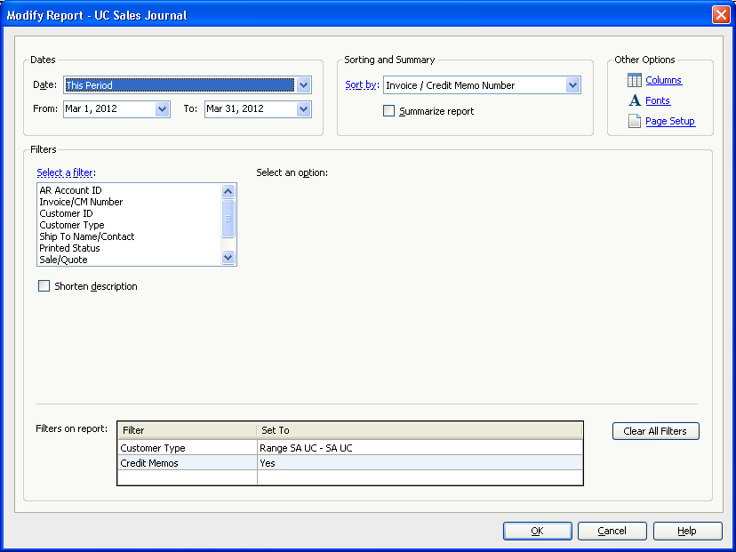

You can change the fields you want to see, the date, arrange in a different order, etc. Your standard report has been set up for you, but this can be changed so that you always get the report the way you want it. By changing the criteria and selecting OK, the report will be refreshed to what you have selected. If you find a report that is exactly the way you want it, and it is different than the standard report we have set up for you, simply Save the report, and give it a new name starting with your department’s prefix.

Write off and Bad Debt

To take a look at the customer ledger that will show what the problem was click on the arrow next to the Balance in the bottom left corner of this screen.

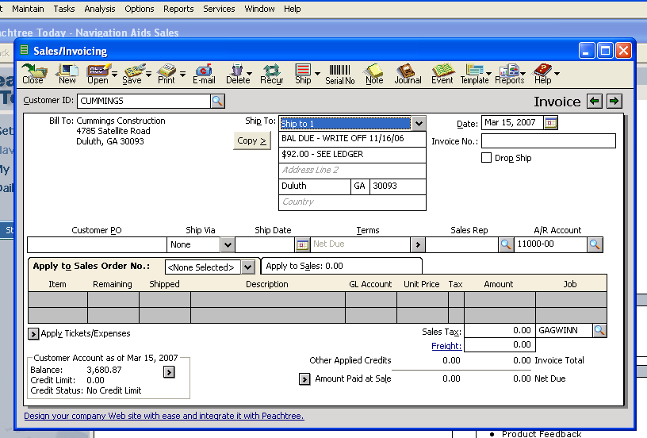

Once pressed, this will bring up the customer ledger for this customer as shown below. The ledger will only show current period transactions, so you may have to go back some periods to see the problem. The customer ledger shows all invoices, payments and credits for a customer.

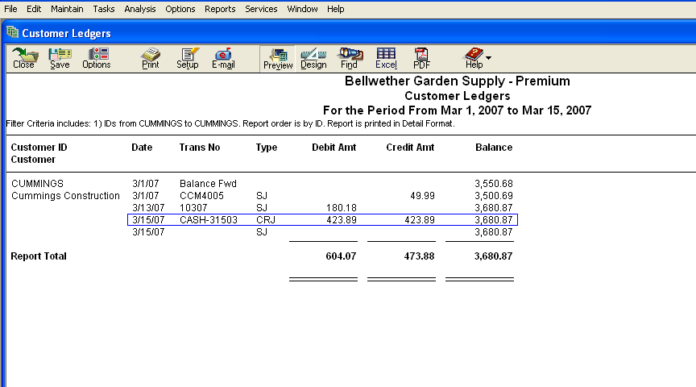

To go back to other periods, click on Options and select the period(s) you want to see.

Once you have viewed the invoice that was unpaid, you will need to decide if you will provide service to this customer. If you have already provided the service, you should contact the customer to explain that you will be billing for the previous unpaid amount as well, and send both invoices (see printing old invoices in the reports section).

Collection

Customer statements will be processed monthly for accounts with balances that are overdue. Financial Services will print and send out the statements as reminders to your customers. Departments should review their monthly aged receivables reports and follow up with their customers to address billing questions or payment problems.

Invoices not paid within 6 months may be sent to the collection agency. It is the department’s responsibility to ensure that contact has been made with the customers to determine if there is a problem with the invoice, and to gather necessary information for the collection agency, such as contacts made, current contact info, etc.

The standard statement that will be sent looks like this:

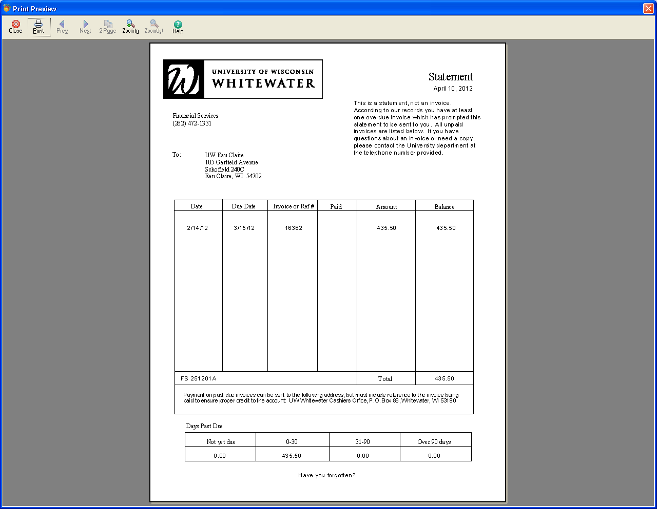

It will list all unpaid items and then age the amounts in the categories at the bottom of the page.

Messages will appear after the aging section that will advise them to give this prompt attention or to contact you about payment.

Internal Billing/Chargebacks

A separate company in Peachtree has been created to process internal billings. These are chargebacks from one department to another for services they have provided. If the department uses an automated chargeback process, they do not need to use Peachtree for this.

At the login screen, this company is called UW-Internal Billing/Chargebacks. This company provides the department providing the service with the same invoicing capabilities as are used for external billings. The same login and password are used for this company as for UW-Whitewater and for UW-TEST.

The advantages of using this software for this process is that the customer gets an actual bill for the service provided, the provider enters the information for the bill and this is the only data entry done for it (so there is less chance for keying error), Financial Services extracts the information for importing into the general ledger allowing for many department’s chargebacks to be loaded at one time. The transfers are done weekly.

The process uses the same features as discussed in Maintain, Tasks, and Reporting sections. Differences are few:

The invoice prepared for the customer will look slightly different so the customer knows that it is an internal bill and not to pay it.

Because we are transferring expenses within the general ledger, we need to obtain the customers billing coding.

The invoice is prepared as is done with external billing. Below is a screen shot of a bill in the internal billing/chargeback company.

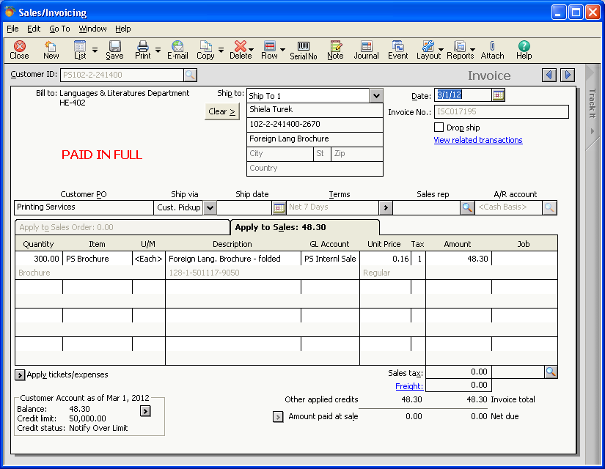

The differences are that the Customer PO field contains the Billing department name. This is defaulted in from the customer set up using the department’s template. This is pulled into the Jrnl Ref Line field in SFS, so the billed department can identify the charge on WISDM.

The Ship to fields contains the name of the person from the department receiving the service that authorized the charge, the expense coding string to be charged for the cost of the service, and a description of the item being billed that will be used in WISDM to describe the payment made by the customer. Billing information and authorization must be obtained with each order by the department providing the service. DO NOT ASSUME THE CODING FOR EVERY ORDER IS THE SAME JUST BECAUSE THIS PERSON OR DEPARTMENT HAS ORDERED FROM YOU BEFORE. This information is entered in the Ship To fields.

In order for Financial Services to process this chargeback, there MUST be an entry in all three of the following fields. Incomplete fields will cause the chargeback not to be processed.

The Name is the name of the person who authorized the charge. Coding to be charged is entered in the Address Line 1 filed in the order shown – fund-program-org-account-subaccount-project. Only one coding line can be used per invoice. Address Line 2 is used for the description of the services provided and being billed. This description field will hold 29 characters and will display in the customers account in WISDM to describe the service be paid. If any of the shipping information was set up in the Customers maintenance screen, this will come from that set up into the ship to fields. Any information that came in automatically can be changed when you are preparing the invoice, and it will not change the customer set up.

Setting up the customer’s Ship To info in the customer maintenance screen. If you regularly bill a customer for the same services and the same coding, you can set up the Ship To information for the customer. If you have some of the information already entered for the customer, you can start the Ship To information by pressing the Copy to Ship Address 1 button on the set up screen as shown in the screen shot below. This will take some of the information to the set up screen, which you can then edit.

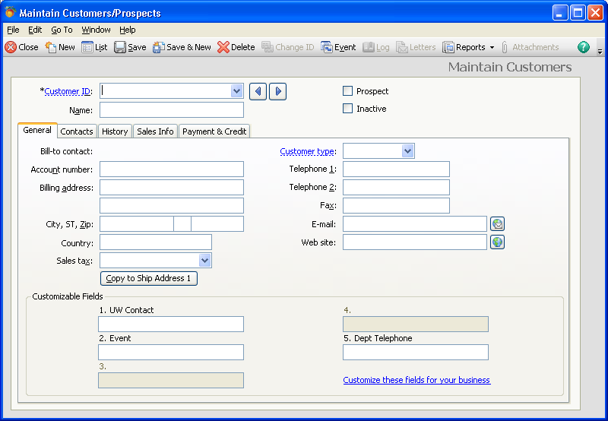

You can also just go the set up screen by selecting “Edit Addresses” from the Contacts tab.

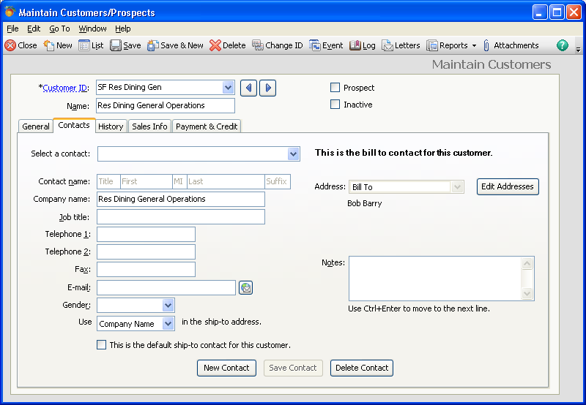

This will bring up the shipping address so you can enter the information into the fields as directed above.

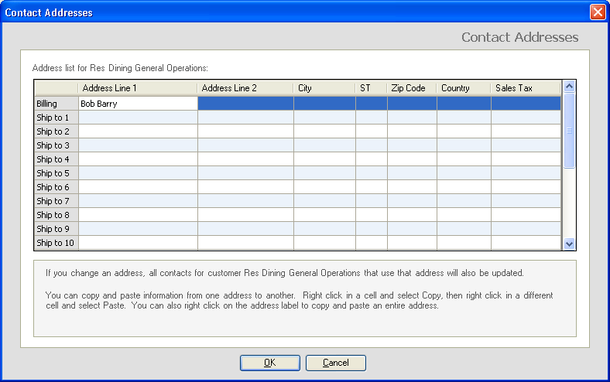

Once the customer information has been entered, the invoice preparation is the same as the process describing in the Invoicing section. The invoice is printed or e-mailed, selecting the invoice template for Internal Billing/Chargebacks with the preparing department’s prefix or the general internal invoice. The printed invoice looks slightly different as shown:

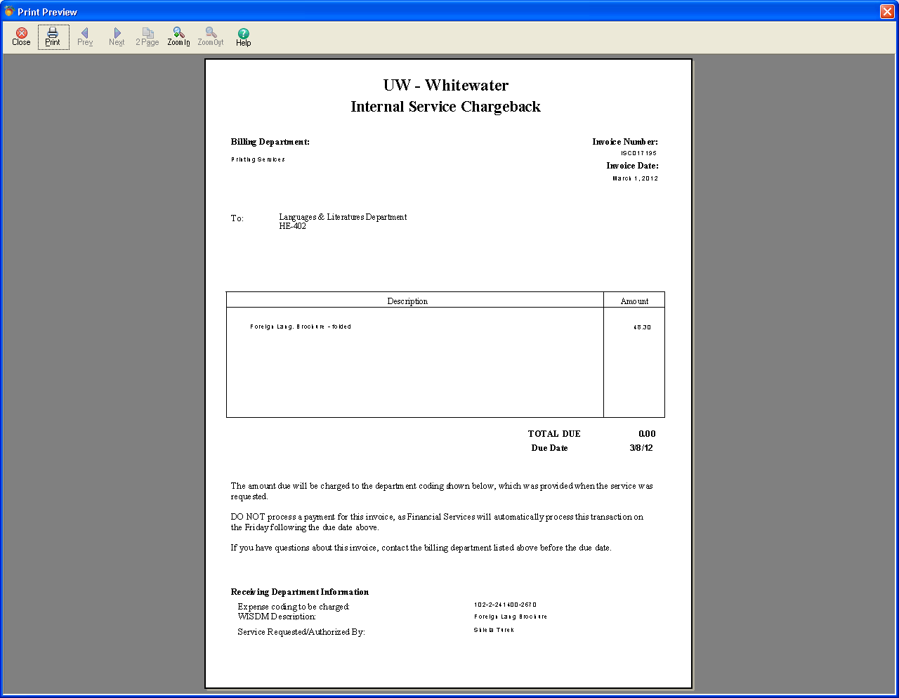
The bottom contains instructions to the department receiving the invoice not to pay it, and indicates the coding to be charged and the person who authorized the chargeback.

The invoice is sent by campus mail or e-mail to the customer. The customer does not have to do anything if the invoice is correct. If they have questions, they must contact the billing department by the date indicated on the invoice. After the date has passed, Financial Services will post the invoice to the ledger.

If you are not yet set up for doing chargebacks, but believe this would be useful to you, please contact Financial Services.
Printing a Posted Invoice

Once the nightly posting has occurred, you will be unable to print an invoice using the standard printing process. To print an invoice that has been posted, look up the invoice number as you will need to know this, go to Reports and Forms, Forms, Invoices and Packing Slips, and click once to open the folder. Scroll down to select your invoice to use for printing. Select by double clicking on it (it may take a few seconds to get to the next screen). Select “Printed Invoices” from the dropdown box. When you do this the screen will change slightly to that shown below:

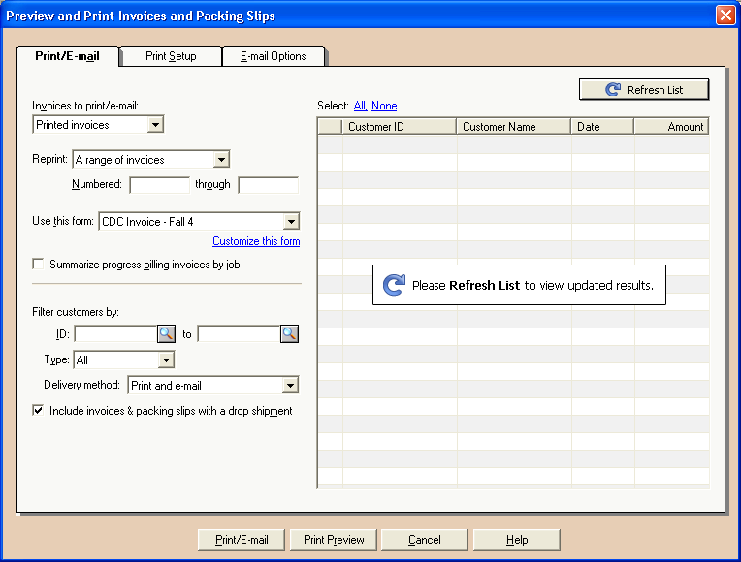

Enter the invoice number in both the “Numbered” and “through” fields. Verify that the invoice form you want to use is listed in the “Use this Form” box. If using e-mail, select that tab, and then your preference for just e-mail or e-mail and a paper copy. When finished press Print/E-mail. The invoice will print or pop up in an e-mail screen for you to send.

Printing a Group of Invoices

To print a group of invoices that has been prepared (whether posted or not), go to Reports and Forms, Forms, Invoices and Packing Slips, and click to open the folder. Scroll down to select your invoice to use for printing. Select by double clicking on it (it may take a few seconds to get to the next screen. Check the “Printed Invoices” from the drop down box if the invoices you want to print have already been printed and posted, check the “Unprinted” invoices box if you are printing the invoice for the first time. The fields to complete will be different depending on this selection.

To print an already printed invoice, enter the range of invoices you want to print for your customers in the “Numbered” and “through” fields. For already printed invoices, verify that the invoice form you want to use is listed in the Use this Form box. Enter the range of customer IDs in the fields indicated. You can use the dropdown list to help you select your customers.

If you are printing invoices that have not been printed already, the system will tell you the next available number to be used for the invoices you are going to print and will default with today’s date. You will need to select the form to use. You can use the dropdown list to help you select your customers.

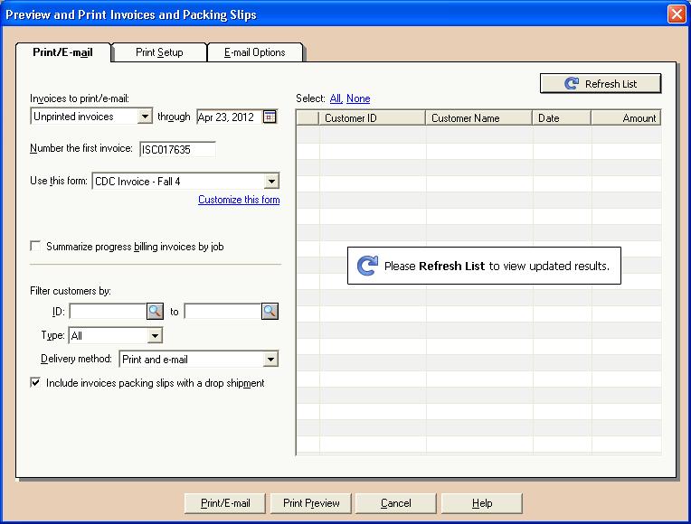

The system will print the invoices and ask if they printed OK and is it OK to assign the invoices numbers, press Yes. The invoices are now saved and assigned invoice numbers. Until posted, you can still go back to edit any one of them as you have before.

Troubleshooting

“I can’t see the revenue codes that will be used to deposit the payments” - The revenue coding should be visible below each description line of the invoice. If you see “miscellaneous revenue” you have not yet selected the revenue code to be used. Go the GL Account field column, and using the spy glass select the revenue code that should be used for that revenue. Be sure to select one that is within your department’s prefix.

“I don’t see the GL Account column” - The GL Account field column shows your revenue code that the amount will be deposited to. It is your prefix followed by the name given to that revenue coding string. This field controls how the invoice revenue will be deposited by the cashier. If you do not see this column, you cannot verify the revenue code string, which you need to do before finalizing the invoice. If you do not check the coding, your revenue may not go to your account. To display this column, go to the icon Options, Global, on the Accounting tab, Hide General Ledger Accounts, and uncheck the box in front of Accounts Receivable and click on OK. If you were in invoicing, you will need to go out and come back into it and the column should now be there.

“How do I get rid of customers I no longer want to see?” - Customers that have been used cannot be deleted. You will need to go into the customer – Maintain, Customer, and select that customer, and put a check in the inactive box. Save. The customer is now inactive. See next section if inactive customers show up.

“Inactive customers still show up in my list - How do I get rid of them?” To change your view to see only active items, go to Options, Global, on the Accounting tab, Other Options, check the box in front of Hide Inactive Accounts, and click on OK. Inactives will no longer show up in your lists.

“I inactivated a customer, but need to get them back again” - Change your view to see both active and inactive items, go to Options, Global, on the Accounting tab, Other Options, uncheck the box in front of Hide Inactive Accounts, and click on OK. Inactives will show up in your list and you can go into the customer account and remove the check in the inactive box, save it. Once you have done this, go back in to change your settings to Hide Inactive Accounts again.

“The invoice is printing on the wrong form” - When printing an invoice, be sure that the invoice form shown is yours – it starts with your prefix, and is the form you want to use. If it isn’t, check the Select From All Existing Forms box to bring up other forms. This will take a little while to bring up the list, as there are many different form templates in the system. Find the form you want to use and select it – click on it and proceeds through the printing process. Once you have selected the form, the system will remember which form you used last.

“The invoice I am using doesn’t show the information I need” - The invoice forms have been customized for each departments at the time of set up. If your needs change, or you find that your invoice doesn’t include something, call Financial Services for assistance 472-1331.

